Supporting Information for

Public Service Announcements and

Promoting Face Masks During the Covid-19 Pandemic

STEVEN GREENE, MARC HETHERINGTON, RAHSAAN MAXWELL and TIMOTHY J. RYAN

**Table of Contents**

Sample Characteristics 1

Question Wording – Study 1 2

Question Wording – Study 2 7

PSA Scripts 10

Consent details for Qualtrics surveys 12

Distribution of Exposure Variables 13

News Habits and PSA Memories 14

Full Regression Models in Study 1 15

Analysis of Individual Items in Study 1 16

Analysis with Dichotomized Exposure Variables 17

Non-Republican Respondents in Study 1 18

# Sample Characteristics

Table SI-1: Sample characteristics

|  |  |  |  |  |
| --- | --- | --- | --- | --- |
|  |  | Study 1  (All respondents) | Study 1  (Republican  Respondents) | Study 2 |
|  |  |  |  |  |
| Gender | |  |  |  |
|  | Male | 49.4% | 48.2% | 49.6% |
|  | Female | 50.6 | 51.8 | 50.0 |
|  |  |  |  |  |
| Race | |  |  |  |
|  | White (non-Hispanic) | 82.6% | 88.2% | 62.0% |
|  | Black | 7.7 | 4.0 | 14.0 |
|  | Latino | 2.8 | 2.0 | 17.0 |
|  | Other | 6.9 | 5.7 | 7.0 |
|  |  |  |  |  |
| Education | |  |  |  |
|  | High School or less | 21.7% | 20.3% | 40.7% |
|  | Some college | 37.9 | 39.1 | 27.9 |
|  | BA | 24.3 | 24.2 | 19.8 |
|  | Advanced Degree | 16.2 | 16.5 | 11.7 |
|  |  |  |  |  |
| Age | |  |  |  |
|  | 18-34 | 12.4% | 13.9% | 29.0% |
|  | 35-44 | 7.4 | 8.7 | 18.4 |
|  | 45-54 | 5.5 | 5.9 | 16.7 |
|  | 55+ | 47.5 | 55.8 | 35.9 |
|  | Missing age[1] | 27.3 | 15.6 | -- |
|  |  |  |  |  |
| N |  | 1,189 | 978 | 2,400 |

We report sample characteristics in two ways for Study 1 because the analyses in the main text are limited to Republicans only (the second column).

# Question Wording – Study 1

***Outcome Measures***

Wearing a face covering over your mouth and nose (a face mask) when you are in public is important to stop the spread of the coronavirus.

Strongly agree

Agree

Neither agree nor disagree

Disagree

Strongly disagree

How effective do you think masks are at lowering the chances that you will contract the coronavirus from another person?

Not at all effective

Somewhat effective

Effective

Very effective

Extremely effective

How effective do you think masks are at lowering the chances that you will spread the coronavirus to another person?

Not at all effective

Somewhat effective

Effective

Very effective

Extremely effective

How often do you wear a mask outside the home in situations where you cannot always maintain appropriate distance?

Always

Very often

Sometimes

Rarely

Never

***PSA exposure measures***

Do you remember seeing any public service announcements on television saying that you should wear a face mask in the past few weeks?

Yes

No

Unsure

[The following recall questions were presented to respondents who answered Yes or Unsure to the question above.]

Do you recall seeing the following Public Service Announcement?

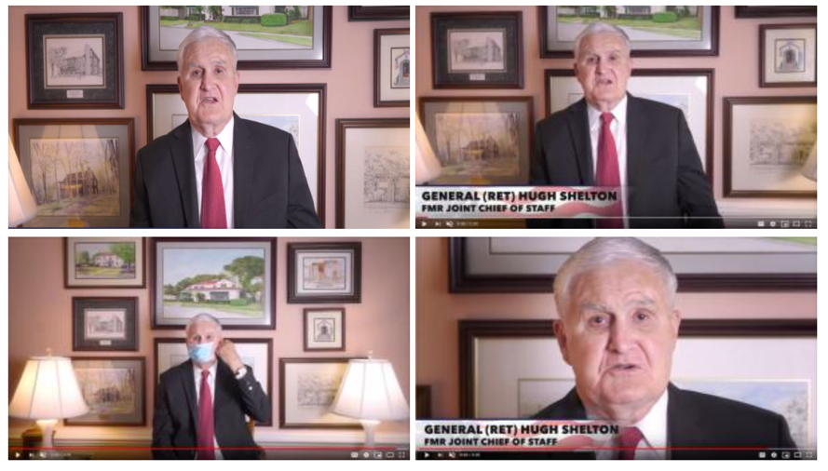

I don't recall seeing this Public Service Announcement

I'm not sure whether I saw this Public Service Announcement

I'm certain I saw this Public Service Announcement

Do you recall seeing the following Public Service Announcement?

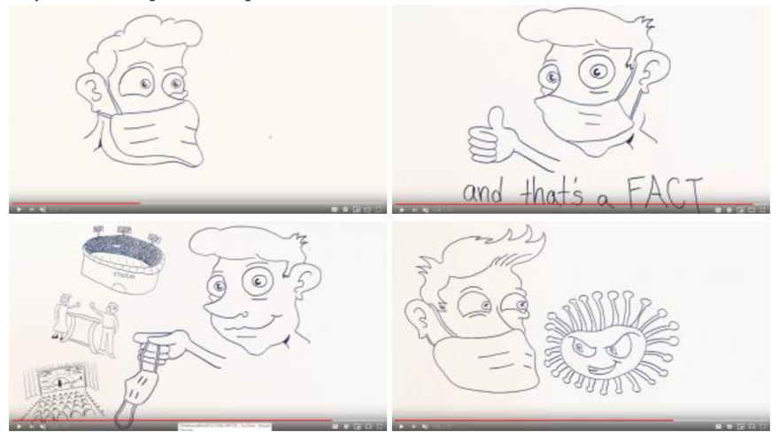

I don't recall seeing this Public Service Announcement

I'm not sure whether I saw this Public Service Announcement

I'm certain I saw this Public Service Announcement

Do you recall seeing the following Public Service Announcement?

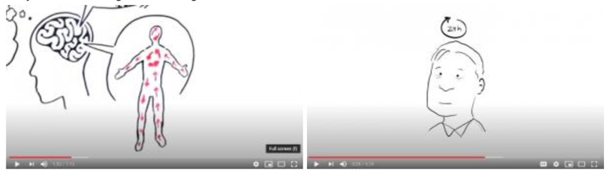

I don't recall seeing this Public Service Announcement

I'm not sure whether I saw this Public Service Announcement

I'm certain I saw this Public Service Announcement

Do you recall seeing the following Public Service Announcement?

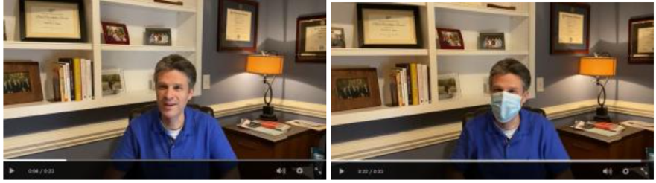

I don't recall seeing this Public Service Announcement

I'm not sure whether I saw this Public Service Announcement

I'm certain I saw this Public Service Announcement

[The following question was asked whenever a respondent said they were certain they saw a particular PSA.]

About how many times did you see this Public Service Announcement (just your best guess)?

Just once

Between two and five times

Between six and ten times

More than ten times

***News Exposure***

Next, we're interested in how often you watch local NEWSCASTS. How often do you watch any of the following local NEWSCASTS during the typical week?

[Networks: WRAL (NBC5); WRAZ (FOX 50); WNCN (CBS 17); WTVD (ABC 11)]

Not at all

At least once

3-5 times

Almost every day

Everyday

***Demographics***

How would you describe your gender?

Male

Female

Other

What is your current age?

[open-ended]

What is the highest level of school you have completed or the highest degree you have recieved [sic.]?

Less than high school degree

High school graduate (high school diploma or equivalent including GED)

Some college but no degree

Associate’s degree in college (2-year)

Bachelor’s degree in college (4-year)

Master’s degree

Doctoral degree

How would you describe your race or ethnicity

White, non-Hispanic

Black or African American, non-Hispanic

Latino, Latinx, or Hispanic

Asian

American Indian or Alaska Native

Native Hawaiian or Pacific Islander

Other

Please indicate your yearly household income

Less than $10,000

$10,000 - $19,999

$20,000 - $29,999

$30,000 - $39,999

$40,000 - $49,999

$50,000 - $59,999

$60,000 - $69,999

$70,000 - $79,999

Generally speaking, do you usually think of yourself as a DEMOCRAT, a REPUBLICAN, an INDEPENDENT, or what?

Democrat

Republican

Independent

No preference

Other party (specify)

[Asked of Republicans] Would you call yourself a STRONG Republican or a NOT VERY STRONG Republican?

Strong

Not very strong

[Asked of Democrats] Would you call yourself a STRONG Republican or a NOT VERY STRONG Democrat?

Strong

Not very strong

[Asked of independents] Do you think of yourself as CLOSER to the Republican Party or the Democratic Party?

Closer to Republican

Closer to Democratic

Neither

# Question Wording – Study 2

***Outcome measures***

Wearing a face covering over your mouth and nose (a face mask) when you are in public is important to stop the spread of the coronavirus.

Strongly agree

Agree

Neither agree nor disagree

Disagree

Strongly disagree

How effective do you think masks are at lowering the chances that you will contract the coronavirus from another person?

Not at all effective

Somewhat effective

Effective

Very effective

Extremely effective

How effective do you think masks are at lowering the chances that you will spread the coronavirus to another person?

Not at all effective

Somewhat effective

Effective

Very effective

Extremely effective

***Moderating variables***

Generally speaking, do you usually think of yourself as a DEMOCRAT, a REPUBLICAN, an INDEPENDENT, or what?

Democrat

Republican

Independent

No preference

Other party (specify)

[Asked of Republicans] Would you call yourself a STRONG Republican or a NOT VERY STRONG Republican?

Strong

Not very strong

[Asked of Democrats] Would you call yourself a STRONG Republican or a NOT VERY STRONG Democrat?

Strong

Not very strong

[Asked of independents] Do you think of yourself as CLOSER to the Republican Party or the Democratic Party?

Closer to Republican

Closer to Democratic

Neither

Below, please indicate how much of a threat you believe that the coronavirus pandemic will pose to each of the following items. 1 means you think it is not much of a threat at all, while 10 means that you think the coronavirus is a devastating threat.

[Item:] Your health and wellbeing

[10-point response scaled labeled from 1 = “Not a threat at all” to 10 = “A devastating threat”]

[Responses 1-4 form one tercile (N=651). Responses 5-7 form the second tercile (N=947). Responses 8-10 form the final tercile (N=802).]

I am going to name some institutions in this country. As far as the people running these institutions are concerned, would you say that you have a great deal of confidence, only some confidence, or hardly any confidence at all in them?

[Items: Scientific community, US military]

A great deal of confidence

Only some confidence

Hardly any confidence

***Demographics***

How would you describe your gender?

Male

Female

Other (specify)

How would you describe your race or ethnicity?

White, non Hispanic

Black or African American, non Hispanic

Latino, Latinx, or Hispanic

Asian

American Indian, Native American, or Alaska Native

Native Hawaiian or Pacific Islander

Other

What is the highest level of school you have completed or the highest degree you received?

Less than high school degree

High school graduate (high school diploma including GED)

Some college but no degree

Associate degree (2-year)

Bachelor's degree (4-year)

Master's degree

Doctoral degree

Professional degree (JD, MD)

Please select your age

Under 18

18 - 24

25 - 34

35 - 44

45 - 54

55 - 64

65 - 74

75 - 84

85 or older

# PSA Scripts

*Generic Ad Transcript:*

“Picture this stadiums full; movie theaters crowded; restaurants bustling. It can happen sooner with this [animated image of person wearing a mask]. Masks drastically cut down on the bacteria you breathe in… and out. Yeah it's gross but it’s a fact. And while we're talking facts, here's another. Masks are proven to help stop Covid-19 in its tracks so if you want all this [animated images of full stadiums, theaters, and restaurants] do this [animated image of face donning a mask] you'll be glad you did. And that's a fact”

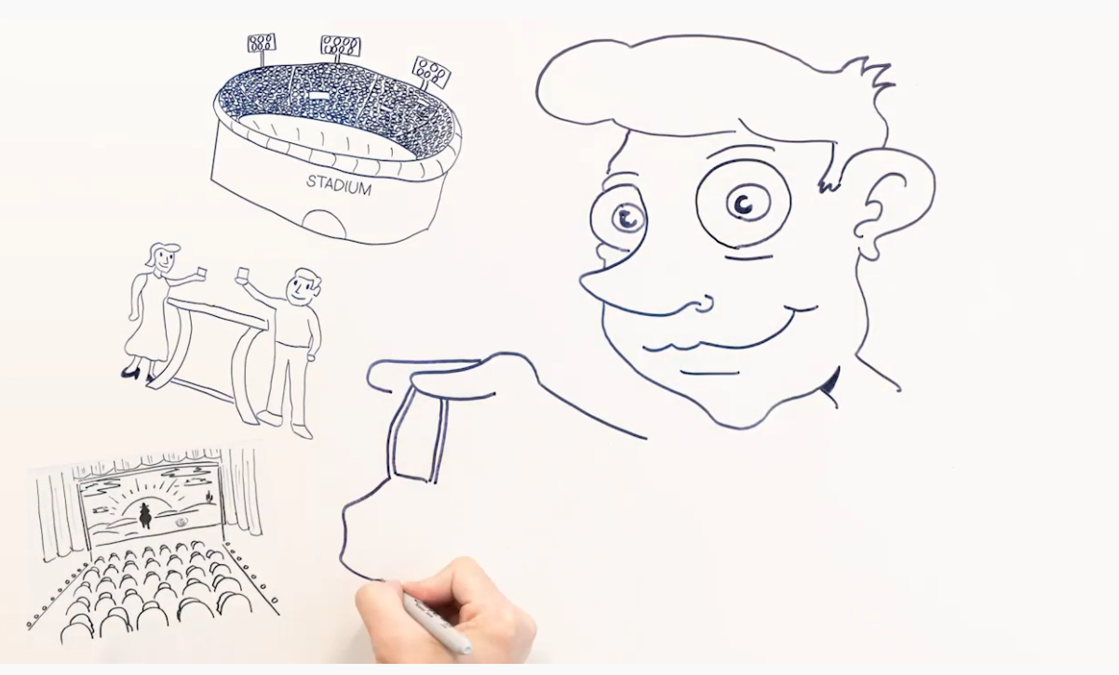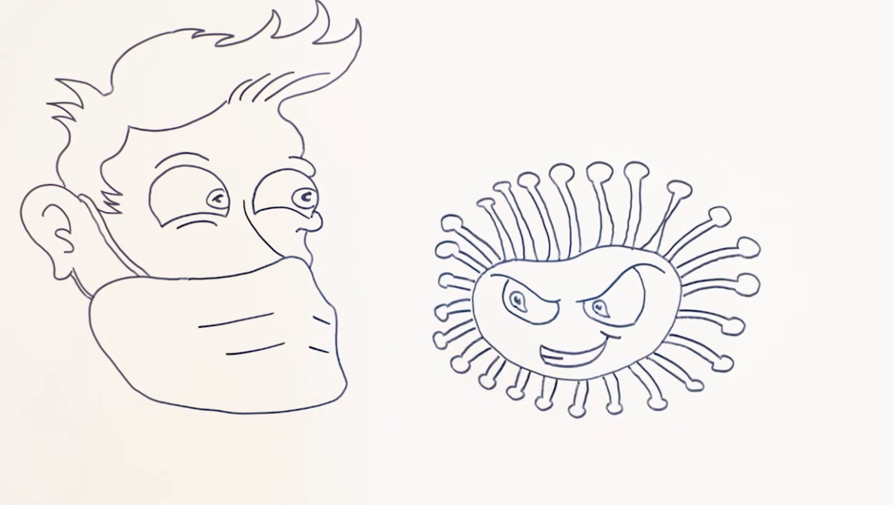

*Shelton Ad Transcript*:

“I served my country for many years. This is a crisis unlike any that I have seen. In the span of a few short months America has had more deaths than in the entire 38 years that I served on active duty. Now it's time to turn the tide; to fight. Wear a mask; it works and it will save lives. I wear a mask to protect you. You wear a mask to protect me. We wear a mask to protect our great nation. God bless America”

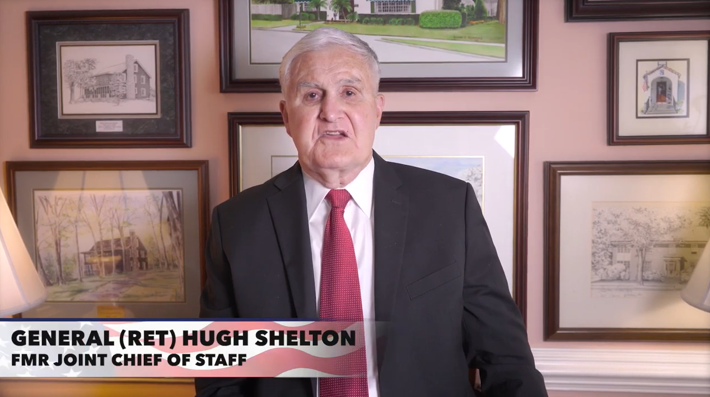 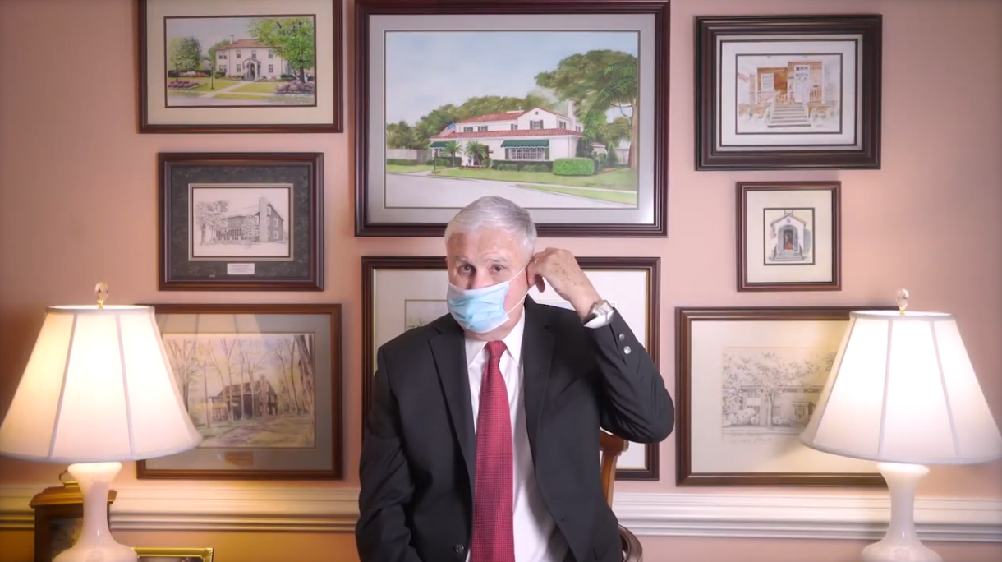

# Consent details for Qualtrics surveys

The Qualtrics surveys for both studies included an informed consent disclosure that clarified, per IRB guidelines, the precise process of the studies. We did not anticipate any harm from participating in the studies. One impact of the studies is that (on average) respondents who viewed the PSAs should have become more likely to wear masks. Given the public health benefits of masking during the COVID-19 benefit, we consider this impact to be positive for respondents and for those around them. Our subjects for both studies were recruited through the opt-in Qualtrics panel. These respondents are people who have agreed to be sent survey invitations. Each invitation offers the respondent a modest incentive (cash, or points redeemable for merchandise) for completion, and invitees can simply skip surveys if they do not wish to participate. The exact compensation is determined by Qualtrics and is not revealed to the research team.

# Distribution of Exposure Variables

The figure below reports the distribution of the self-reported exposure variables we use in Study 1. Values of 0 signify that a respondent is certain they did not see a particular ad. Values of 0.2 signify the respondent is not sure whether they saw the ad or not. Values of 0.4 signify the respondent is certain they saw the ad, and thinks they saw it about once. Values of 0.6 signify the respondent is certain they saw the ad, and thinks they saw it about once. between two and five times. Values of 0.8 signify the respondent is certain they saw the ad, and thinks they saw it between six and ten times. Values of 1.0 signify the respondent is certain they saw the ad, and thinks they saw it more than ten times.

Figure SI-1: Distribution of Exposure Variables, Study 1



Given that these distributions look similar, one might wonder about the correlations among them. Are they all reflective of a single underlying construct, such as TV exposure? Table SI-2 reports the relevant correlations. They are moderate, and the highest among them is 0.62, suggesting that they are distinct. Most important for our objective to compare the genuine Shelton Ad to the genuine Generic ad, the correlation between these two measures is only moderate: 0.44.

Table SI-2: Correlations Among Exposure Variables (Study 1)

|  |  |  |  |  |
| --- | --- | --- | --- | --- |
|  | Shelton Ad | Generic Ad | Decoy Shelton | Decoy Generic |
| Shelton Ad | 1.0 |  |  |  |
| Generic Ad | 0.44 | 1.0 |  |  |
| Decoy Shelton | 0.49 | 0.52 | 1.0 |  |
| Decoy Generic | 0.49 | 0.62 | 0.60 | 1.0 |

# News Habits and PSA Memories

Table SI-3: News Habits and PSA Memories (Study 1)

|  |  |  |
| --- | --- | --- |
|  | Shelton PSA Exposure | Generic PSA Exposure |
|  |  |  |
| WRAL | 0.142** | 0.010 |
|  | (0.023) | (0.016) |
|  |  |  |
| WRAZ | 0.046 | 0.040** |
|  | (0.024) | (0.019) |
|  |  |  |
| CBS | 0.008 | 0.012 |
|  | (0.027) | (0.022) |
|  |  |  |
| ABC | -0.010 | 0.003 |
|  | (0.022) | (0.015) |
|  |  |  |
| Decoy Shelton PSA | 0.290** | 0.184** |
|  | (0.053) | (0.042) |
|  |  |  |
| Decoy Generic PSA | 0.404** | 0.521** |
|  | (0.064) | (0.061) |
|  |  |  |
| Constant | 0.011* | 0.001 |
|  | (0.005) | (0.004) |
|  |  |  |
| Observations | 1,189 | 1,189 |
| R-squared | 0.362 | 0.431 |

Robust standard errors in parentheses

** p<0.01, * p<0.05

This analysis assesses whether self-reports of watching WRAL and WRAZ (the networks that aired the PSAs in Study 1) is associated with memories of seeing the two PSAs (a way to validate the exposure self-reports). The dependent variable for each model is memory of each PSA, scaled from 0 = did not see the PSA to 1 = saw it between six and ten times. The independent variables are self-reports of watching each network, scaled from 0 = Not at all to 1 = Several times per day. Measures of exposure to the decoy PSAs are included to help distinguish genuine memories from a general proclivity to provide affirmative responses to survey questions (acquiescence bias). As the Table shows, the appropriate networks (WRAL and WRAZ) are generally more predictive of PSA memories than the other networks.

# Full Regression Models in Study 1

Table SI-4: Full Regression Models for Study 1

|  |  |  |  |  |
| --- | --- | --- | --- | --- |
|  | Mask Support | | Mask Behavior | |
|  |  |  |  |  |
| Shelton PSA | 0.192** | 0.177** | 0.151** | 0.135** |
|  | (0.050) | (0.049) | (0.045) | (0.044) |
|  |  |  |  |  |
| Generic PSA | 0.177* | 0.207** | 0.102 | 0.126 |
|  | (0.070) | (0.068) | (0.076) | (0.073) |
|  |  |  |  |  |
| Decoy Shelton PSA | 0.084 | 0.122 | 0.050 | 0.118 |
|  | (0.067) | (0.067) | (0.073) | (0.069) |
|  |  |  |  |  |
| Decoy Generic PSA | -0.151 | -0.129 | -0.156 | -0.138 |
|  | (0.078) | (0.080) | (0.084) | (0.082) |
|  |  |  |  |  |
| Age (0-1) |  | 0.270** |  | 0.240** |
|  |  | (0.042) |  | (0.045) |
|  |  |  |  |  |
| Black = 1 |  | 0.069 |  | 0.030 |
|  |  | (0.044) |  | (0.047) |
|  |  |  |  |  |
| Latino = 1 |  | -0.013 |  | -0.023 |
|  |  | (0.063) |  | (0.073) |
|  |  |  |  |  |
| Other race = 1 |  | 0.047 |  | -0.006 |
|  |  | (0.045) |  | (0.047) |
|  |  |  |  |  |
| Some college = 1 |  | -0.023 |  | -0.001 |
|  |  | (0.025) |  | (0.027) |
|  |  |  |  |  |
| BA = 1 |  | -0.022 |  | 0.009 |
|  |  | (0.029) |  | (0.031) |
|  |  |  |  |  |
| Adv. Degree = 1 |  | -0.029 |  | -0.008 |
|  |  | (0.033) |  | (0.034) |
|  |  |  |  |  |
| Female = 1 |  | -0.002 |  | 0.042** |
|  |  | (0.018) |  | (0.019) |
|  |  |  |  |  |
| Income (0-1) |  | 0.098** |  | 0.093** |
|  |  | (0.032) |  | (0.033) |
|  |  |  |  |  |
| Mean-replaced age = 1 |  | -0.039 |  | -0.003 |
|  |  | (0.025) |  | (0.024) |
|  |  |  |  |  |
| Constant | 0.552** | 0.379** | 0.778** | 0.579** |
|  | (0.010) | (0.035) | (0.011) | (0.039) |
|  |  |  |  |  |
| Observations | 978 | 977 | 978 | 977 |
| R-squared | 0.038 | 0.087 | 0.016 | 0.056 |

Robust standard errors in parentheses

** p<0.01, * p<0.05

# Analysis of Individual Items in Study 1

Table SI-5: Analysis of Individual Scale Items in Study 1

|  |  |  |  |  |  |
| --- | --- | --- | --- | --- | --- |
|  | Mask Important | | Mask Prevent Contagion | | Masks Prevent Spread |
|  |  |  |  |  |  |
| Shelton PSA | 0.196** |  | 0.208** |  | 0.173** |
|  | (0.047) |  | (0.059) |  | (0.063) |
|  |  |  |  |  |  |
| Generic PSA | 0.152* |  | 0.216* |  | 0.165 |
|  | (0.065) |  | (0.086) |  | (0.086) |
|  |  |  |  |  |  |
| Decoy Generic PSA | -0.169 |  | -0.164 |  | -0.120 |
|  | (0.088) |  | (0.095) |  | (0.092) |
|  |  |  |  |  |  |
| Decoy Shelton PSA | 0.080 |  | 0.077 |  | 0.095 |
|  | (0.077) |  | (0.076) |  | (0.079) |
|  |  |  |  |  |  |
| Intercept | 0.753** |  | 0.432** |  | 0.472** |
|  | (0.011) |  | (0.011) |  | (0.011) |
|  |  |  |  |  |  |
| R-squared |  |  |  |  |  |
| N | 978 |  | 978 |  | 978 |

Robust standard errors in parentheses

** p<0.01, * p<0.05

This table reports analyses parallel to Table 1 in the main text, but with the summary mask scale broken up into its constituent items.

# Analysis with Dichotomized Exposure Variables

As the Distribution of Exposure Variables section above reviews, the ad exposure variables we use for Study 1 are right-skewed. Such distributions raise the possibility that our results are dependent on a small number of respondents who have extreme values on the explanatory variables, and therefore exert excessive leverage in our regression models. To assess this possibility, we estimate the models in Table 1 of the main text, substituting dichotomized versions of the exposure variables, which more tightly constrain the leverage of any particular observation. Because the number of observations with exposure values higher than 0.2 is fairly limited, the only dichotomous version of the exposure variable that we can reasonably examine is one that compares respondents who are certain they did not see a particular PSA (exposure = 0.0) against all others (exposure ≥ 0.2). Table SI-6 below reports the relevant results.

The effect magnitudes reported below are noticeably different than in Table 1, as should be expected given the different scaling of the independent variables. The substantive account, however, is much the same: exposure to either PSA is significantly associated with mask support. Accounting for estimate uncertainty, effects associated with the Shelton and Generic PSAs are comparable in magnitude. The relationships for the decoy PSAs are statistically significant in some cases—suggestive evidence that people reporting false memories have a more skeptical orientation vis-à-vis masks.

Table SI-6: PSA Exposure and Mask Support (Dichotomized Exposure Variables, Study 1)

|  |  |  |  |  |
| --- | --- | --- | --- | --- |
|  | Mask Support | | Mask Behavior | |
|  |  |  |  |  |
| Shelton PSA | 0.073** | 0.071** | 0.058* | 0.056* |
|  | (0.023) | (0.023) | (0.023) | (0.023) |
|  |  |  |  |  |
| Generic PSA | 0.067* | 0.084** | 0.040 | 0.062* |
|  | (0.029) | (0.029) | (0.032) | (0.031) |
|  |  |  |  |  |
| Decoy Shelton PSA | 0.042 | 0.049* | 0.033 | 0.042 |
|  | (0.024) | (0.023) | (0.024) | (0.024) |
|  |  |  |  |  |
| Decoy Generic PSA | -0.066* | -0.050 | -0.084* | -0.068 |
|  | (0.032) | (0.032) | (0.035) | (0.035) |
|  |  |  |  |  |
| Intercept | 0.055** | 0.376** | 0.777** | 0.580** |
|  | (0.011) | (0.036) | (0.011) | (0.040) |
|  |  |  |  |  |
| Demographic controls? | No | Yes | No | Yes |
|  |  |  |  |  |
| R-squared | 0.030 | 0.080 | 0.016 | 0.055 |
| N | 978 | 977 | 978 | 977 |

Robust standard errors in parentheses

** p<0.01, * p<0.05, two-tailed

Note: Analysis includes self-identified Republicans and Republican leaners. Dependent variables are scaled from 0 to 1, with high values representing greater support for masking.

# Non-Republican Respondents in Study 1

Table SI-7: Non-Republican Respondents in Study 1

|  |  |  |  |  |
| --- | --- | --- | --- | --- |
|  | Mask Support | | Mask Behavior | |
|  |  |  |  |  |
| Shelton PSA | 0.134 | 0.074 | 0.121 | 0.080 |
|  | (0.071) | (0.073) | (0.068) | (0.070) |
|  |  |  |  |  |
| Generic PSA | 0.064 | 0.113 | -0.187 | -0.206 |
|  | (0.104) | (0.101) | (0.179) | (0.167) |
|  |  |  |  |  |
| Decoy Shelton PSA | -0.174 | -0.163 | -0.026 | -0.071 |
|  | (0.148) | (0.141) | (0.106) | (0.110) |
|  |  |  |  |  |
| Decoy Generic PSA | -0.119 | -0.150 | 0.074 | 0.099 |
|  | (0.107) | (0.098) | (0.109) | (0.112) |
|  |  |  |  |  |
| Age (0-1) |  | 0.501** |  | 0.268 |
|  |  | (0.190) |  | (0.203) |
|  |  |  |  |  |
| Black = 1 |  | 0.012 |  | -0.048 |
|  |  | (0.043) |  | (0.041) |
|  |  |  |  |  |
| Latino = 1 |  | -0.011 |  | -0.033 |
|  |  | (0.063) |  | (0.066) |
|  |  |  |  |  |
| Other race = 1 |  | 0.102* |  | -0.044 |
|  |  | (0.049) |  | (0.062) |
|  |  |  |  |  |
| Some college = 1 |  | 0.046 |  | 0.045 |
|  |  | (0.047) |  | (0.048) |
|  |  |  |  |  |
| BA = 1 |  | 0.065 |  | 0.086 |
|  |  | (0.046) |  | (0.045) |
|  |  |  |  |  |
| Adv. Degree = 1 |  | -0.028 |  | 0.092 |
|  |  | (0.063) |  | (0.050) |
|  |  |  |  |  |
| Female = 1 |  | -0.035 |  | 0.070* |
|  |  | (0.037) |  | (0.035) |
|  |  |  |  |  |
| Income (0-1) |  | 0.135* |  | 0.110 |
|  |  | (0.059) |  | (0.056) |
|  |  |  |  |  |
| Mean-replaced age = 1 |  | 0.101 |  | 0.123* |
|  |  | (0.051) |  | (0.053) |
|  |  |  |  |  |
| Constant | 0.679** | 0.309** | 0.825** | 0.509** |
|  | (0.022) | (0.098) | (0.021) | (0.091) |
|  |  |  |  |  |
| Observations | 211 | 208 | 211 | 208 |
| R-squared | 0.019 | 0.180 | 0.022 | 0.159 |

Robust standard errors in parentheses

** p<0.01, * p<0.05

This analysis is exactly parallel to Table SI-3, except it is conducted on the non-Republican identifiers in our sample.

1. See a footnote in the main text.