Figure 1 Control Visual of Google News Search without Stories about 1979 US House Special Committee Report

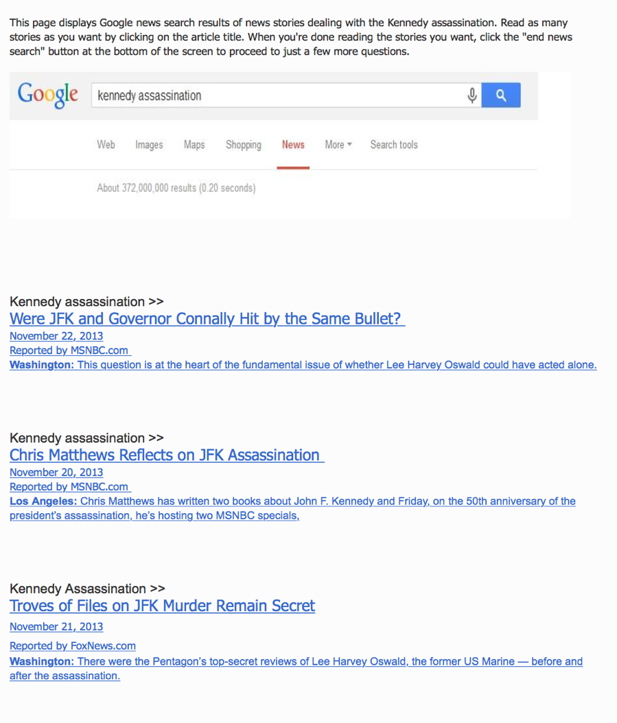

Figure 2 Treatment Visual of Google News Search with Stories about 1979
US House Special Committee Report

