Supplementary S1. Mortality summary of the overall study and regional referral pathways
Variable | Regional referral pathways |  |  | Study total  13977
 | Intraregional  3536 | OUT of region  7776 | INTO region  2665
Death after flight
Total n(% of total) | 304(9) | 949(12) | 675(25) | 1928(14)***
Time post-flight to death  0-7 days n(%) | 55(18) | 118(12) | 60(9) | 233(12)***
7-31 days n(%) | 32(11) | 104(11) | 115(17) | 251(13)
1-6months n(%) | 46(15) | 176(19) | 182(27) | 404(21)
6-12month n(%) | 23(8) | 102(11) | 65(10) | 190(10)
>1 year n(%) | 145(48) | 443(47) | 250(37) | 838(44)
Death All Cause top three
Cancer n(%) | 74(24) | 332(35) | 319(47) | 725(38)
Circulatory n(%) | 75(25) | 263(28) | 138(20) | 476(25)
Respiratory n(%) | 33(11) | 61(6) | 53(8) | 147(8)
Death 0-7days after flight
Most frequent category of death 0-7days after flight
Cardiology n(%)  flight priority(P1-P5)(%)  sending ARIA+ (%) | 18(33)  P1(38)  Rural(63) | 51(43)  P4ª(39)  Inner  Regional(51) | 11(18)  P4(45)  Rural(73) | 80(34)  P4ª(34)  Inner  Regional(36)
Second most frequent category of death 0-7days after flight
Cancer n(%)  flight priority(P1-P5) (%)  sending ARIA+ (%) | 8(15)  P4(50)  Rural(75) | 23(19)  P4(43)  Inner regional(74) | 34(57)  P4(94)  Major city(94) | 65(28)  P4(71)  Major  city(49)
Statistical significance codes: ***<0.001; Cohen’s h=.20 (small effect). Abbreviations: ARIA+: Accessibility/Remoteness Index of Australia, P1: priority category 1 (most urgent); P5 priority category 5:(lower urgency). a.) One (<1%) missing priority category.

Supplementary S2. Patient and service summary of the overall study and regional referral pathways
Variable | Regional referral pathways |  |  | Study total  N=13977
 | Intraregional  n=3536 | OUT of region  n=7776 | INTO region  n=2665
Patient
Age years mean(sd) | 41.1(23.8) | 52.2(24.1) | 51.1(28.2) | 49.1(25.3)***
Female n(%) | 1437(41) | 3044(39) | 1154(43) | 5635(40)***
Aeromedical
Task: IHT n(%) | 2901(82) | 7470(96) | 2440(92) | 12811(92) ***
primary n(%) | 599(17) | 176(2) | 170(6) | 945(7)
non-hospital return n(%) | 36(1) | 130(2) | 55(2) | 221(2)
Asset: Fixed Wing n(%) | 2345(66) | 7453(96) | 2444(92) | 12242(87)***
Asset: Rotor Wing n(%) | 1002(28) | 26(<1) | 31(1) | 1059(8)
Priority: P4 & P5 n(%) | 1123(32) | 5334(69) | 2011(75) | 8468(61)*
P4 & P5 Request-activation interval(hours) mean(sd)  median(min-max) | 10.1(18.0)  4(0-158) | 22.1(25.1)  16(0-259) | 27.8(32.6)  17(0-374) | 21.9(26.7)***  15(0-374)
Sending location/ department
ARIA+ most common  n(%) | Rural  3316(94) | Inner regional 6566(84) | Major City 1575(59) | Inner regional  6957(50)
Sending ED n(%) | 166(5) | 539(7) | 69(3) | 774(6)***
most common ICD  n(%) | Appendicitis  25(15) | Myocardial Infarct  112(21) | Appendicitis  6(9) | -
LOS (hours) mean(sd) | 2.9(2.2) | 4.8(3.6) | 3.1(3.0) | 4.3(3.4)***
Sending hospital n(%) | 2768(78) | 7056(91) | 2426(91) | 12250(88)***
DRG most common  n(%) | Digestive  271(10) | MI  1527(22) | Injuries  95(4) | -
LOS (days) mean(sd) | 1.1(3.0) | 3.2(5.9) | 10.3(16.3) | 4.1(9.2) ***
Receiving location/ department
ARIA+ most common  n(%) | Inner regional  3401(96) | Major City  7484(96) | Inner regional  2522(95) | Major City  7449(53)
Receiving ED n(%) | 2738(77) | 2017(26) | 1752(66) | 6507(47)***
ICD most common  n(%) | Appendicitis  172(6) | Myocardial Infarct  77(4) | Stroke  53(3) | -
LOS (hours) mean(sd) | 4.3(3.1) | 1.7(1.8) | 4.6(4.0) | 3.6(3.3)***
Disposition:  discharged n(%) | 290(11) | 79(4) | 131(7) | 500(8) ***
admit to hospital n(%) | 2302(84) | 1916(95) | 1562(89) | 5780(89)
transferred n(%) | 131(5) | 20(1) | 47(3) | 198(3)
LAMA n(%) | n.p | nil | 12(1) | 21(<1)
died in ED n(%) | n.p | n.p | nil | n.p
Direct hospital admission n(%) | 759(21) | 5621(72) | 851(32) | 7231(52)***
DRG most frequent  n(%) | Vaginal birth  39(5) | Interventional cardiology  529(9) | Surgical followup  70(8) | -
LOS (days) mean(sd) | 4.6(8.3) | 8.8(12.7) | 8.9(12.1) | 8.4(12.3)***
Disposition:  home n(%) | 412(54) | 4319(77) | 560(66) | 5291(73) ***
transferred n(%) | 298(39) | 857(15) | 154(18) | 1309(18)
died in hospital n(%) | 17(2) | 109(2) | 62(7) | 188(3)
other n(%) | 32(4) | 335(6) | 75(9) | 442(6)
Statistical significance codes: *<0.05, ***<0.001; Cohen’s d/h=.20 (small effect), d/h=.50 (medium effect), d/h=.80 or higher (large effect). Abbreviations: ARIA+: Accessibility/Remoteness Index of Australia; d: Cohen’s d; ED: emergency department; h: Cohen’s h; LOS: length of stay; LAMA: left against medical advice; MI: myocardial infarct, n.p: not presented (for patient sums <10), P4 & P5: least urgent priority categories. Missing data was subtracted from denominators (for missing data see supplementary file S8).

Supplementary S3. Multiple flights per person during the study period
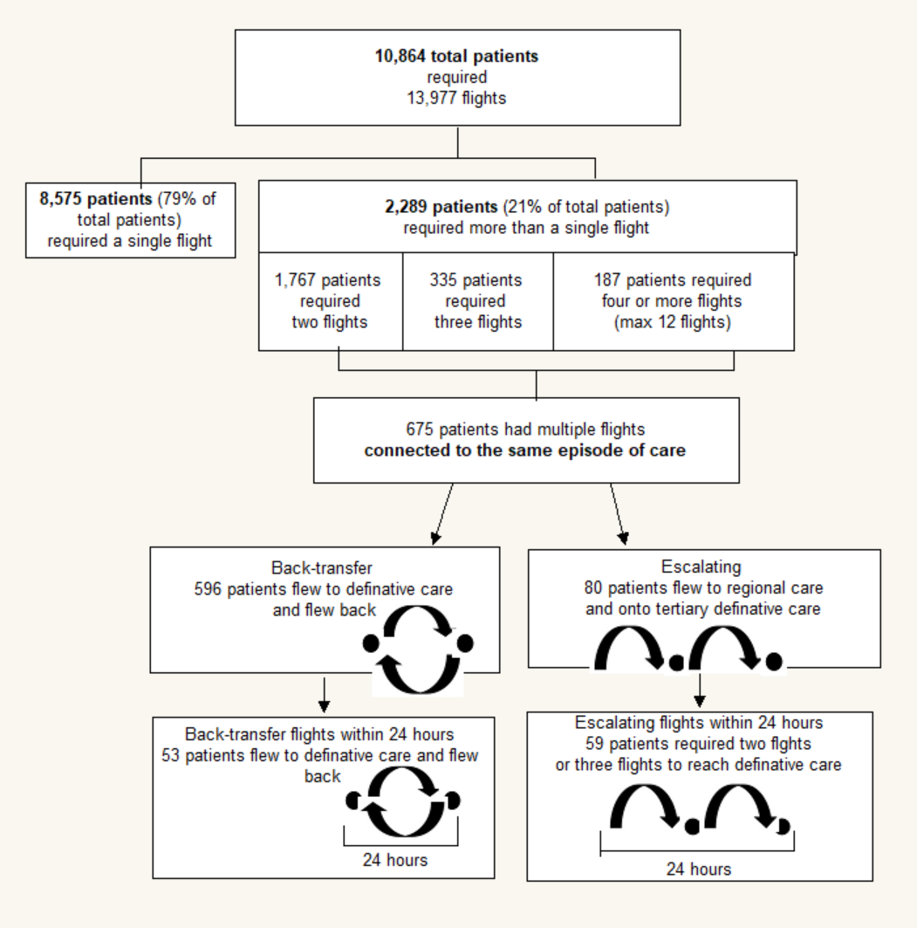

Supplementary S4. Map of study region
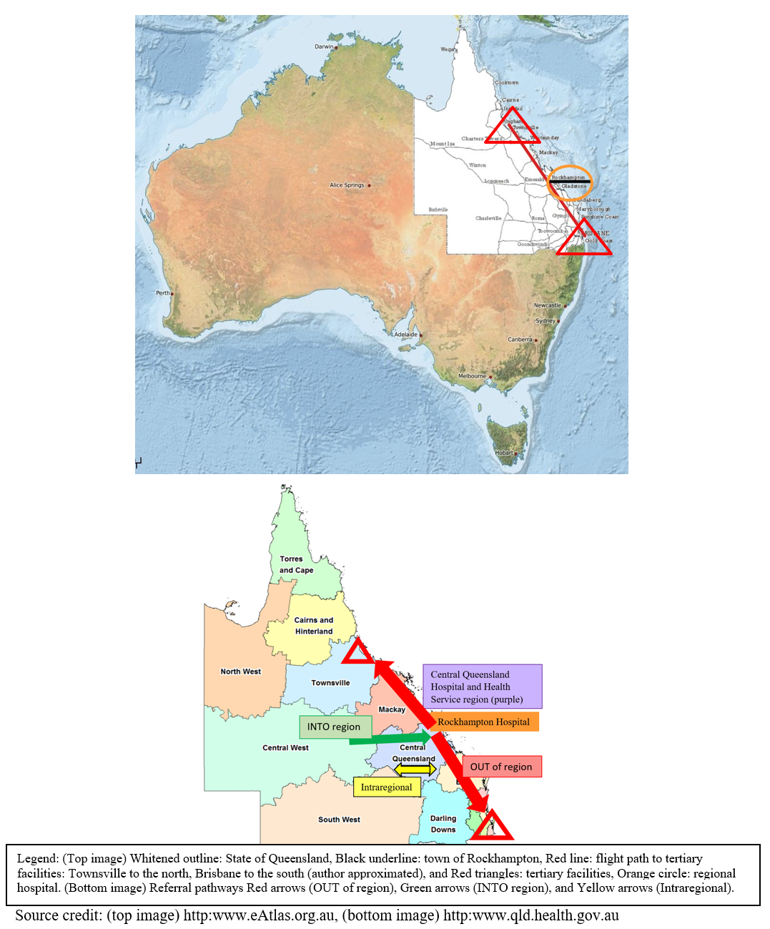

Supplementary S5. Map of Central Queensland Hospital and Health Service region
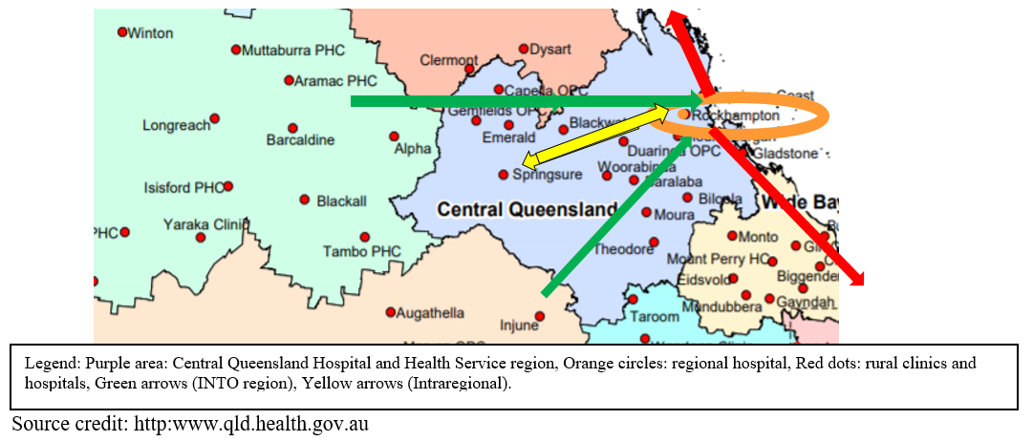

Supplementary S6.Queensland air ambulance priority categories (P1-P5)
Asset type | Priority 1 | Priority 2 | Priority 3 | Priority 4 | Priority 5
Fixed wing (FW):  Rotor wing (RW) | FW:  30 minutes during 0800-2000,  45 minutes during 2000-0800  ________________  RW:  15 minutes during 0800-2000,  30 minutes during 2000-0800. | 1-3 hours  All aircraft  Day or night | 3-6 hours  All aircraft  Day or night | 6-24 hours  All aircraft  Day or night | 24 hours  All aircraft  Day or night
Queensland Emergency Helicopter Network Tasking Guidelines (2011)¹⁷

Supplementary S7. STROBE Statement
 |  | Item No | Recommendation |  | Page  No
Title and abstract |  | 1 | (a) Indicate the study’s design with a commonly used term in the title or the abstract |  | 1
 |  |  | (b) Provide in the abstract an informative and balanced summary of what was done and what was found |  | 2
Introduction
Background/rationale |  | 2 | Explain the scientific background and rationale for the investigation being reported |  | 4,5
Objectives |  | 3 | State specific objectives, including any prespecified hypotheses |  | 1,5
Methods
Study design |  | 4 | Present key elements of study design early in the paper |  | 5
Setting |  | 5 | Describe the setting, locations, and relevant dates, including periods of recruitment, exposure, follow-up, and data collection |  | 5,6
Participants |  | 6 | (a) Cohort study—Give the eligibility criteria, and the sources and methods of selection of participants. Describe methods of follow-up  Case-control study—Give the eligibility criteria, and the sources and methods of case ascertainment and control selection. Give the rationale for the choice of cases and controls  Cross-sectional study—Give the eligibility criteria, and the sources and methods of selection of participants |  | 1,13
Variables |  | 7 | Clearly define all outcomes, exposures, predictors, potential confounders, and effect modifiers. Give diagnostic criteria, if applicable |  | 7,8
Data sources/ measurement |  | 8* | For each variable of interest, give sources of data and details of methods of assessment (measurement). Describe comparability of assessment methods if there is more than one group |  | 7,8
Bias |  | 9 | Describe any efforts to address potential sources of bias |  | 10
Study size |  | 10 | Explain how the study size was arrived at |  | 12
Quantitative variables |  | 11 | Explain how quantitative variables were handled in the analyses. If applicable, describe which groupings were chosen and why |  | 8,9,10
Statistical methods |  | 12 | (a) Describe all statistical methods, including those used to control for confounding |  | 14
 |  |  | (b) Describe any methods used to examine subgroups and interactions |  | 14
 |  |  | (c) Explain how missing data were addressed |  | 14
(d) Cohort study—If applicable, explain how loss to follow-up was addressed
Case-control study—If applicable, explain how matching of cases and controls was addressed
Cross-sectional study—If applicable, describe analytical methods taking account of sampling strategy
 |  |  | (e) Describe any sensitivity analyses
Results
Participants | 13* | (a) Report numbers of individuals at each stage of study—eg numbers potentially eligible, examined for eligibility, confirmed eligible, included in the study, completing follow-up, and analysed |  | 12,15,16
 |  | (b) Give reasons for non-participation at each stage |  | 12
 |  | (c) Consider use of a flow diagram |  | 12
Descriptive data | 14* | (a) Give characteristics of study participants (eg demographic, clinical, social) and information on exposures and potential confounders |  | 15,16
 |  | (b) Indicate number of participants with missing data for each variable of interest |  | 36,37
 |  | (c) Cohort study—Summarise follow-up time (eg, average and total amount)
Outcome data | 15* | Cohort study—Report numbers of outcome events or summary measures over time |  | 15,16
 |  | Case-control study—Report numbers in each exposure category, or summary measures of exposure |  | NA
 |  | Cross-sectional study—Report numbers of outcome events or summary measures |  | NA
Main results | 16 | (a) Give unadjusted estimates and, if applicable, confounder-adjusted estimates and their precision (eg, 95% confidence interval). Make clear which confounders were adjusted for and why they were included |  | NA
 |  | (b) Report category boundaries when continuous variables were categorized |  | 15,16
 |  | (c) If relevant, consider translating estimates of relative risk into absolute risk for a meaningful time period |  | NA
Other analyses | 17 | Report other analyses done—eg analyses of subgroups and interactions, and sensitivity analyses |  | NA
Discussion
Key results | 18 | Summarise key results with reference to study objectives |  | 21,22
Limitations | 19 | Discuss limitations of the study, taking into account sources of potential bias or imprecision. Discuss both direction and magnitude of any potential bias |  | 23
Interpretation | 20 | Give a cautious overall interpretation of results considering objectives, limitations, multiplicity of analyses, results from similar studies, and other relevant evidence |  | 23
Generalisability | 21 | Discuss the generalisability (external validity) of the study results |  | 23
Other information
Funding | 22 | Give the source of funding and the role of the funders for the present study and, if applicable, for the original study on which the present article is based |  | 24

Supplementary S8. Missing values
MISSING  Variable | MISSING  Referral pathway |  |  | Study total  N=13977
 | Intraregional  n=3536 | OUT of region  n=7776 | INTO region  n=2665
Aircraft type (e.g., FW, RW) n(%) | 189(5) | 297(4) | 190(7) | 676(5)
Aeromedical priority categories | 14(<1) | 41(<1) | 8(<1) | 63(<1)
P4 Request-activation interval | 99(9) | 208(4) | 117(7) | 424(6)
P5 Request-activation interval | 5(13) | 48(7) | 86(32) | 139(14)

