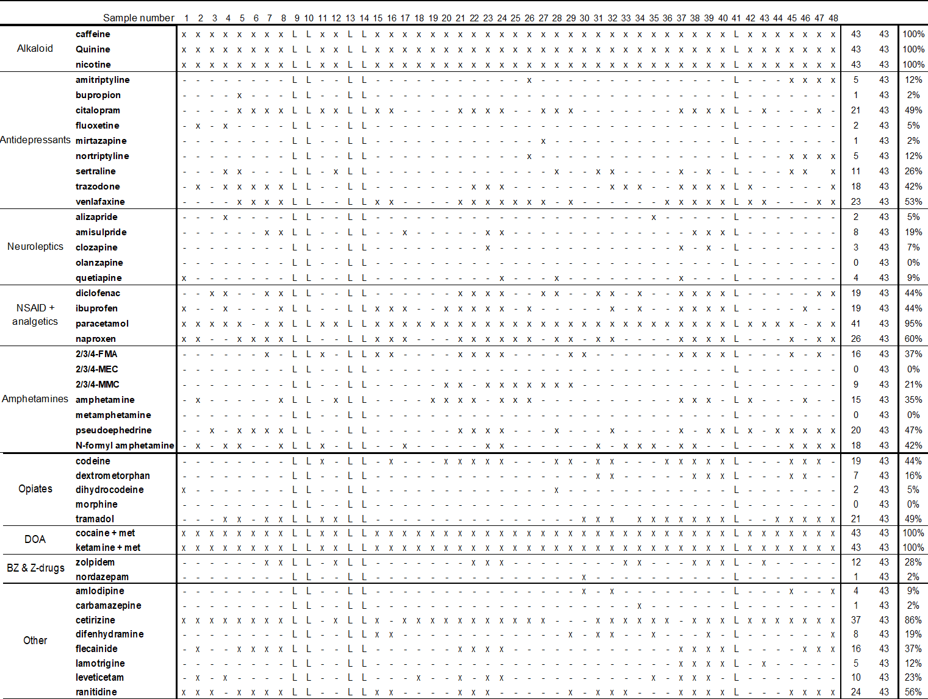
Table 3. Qualitative determination of DOA’s using MSMS analysis on QTOF

By using QTOF, 46 different substances were screened on 43 samples. Five samples were not usable, the results of these samples are referred to with ‘L’. The percentage of positive samples was calculated without these 5 samples. ‘X’ means the presence of the substance was confirmed, ‘-‘ means the substance was not detected. DOA, drugs of abuse; Z-drugs, Nonbenzodiazepines; BZ, benzodiazepines, 2/3/4-FMA, 2/3/4-fluoromethamphetamine; 2/3/4-MEC, methylethcathinone; 2/3/4-MMC: 2/3/4-methylmethcathinone

