Supplementary Material for online publication only.
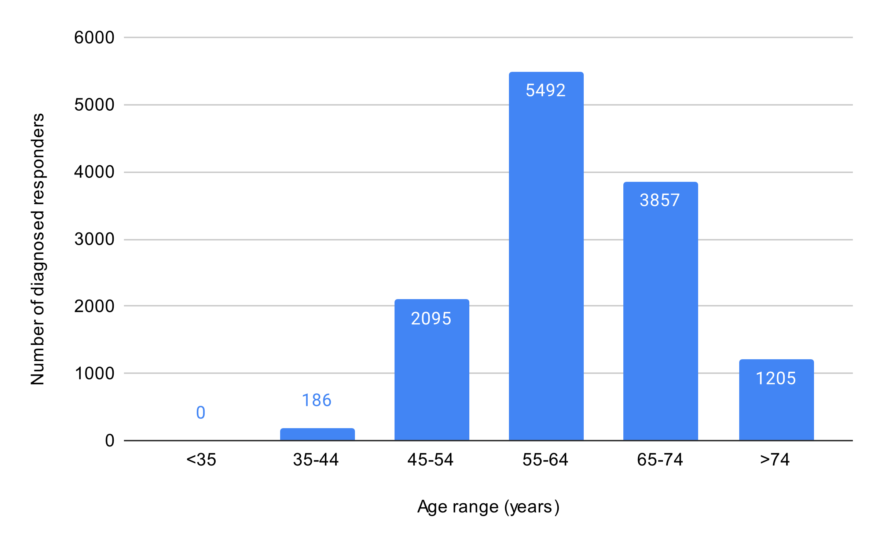
Figure 5 (available online only). Number of Cancer Certifications by Age (Responders).

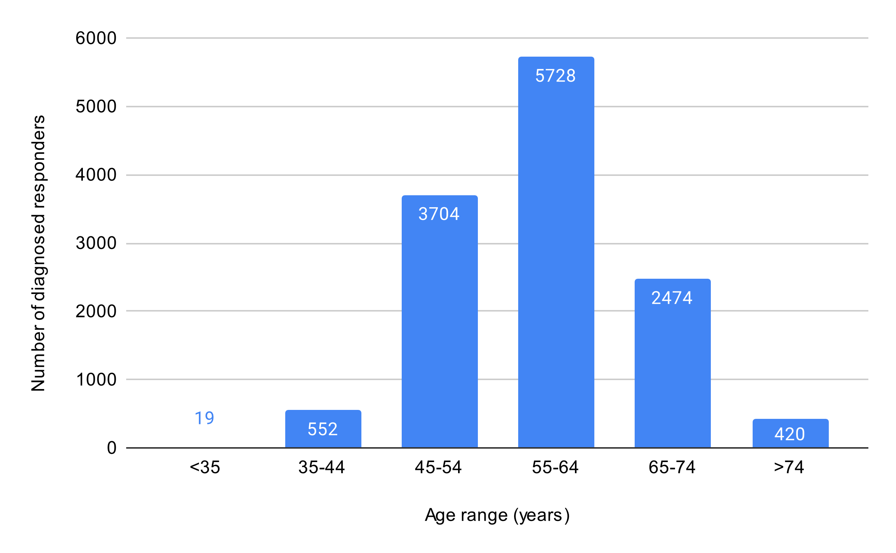
Figure 6 (available online only). Mental Health Certifications by Age (Responders).

