Supplementary materials

Table S1. Major and minor classifications of places of installation of automated external defibrillators
Major classification | Minor classification
Medical institutions | Public health and medical institutions/Civilian medical facilities/ Public health centers
Public institutions | Central administrative agencies/City halls and provincial government buildings/Police stations/Fire stations/Other public institutions/Libraries/Military camps
Educational institutions | Nursery facilities/Kindergartens/Elementary schools/Middle schools/High schools/Universities or colleges/Private educational institutes/Other educational institutions
Multiuser facilities | National parks/Parks/Camping grounds/Training centers/Theaters/Amusement parks/Zoos/Beaches/Concert halls/Art galleries/Exhibition centers/Senior centers/Welfare centers/Silver halls/Civic centers/Rehabilitation centers/Bathhouses/Internet cafes/Funeral facilities/Religious facilities/Squares/Public telephone stations
Sports facilities | Gymnasia/Baseball parks/Soccer fields/Rugby fields/Swimming pools/Golf courses/Other playgrounds/Fitness centers/Sports complexes
Industrial facilities | Offices/Factories/Construction sites/Warehouses/Train depots
Commercial facilities | Department stores/Shopping malls/Shopping areas/Traditional markets/Cooperative unions/Hotels/Resorts/Motels/Efficiency apartments/Convention centers/Banks/Pharmacies/Restaurants/ Wedding halls/Private parking lots
Gaming facilities | Racecourses/Regattas/Bicycle race tracks/Casinos
Roads and highway service stations | Expressways/Roads/Highway service stations
Transport vehicles | Aircraft/Trains/Ships/Subways/Buses/Cars/Motorcycles/Patrol cars
Terminals and waiting rooms for public transportation | Train stations/Subway stations/Airports/Port waiting rooms/Bus terminals
Correctional facilities | Prisons/Junior correctional institutions/Detention centers/Foreigner detention centers/Youth detention centers/Probation offices
Ambulances | 119 ambulances/Private ambulances/Hospital ambulances/Other ambulances/Pumbulances/Fire-fighting helicopters/Fire engines
Apartment complexes | Apartment houses/Townhouses
Detached houses | Detached houses
Multi-housing facilities | Dormitories/Orphanages/Other multi-housing facilities
Assisted living/nursing homes | Nursing homes/Sanatoria

Fig. S1. Distribution of automated external defibrillators throughout South Korea
AED, automated external defibrillator
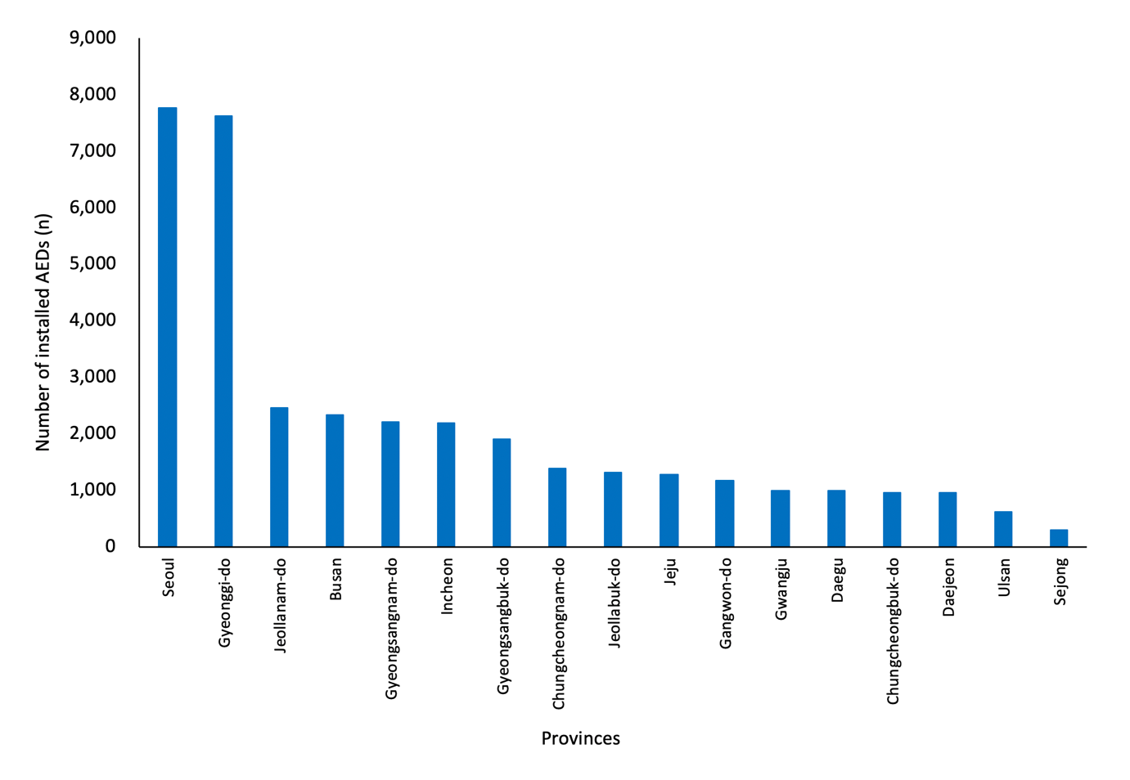

Fig. S2. Distribution of automated external defibrillators throughout South Korea based on population size
AED, automated external defibrillator
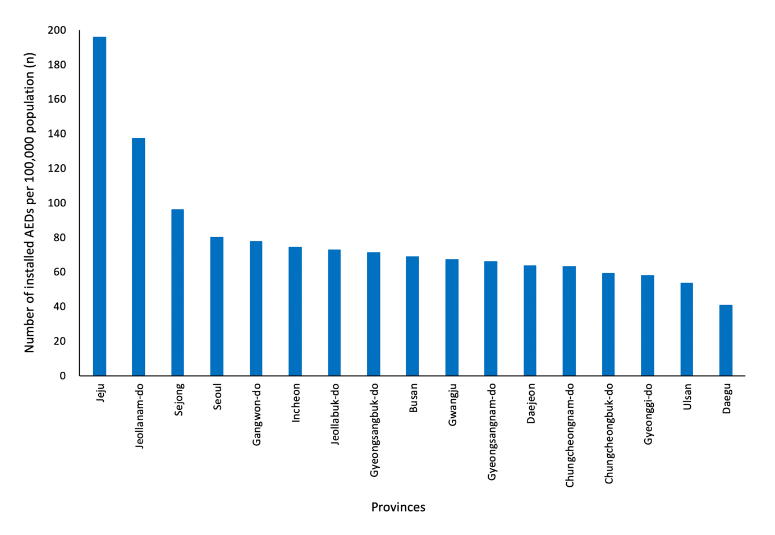

Fig. S3. Distribution of automated external defibrillators according to the major classifications and characteristics of places
AED, automated external defibrillator
Fig. S4. Distribution of automated external defibrillators according to the minor classifications and characteristics of places
AED, automated external defibrillator
Places where the number of installed AEDs was less than 20 are not shown.
Fig. S5. Annual rate of automated external defibrillator use by province
AED, automated external defibrillator
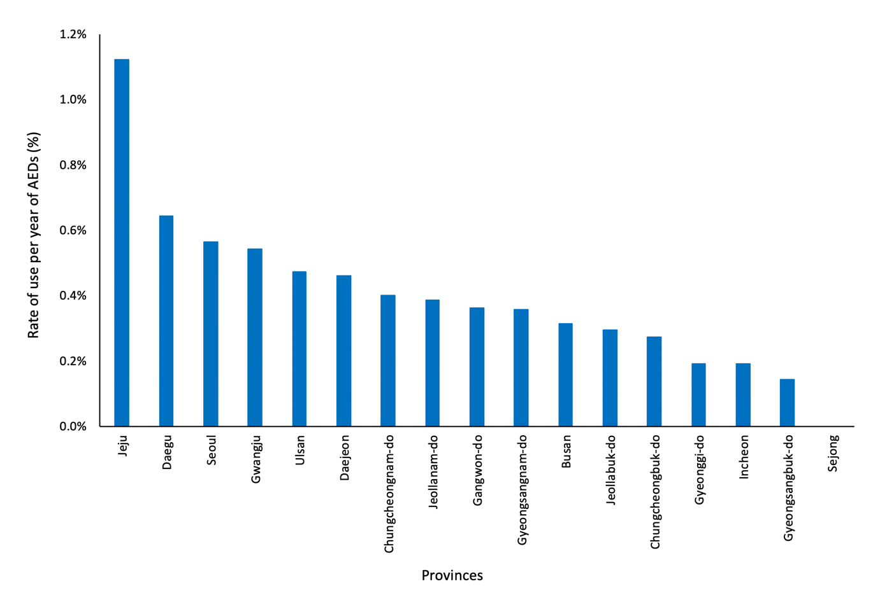

Fig. S6. Annual rate of automated external defibrillator use by major place of installation
AED, automated external defibrillator
Fig. S7. Annual rate of automated external defibrillator use by minor places of installation
AED, automated external defibrillator
The places where the annual rate of AED use was 0.00% are not shown.
Fig. S8. Variations in the usage of automated external defibrillators according to time of day
AED, automated external defibrillator
