Appendix 1
Training: How to manually ventilate with a BVD-tube?
1. One handed ventilation: Hold the BVD with one hand. You can support the hand on your thigh. Press gently but firmly until you fill that your thumb and fingers touch each other with the BV-tube in between, squeeze/press ½ of its volume, then release your grip completely and let the bag fully self-inflate.
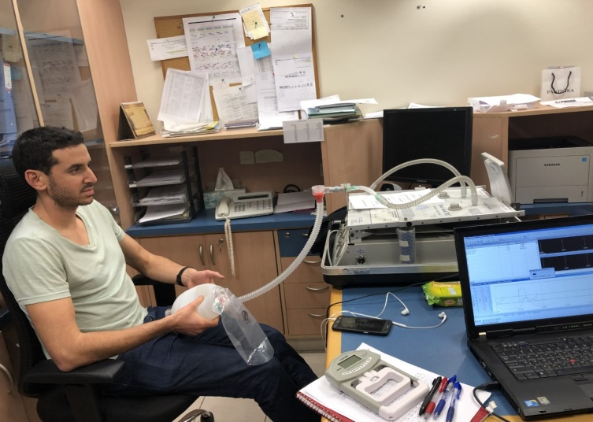
2. Two hands ventilation: press gently but firmly the BVD with both hands until your fingers touch, squeeze/press ½ of its volume, then release the grip completely and let the bag fully self-inflate.
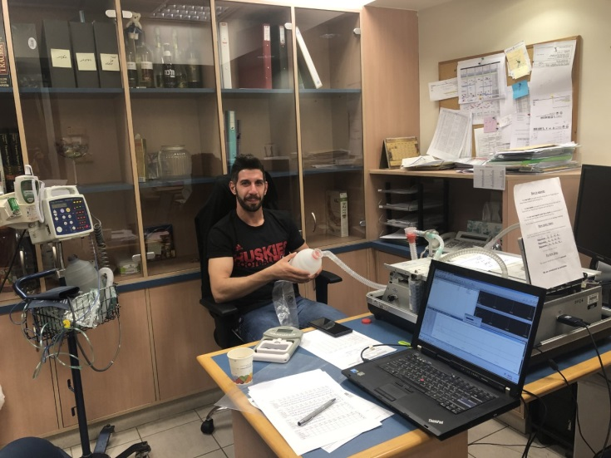
3. Hand-thigh ventilation: press gently but firmly the BVD with your hand against your hip or knee , try to squeeze approximately 1/3 of the bag then release the grip completely and let the bag fully self- inflate .
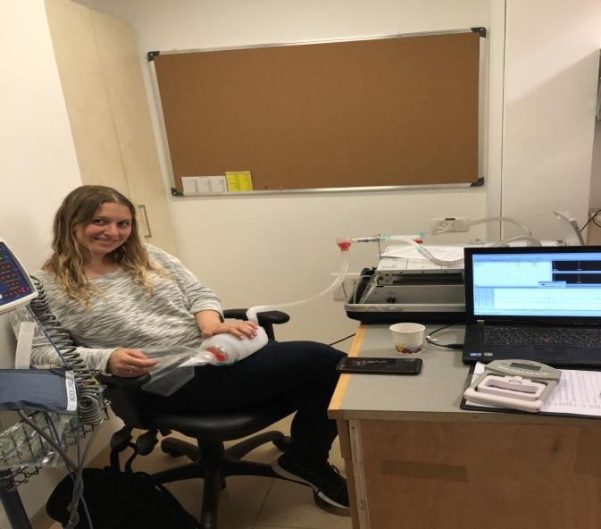

Remember: It is appropriate to alternate between techniques so you fill comfortable in your ventilation, as long as you keep ventilating.
What is the appropriate pace to ventilate? 12-15 times per minute
How do you pace yourself: count 1,2,3,4,then squeeze,1,2,3,4,Squeeze
1,2,3,4, squeeze
1,2,3,4, squeeze
And so forth….
We will instruct you when to take a break.
How long do you hold the bag squeezed before you release? The squeeze should last around 1 second (Count 1, 2)
If you lose count just start over.
Be as consistent as possible.

