Objective Assessment
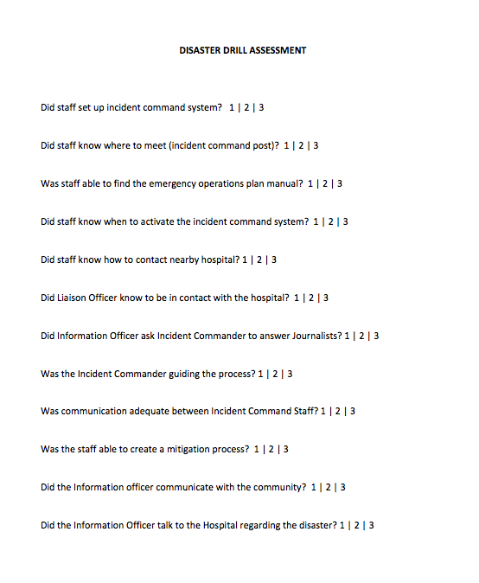

Subjective Assessment

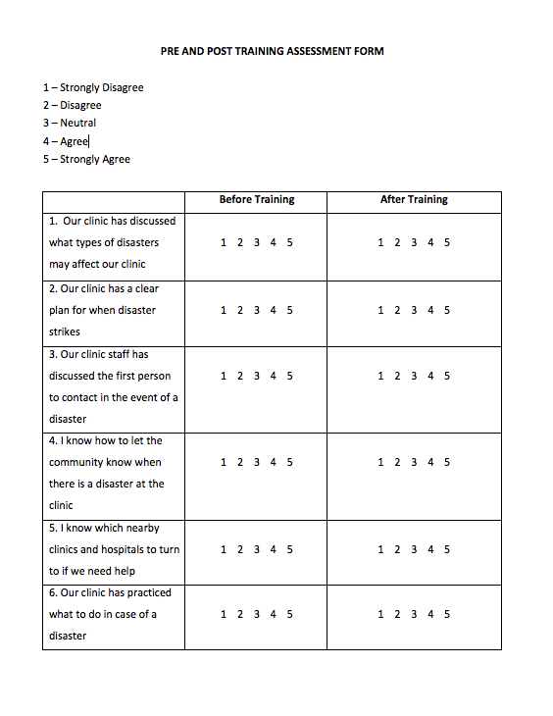

Disaster Manual

Disaster Preparedness for Clinics
Sadia Hussain, MD
Ben Kaufman, MD
Varsha Persaud, MPH
Pia Daniel, MD
Patricia Roblin, MPH
Katherine Uraneck, MD
Matthew Riscinti, MD
Bonnie Arquilla, DO

Illustrations by Andrew Aherne, MD

Introduction

There is a critical need for disaster preparedness training in clinics. Disasters are more and more common in the modern age as climate change modifies our environment, travel increases the spread of disease and technology creates increasingly devastating weapons. Clinics need to prepare for disasters.

Disasters strike without warning. When they do, the knowledge of how to react requires a different tool-set of responses than that used on a daily basis. In many parts of the world, small clinics often have to provide medical care during disasters. Those clinics on the front line need to prepare for disaster management.

What role do local medical clinics play in disaster preparedness?
Disasters overwhelm local resources and require increasingly higher levels of aid (city, state, national, etc) until they reach the international community. Why then focus on local clinics? People in a local community often access clinics first. A hospital may be miles away and clinics often function as local “emergency rooms.” Preparing clinics allows for quicker triage and reduces the resources needed by local hospitals, allowing for more coordinated care. Local clinics are an essential component of disaster management — and one often overlooked.

Goal of this manual
This manual is intended to help clinics throughout the world set up an effective disaster management plan. The manual is divided into four aspects of disaster management: Prevention, Preparedness, Response and Recovery.

What is a disaster?
A disaster is an event that overwhelms a local community. During a disaster there are not enough doctors, nurses or supplies for the amount of injuries that present to clinics and hospitals.
Disasters can be natural or man-made. It may be a natural disaster, such as a hurricane, tornado, fire, or an earthquake. Or it could be a man made one, such as an explosion, pollution, transportation accident, warfare or bioterrorism.
The disaster cycle is a model for understanding how to manage a disaster. First, a community must minimize its risks and attempt to prevent a disaster from occurring. If one occurs, they must have a strategy to respond. Afterwards, the community and clinic must recover.

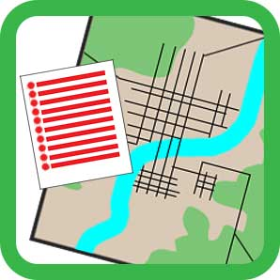
Prevention

What is Prevention?
Prevention is the first part of disaster preparedness and the most important. (Prevention is also known as mitigation). It does not have to be an expensive process. An example is to teach hand-washing policies. These interventions are simple, but have the potential to save many lives.

Risk Identification
It is important to first recognize and understand risks and hazards in a community and to make plans for how to prevent them. The first step is to understand the damages that could occur from a disaster and how prepared the clinic is for each one. For example, one clinic may be in a location with frequent flooding, another may be in an area where there is frequent drought and famine. Knowing what disasters each clinic is at risk for helps to focus prevention efforts.

Discussion for clinic staff:

Identifying the Hazards in your Community

- What is the history of disasters in your community?
- When did the last disaster occur?
- How often do disasters occur in your community?
- What disasters could occur in the future?

Risk assessment

What are risks for disasters that could occur in your community? What damage would they cause? How can you help to prevent this damage in the future?
Examples: earthquake, drought, famine, hurricane, tsunami, sand storms.

Disaster | Damage | Prevention
(Example) Earthquake | 1. Clinic building  2. Electrical lines  3. Life of patients | 1. Prepare clinic structure for an earthquake  2. Back Up Generator  3. Have an evacuation plan

Preparedness
What is ‘Preparedness’?
Once a hazard is identified, the clinic needs a detailed plan to deal with it. This involves training and the creation of specific job roles, as well as identifying where to obtain supplies and workers.

Disaster Plan
This is a system to identify all of the people and organizations that may be needed in a time of disaster and how they will help the community. It is a general plan, but specific changes for disasters are important too. For example, in case of an electrical outage, you may need a plan to have a back up generator.

This is an outline you may choose to use for your Emergency Operations Plan:
DISASTER PLAN
Roles for Staff
Communication & Warning
Resource Identification
Organizations to Involve
Community Education
Training & Exercises

Let’s go through each component.

Roles for Staff
The first step in a disaster is to assign jobs to the clinic staff. Depending on clinic size, people may have more than one job, but it is important to have a leader and a team that has specific responsibilities. The leader and their team could be anyone – not just the leader of the clinic. This system stems from the Incident Command System, a structure used around the world in disasters.

Incident commander is the boss during the disaster. They oversee the overall disaster plan. They are responsible for the clinic staff and their job responsibilities as well as the costs and equipment used in the disaster. In addition, they will recruit volunteers and allocate resources during the disaster.

Operations officer is responsible for the medical response in the clinic and the other primary jobs of the clinic staff as they respond to injuries. They can recruit other staff, doctors, nurses or health workers as needed to the clinic.

Safety officer is responsible for the health and safety of the clinic staff, volunteers and patients. If necessary they can contact police, military or other volunteers to help make sure the clinic is safe.

Information officer is responsible for informing the local community of the disaster and the resources they can find at the clinic, as well as communicating with people that can help the clinic in the disaster.

Liaison officer is responsible for contacting other organizations and agencies that can help in a disaster, such as schools, churches or NGOs.

Name the Members of Your Disaster Plan:

INCIDENT COMMANDER

SAFETY
OFFICER
INFORMATION
OFFICER
OPERATIONS
OFFICER
LIAISON
OFFICER

List the members of your staff and how you can communicate with each person:
POSITION | NAME & TITLE | TELEPHONE | EMAIL/OTHER
Incident Commander
Operations Officer
Safety Officer
Information Officer
Liaison Officer
The incident command center is where the team will meet initially and the base of operations during the disaster. Depending on the disaster, this may need to be an area with space. Since patients may be infectious, it is often best to not have the incident command center in the clinic itself where they are receiving treatment.
Name the location of your incident command center:

Primary Location

Secondary Location

When a disaster first occurs, you need supplies and people to help your clinic.
Make a list of organizations and people who you can contact to help you find workers, such as doctors, nurses or drivers and who can give you supplies such as food, water and medication.
First, how will you communicate with the community and get information on who is injured? How will you tell them what is happening at the clinic?

Next, what supplies do you need for all disasters and what for specific disasters (medical supplies, food, water, staff, buildings, beds, fuel, transportation) ?

Next, which local clinics, hospitals, pharmacies and other agencies could help with supplies or people in a disaster situation? How will you contact them?

NEARBY CLINICS:
NEARBY HOSPITALS:

NEARBY PHARMACIES:

NEARBY GOVERNMENT AGENCIES:

Which international organizations can assist you?

International organizations that can assist you:
Governmental
Non-Governmental

What organizations (schools, churches, businesses, NGOs) can help to provide people (drivers, builders, volunteers) and supplies (food, water, materials)?
ORGANIZATION | PERSON TO CALL | TELEPHONE & ADDRESS

If your clinic stops working or becomes dangerous, where will patients go?
How will you get your staff and patients to this location safely?

Where will patients go if you have too many patients or if a patient is very sick?
ORGANIZATION | PERSON TO CALL | TELEPHONE & ADDRESS
If you need to transport patients, how will you physically transport them?

It is important for the community to know that the clinic is preparing for a disaster and to provide education to help the community prevent and prepare.
How do you plan to educate your community about the potential hazards?

Who can the community ask if they have any questions before, during and after a disaster? How will they contact this person?

You will also need to train your team to prepare for different disasters. Often, this is as simple as talking over what would happen given different disasters. It may be useful to set up monthly training for staff.

Month 1  Date:  Type of Drill: | Month 2  Date:  Type of Drill: | Month 3  Date:  Type of Drill: | Month 4  Date:  Type of Drill:
Month 5:  Date:  Type of Drill: | Month 6:  Date:  Type of Drill: | Month 7:  Date:  Type of Drill: | Month 8:  Date:  Type of Drill:
Month 9:  Date:  Type of Drill: | Month 10:  Date:  Type of Drill: | Month 11:  Date:  Type of Drill: | Month 12:  Date:  Type of Drill:
Now that you have done these exercises, you have started your disaster plan.
To review, here is the checklist for your disaster plan.
DISASTER PLAN
Roles for Staff
Incident Commander: [ ]
Operations Officer: [ ]
Safety Officer: [ ]
Liaison Officer: [ ]
Information Officer: [ ]
Location to meet: [ ]
In case of emergency, secondary location to meet: [ ]
Mode of communication: [ ]
Communication & Warning
Mode of communication with clinic staff: [ ]
Mode of communication with community: [ ]
Resource identification
Medical supplies needed in case of emergency: [ ]
Emergency forms of transportation: [ ]
Organizations to Involve
Organizations that can help your clinic: [ ]
Nearby clinics: [ ]
Contact person(s) at other clinic: [ ]
Nearby hospitals: [ ]
Contact person(s) at hospital: [ ]
Nearby pharmacy: [ ]
Contact person(s) at pharmacy: [ ]
Community Education
Plan for public education: [ ]
Training and Exercises
Schedule for your Table Top Drills and Functional Drills: [ ]
Response
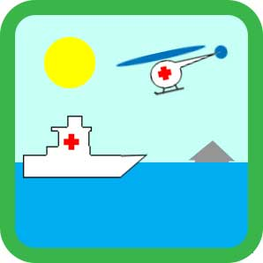
What is ‘Response’?
Response is the time period from just before the disaster until the disaster’s aftermath. In the aftermath there may be ongoing dangers and a period when they stop. The goal of response is to ensure basic human needs, prevent loss of life and ensure and minimal structural damage.

Response is often very high-stress and is the “action” phase during the disaster itself. The goal is to make the response easier by planning and practicing for it during the prevention and preparedness phases. Your Disaster Plan should be put into action, but you will likely need to reassess and change the plan with good communication during a disaster. Staff should meet at the agreed location and should have specific jobs, outlined in Job Action Sheets. These are sheets that clearly outline the tasks of each member of the team.
Lets go through a couple job action sheets below. These are samples and can be used as a guideline, but changing this during a true disaster to better accommodate your staff, clinic and the specific disaster is important.

INCIDENT COMMANDER: Job Action Sheet

Mission: You are the leader. Your mission is to organize the team and to ensure that each team member does their job and helps accomplish the disaster plan.

Immediate:
  - Read this Job Action Sheet.
  - Ask the staff about the disaster and important details.
  - Assign jobs to staff and distribute Job Action Sheets.
  - Talk with staff to plan for this specific emergency.
  - Know which jobs are priorities. Ensure they are done by the correct time.
  - Ensure staff communicates with hospitals, clinics, the community.

Short-term:
  - Keep track of team members, jobs, supplies and the cost of response.
  - Meet with the members of your team routinely to update the plans.
  - Ensure the Security Officer, Liaison Officer, Operations Officer and Information Officer have the tools, staff and direction to do their jobs.
Long-term:
  - Observe all staff for status and signs of stress and provide rest periods.
  - Prepare a report that that summarizes the disaster and response.
  - Create a written plan to restore normal functioning to the clinic.
  - Reassess the disaster plan. Make changes to better prepare.

SAFETY OFFICER: Job Action Sheet

Mission: Your mission is to make sure staff and patients are safe by anticipating unsafe situations, planning for them and stopping them from happening.

Immediate:
  - Read this Job Action Sheet and talk with Incident Commander.
  - Review the Disaster Plan and assess safety for staff and patients.

Intermediate:
  - Exercise emergency authority to stop and prevent unsafe acts.
  - Monitor staff and tell them to report unsafe situations.
  - Investigate and fix unsafe situations. Document actions and observations.
  - Tell the Incident Commander of any unsafe situations immediately.
  - Schedule routine meetings with Incident Commander.

Extended:
  - Observe all staff for signs of stress. Provide rest periods and relief.
  - Check in with Incident Commander and reassess the disaster plan.
INFORMATION OFFICER: Job Action Sheet

Mission: Your mission is to tell the community and other outsiders about the disaster and to maintain a record of the event for future planning.

Immediate:
  - Read this entire Job Action Sheet.
  - Understand the disaster and the clinic’s plan. Tell the community the plan and inform them of the disaster and how to prepare and seek help.
  - Give important phone numbers or contact information to clinic staff.

Intermediate:
  - Monitor the disaster and alert the community with updates, news.
  - Speak with the Incident Commander before sending out news.
  - Document what is happening in the clinic and disaster.
  - If newspapers, television or reporting happens, ensure quality information.

Extended:
  - Observe all staff for signs of stress. Provide rest periods and relief.
  - Check in with Incident Commander and reassess the disaster plan.

LIASON OFFICER: Job Action Sheet

Mission: Your mission is to contact hospitals, clinics and other organizations to distribute information and to tell them about your needs and progress.

Immediate:
  - Read this entire Job Action Sheet.
  - Meet with Incident Commander to plan which hospitals/clinics to contact.
  - Monitor the disaster response and collect data, informing the Incident Commander and other hospitals or clinics of specific needs.

Short-term:
  - Respond to hospitals and clinics requests and issues.
  - Tell doctors and nurses in these hospitals and clinics of disaster needs and the status of your clinic’s response. Monitor and report progress.
  - Meet regularly with the Incident Commander.

Long-term:
  - Maintain a list of nearby hospitals, clinics and local resources.
  - Observe all staff for signs of stress. Provide rest periods and relief.
  - Check in with Incident Commander and reassess the disaster plan.

OPERATIONS OFFICER: Job Action Sheet

Mission: Your mission is to be in charge of the medical response for the staff. You are in charge of the operations of the disaster response.
Immediate:
  - Read this entire Job Action Sheet.
  - Meet with Incident Commander to plan staffing, supplies and response.
  - Contact staff and prepare each staff member for their role in the disaster.

Short-term:
  - Coordinate the medical response for each patient presenting. Assign roles to staff to allow for correct triage and response to medical needs.
  - Assess staffing needs. Reach out to officers with supply & staffing needs.
  - Meet regularly with the Incident Commander.

Long-term:
  - Maintain a list of lessons learned during disasters and ways to improve.
  - Observe all staff for signs of stress. Provide rest periods and relief.
  - Check in with Incident Commander and reassess the disaster plan.

Recovery
What is ‘Recovery’?
Recovery is the last step in a disaster. The goal is to return the clinic and community back to their “pre-disaster” state. It is good to prepare for this during the initial preparedness phase. In certain disasters, recovery takes months to years.

In recovery, you must assess the damage sustained by your clinic during the disaster and what you will need to do to fix these damages. You should also think about the damage within the community and how the clinic interacts.
Ask yourself the following after a disaster:

How was your clinic damaged? How can you fix this? Is this a long-term fix?
Example: Take half of clinic profits for the next 3 months and fix the generator.

How is your clinic staff? (1) Physically? (2) Mentally? (3) Families? (4) Finances?

Have patients been affected? Can the clinic see patients? How will this work?

What is your budget for recovery? How can you obtain these funds?

Damage | Plan to Fix Damage | Cost of This Plan

How will you inform the community on your progress working toward repair?

After a true disaster or after your disaster drills each month, your team should modify the disaster plan and this document to best prepare for the next disaster. This can be a fun process and innovation is encouraged.

Conclusion

Thinking about a disaster before it happens and how you will prevent, prepare, respond to and recover from it is not an easy task. This manual is a starting point for your clinic to make a plan. The authors of this manual congratulate you on establishing the beginning of a disaster plan for your clinic and its patients.
This has a great potential to save many lives in your community.

References:

- Hogan, David E. Disaster Medicine: Second Edition. Philadelphia: Lippincott Williams & Wilkins, 2007. Print.
- Ciottone, Gregory R. Disaster Medicine: Third Edition. Philadelphia: Mosby Elsevier, 2006. Print.
- Partridge, Robert A. Oxford American Handbook of Disaster Medicine. New York: Oxford University Press, 2012. Print.
- Zibulewsky, Joseph. Defining Disaster: The Emergency Department Perspective. Proceedings (Baylor University Medical Center). 2001 April; 14(2): 144-149.
- Haddow, George D. Introduction to Emergency Management. Burlington: Elsevier, 2011. Print.
- Bumgarner, Jeffrey B. Emergency Management: a Reference Handbook. Santa Barbara: ABC-CLIO, 2008. Print.
- Miller, DeMond S. Comparative Emergency Management: Examining Global and Regional Responses to Disasters. Boca Raton: CRC Press, 2011. Print.
- Schneid, Thomas D. Disaster Management and Preparedness. Boca Raton: CRC Press LLC, 2000. Print.
- Coppola, Damon P. Introduction to International Disaster Management. Burlington: Elsevier, 2011. Print.
- Alexander, David E. Principles of Emergency Planning and Management. New York: Oxford University Press, 2002. Print.
- Ansell, J. Risk: Analysis, Assessment and Management. Chichester: John Wiley and Sons. Print.
- United States Department of Labor: Occupational Safety and Health Administration. Incident Command System. https://www.osha.gov/SLTC/etools/ics/what_is_ics.html. Accessed September 9, 2013

