Online supplement
Figure 1.
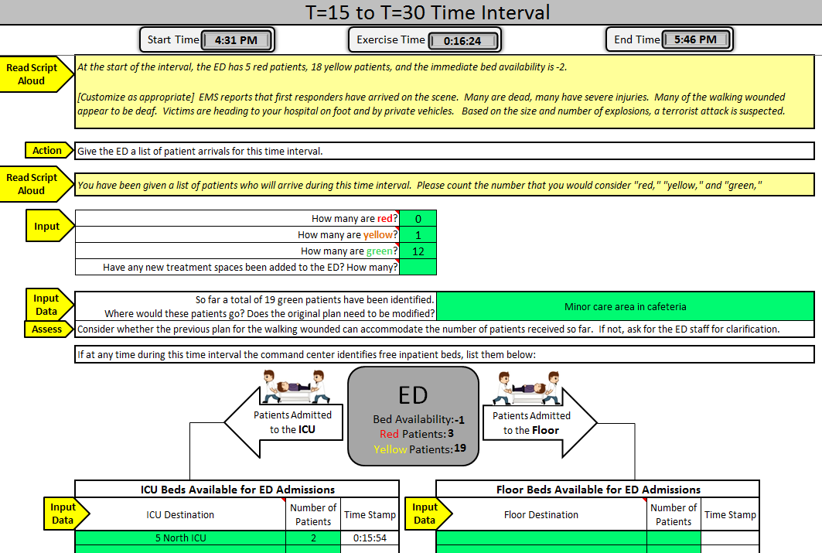
Figure 1. This is a partial screenshot of the exercise controller’s worksheet for use during the 15-30 minute time interval. The exercise clock at top indicates that the exercise had been ongoing for 16 minutes, 24 seconds. The script indicates that at 15 minutes into the exercise, there were 5 red patients and 18 yellow patients, for an IBA of -2 (e.g. two patients in the waiting room). One can infer that the ED had 21 treatment spaces (although that number is not directly shown here). During the interval, one yellow patient arrived and ICU beds were found for two ICU patients (at time 15:54). The updated census is at the time of the screenshot is shown in the central grey box.
Figure 2.
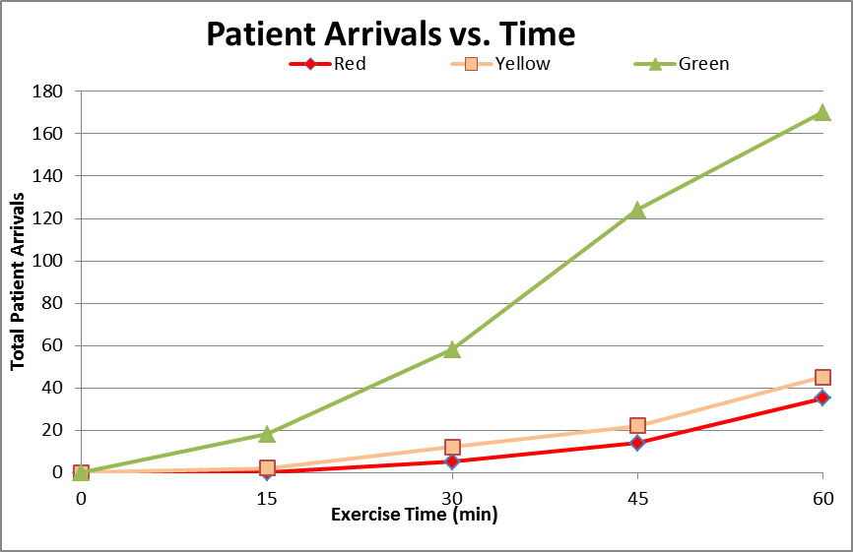

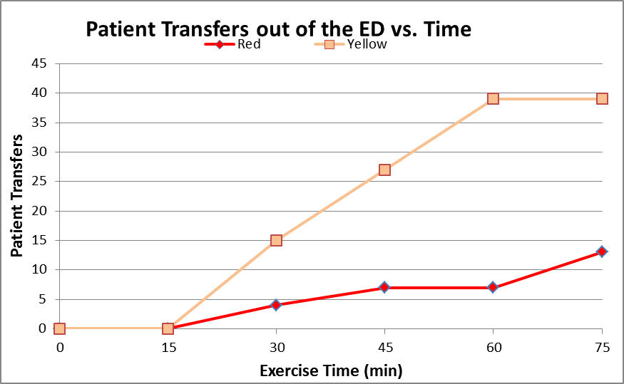

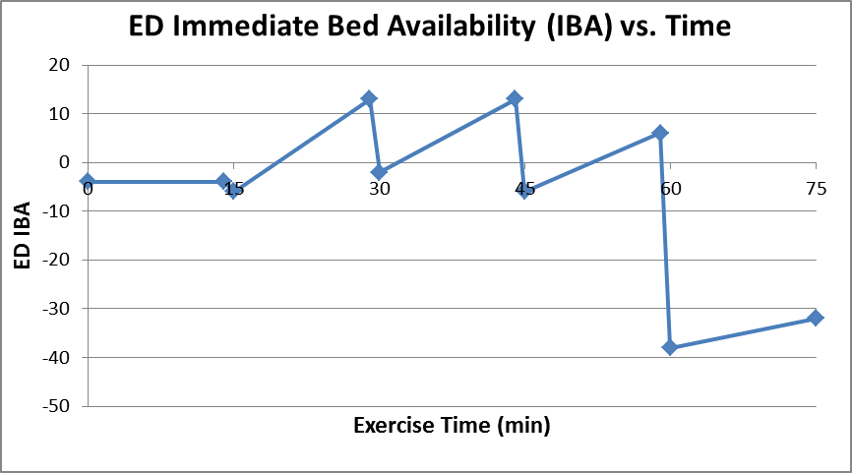

Figure 2. These three graphs are automatically generated as the exercise progresses. The top graph shows the cumulative number of “mass casualty arrivals,” according to triage level, at 15-minute intervals. The second graph shows the number of (yellow or red) ED patients who have been moved to inpatient locations, thereby freeing up their ED beds. The third graph shows the number of available ED “beds” immediately available for new patients, at 15 minute increments. IBA is figured as the net of difference between the number of beds and the number of patients at any point in time. These figures are a function of both conditions at the start of the exercise, patient flux, and the creation of “new treatment space” in the ED. Note that ED IBA starts out negative, meaning that there were more registered patients than beds at the start of the exercise.

