Research Information for Informant

You are hereby formally invited to take part in the survey of SMART-Tag in the prehospital care setting. A cornerstone in disaster medical resource management is priority setting (triage) in order to identify patients in greatest need of medical treatment and transport. Triage is performed using the triage tag. Color-coded triage tags are attached to each patient to indicate the patient’s condition and to visualize the priority of treatment and transport.

Moreover, these tags also have a place to document conditions and vital signs of the patients, thereby serving as a patient file.

Although triage concepts are presented in textbooks worldwide and regularly practiced in training and education, there are some concerns that the effects of training can be hampered by the lack of regular use of the triage system.

This web-survey is a part of a research and development project in Stockholm County Council (SCC). The aim is to explore ambulance nurses’ and physicians’ attitude towards, and experiences of, practicing triage tagging system SMART Tag in the prehospital care settings before and after the implementation of a new routine in SCC (during April to December 2010).

Participation is strictly voluntary and your answers will be treated in confidence (ie, no name or ambulance entrepreneurs will be identified).

Thank you in advance for your time, effort, and participation.

If you have questions concerning the survey, please contact:

Monica Rådestad
RN, PhD
Department of Clinical Science and Education and Section of Emergency Medicine,
Södersjukhuset, Karolinska Institutet, Stockholm, Sweden
monica.radestad@ki.se

Mobilphone: + 46 70 484 62 12

Part 1.

- Gender
 Man
 Female

- How long have you been employed in the pre-hospital care service?
 less than 1 year
 1-5 year
 6-10 year
 11-20 year
 > 20 year

- As a registered nurse, what is your specialty?
(Mark the alternative or alternatives that correspond to you)
 ambulance
 anesthesiology
 intensive-care
 other training on advanced level
 no training on advanced level

- Have you been educated in the use of SMART Tag™ by your organization/employer or current employer?
 Yes
 No

- If Yes: How was this education conducted?

By:
 trained instructor
 web-based learning

- Have you used SMART Tag™ in a real incident after you had your education?
 Yes
 No

If yes:

- Describe the type of incident and number of injured.

- How many times have you used SMART Tag™ during simulation exercises?
 never
 1 time
 2-5 times
 6-10 times
 >10 times
Part 2

- How easy did you find the use of SMART Tag™ during your exercises?
 very easy
 rather easy
 it worked, with some problems
 it was hard, several problems
 don´t remember/no opinion

- To what extent have the following alternatives provided added value to prepare
you for the use of SMART Tag™?

- one full day participation regarding the use of SMART Tag™ within your organization.
 very much
 considerably
 very little
 not at all contributed
 has not participated in such occasion
 don’t remember/no opinion

b) participation in training sessions with live figurants.
 very much
 considerably
 very little
 not at all contributed
 has not participated in such occasion
 don’t remember/no opinion

- by using SMART Tag™ also in daily routines for example during a”minor incident”.
 very much
 considerably
 very little
 not at all contributed
 has not used SMART Tag™ in daily routines
 don’t remember/no opinion

- When using SMART Tag™ during an incident, to what extent is your decision based on regarding the following alternatives:

- your daily working routines.
 very much
 considerably
 very little
 not at all contributed
 not able to assess

- your own critical decision.
 very much
 considerably
 very little
 not at all contributed
 not able to assess

- a decision by the Medical Incident Commander on scene?
 very much
 considerably
 very little
 not at all contributed
 not able to assess

- Considering the general use of SMART Tag ™:

- does the SMART Tag ™ facilitate your triage/re-triage of casualties
 very much
 considerably
 very little
 not at all contributed
 not able to assess

- does the SMART Tag ™ increase the possibility of optimizing the use of pre-hospital resources
 very much
 considerably
 very little
 not at all contributed
 not able to assess

- does the use of SMART Tag ™ add to better care for life-threatening conditions
 very much
 considerably
 very little
 not at all contributed
 not able to assess

- does the use of SMART Tag ™ add to better care for casualties without life-threatening conditions
 very much
 considerably
 very little
 not at all contributed
 not able to assess

- Do you consider yourself inexperienced in the use of SMART Tag™?
 very much
 considerably
 very little
 not at all contributed
 not able to assess

- Do you feel comfortable to use SMART Tag™ in stressful situations?
 very much
 considerably
 very little
 not at all contributed
 not able to assess

- Do you use the SMART Tag ™ when you need to triage several injured patients?
 yes, always since I have a routine in using them
 no, not always but frequently
 no, only occasionally
 no, it has never happened

- To which extent do you feel that you in a reliably manner can use the scoring system Triage Sort is based on
 very much
 considerably
 very little
 not at all contributed
 not able to assess

- How do you rate the simplicity of using SMART Tag ™ for documentation in relation to:

- visualize the priority i.e. to fold Red, Yellow or Green (see picture, page 6)
 very simple
 considerably simple
 possible but with some difficulties
 not possible at all, considerable difficulties
 not able to assess

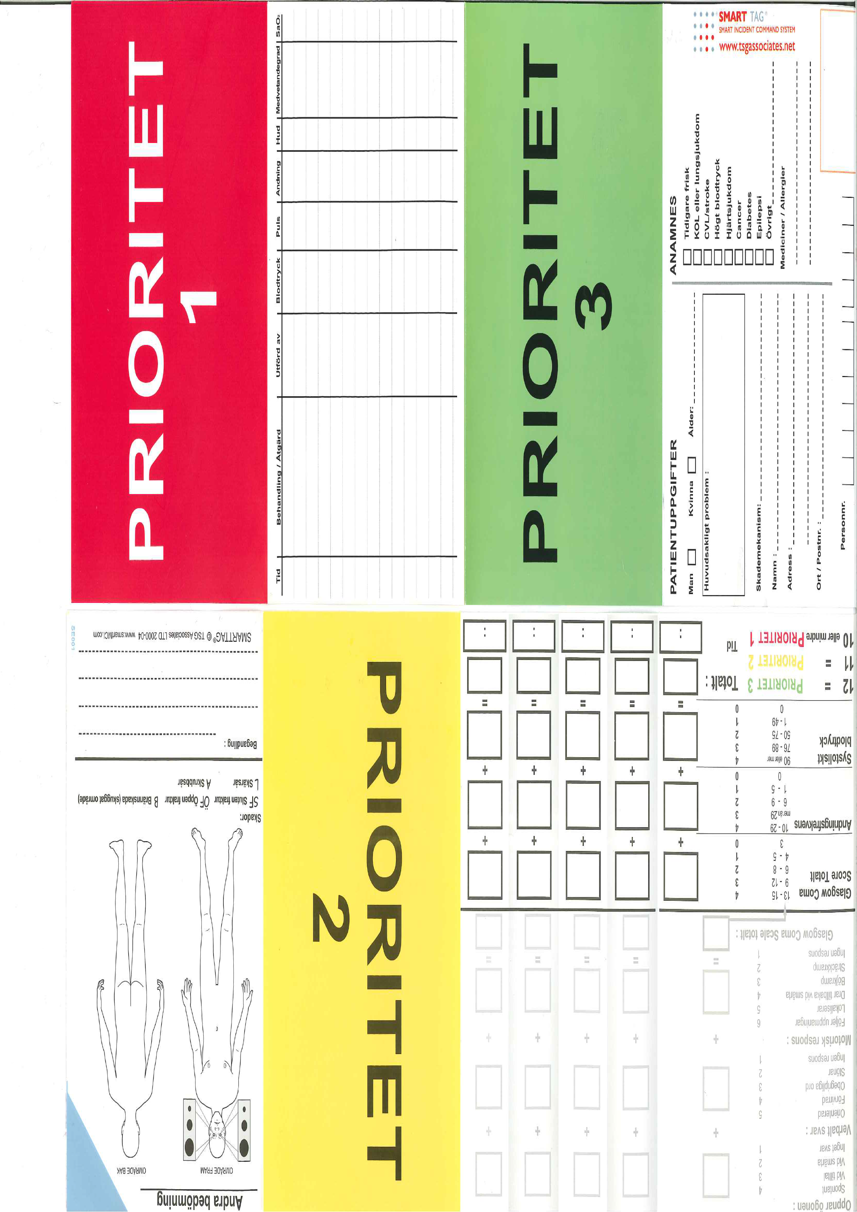
d)
b)
c)
e)
(Used with permission from TSG associates)

- to document vital signs and treatments performed (see picture)
 very simple
 considerably simple
 possible but with some difficulties
 not possible at all, considerable difficulties
 not able to assess

- to document patients’ data and medical history? (see picture)
 very simple
 considerably simple
 possible but with some difficulties
 not possible at all, considerable difficulties
 not able to assess

- to document additional information regarding mechanism of trauma and injury localisation (see picture)
 very simple
 considerably simple
 possible but with some difficulties
 not possible at all, considerable difficulties
 not able to assess

- triage sort with space to document secondary triage information (see picture)
 very simple
 considerably simple
 possible but with some difficulties
 not possible at all, considerable difficulties
 not able to assess

- Do you find documentation of SMART Tag™ time-consuming?
 yes, very much
 yes, considerably much
 yes, but to a low extension
 no
 not able to assess

- In your opinion, can the use of SMART Tag ™ delay the medical care of casualties?
 yes, very much
 yes, considerably much
 yes, but to a low extension
 no
 not able to assess

- In your opinion, does the SMART Tag™ system support the process of reporting to medical commander on scene?
 yes, very much
 yes, considerably much
 yes, but to a low extension
 no
 not able to assess

- In your opinion, does the SMART Tag™ system support the process of reporting patient data to a receiving hospital?
 yes, very much
 yes, considerably much
 yes, but to a low extension
 no
 not able to assess

- In your opinion, is the SMART Tag™ documentation to be considered as part of the patient file?
 yes, very much
 yes, considerably much
 yes, but to a low extension
 no
 not able to assess

- Do you think that there are clear guidelines within your organization regarding when to use triage tags?
 yes, very much
 yes, considerably much
 yes, but to a low extension
 no
 not able to assess

Part 3

- What do you think is most important benefit in the use of SMART Tag™?

- What measures do you think need to be implemented in order to increase the use of SMART Tag™?

- Do you think that the routine use of SMART Tag™, during the nine months test period, increased your familiarization with the system so that you will feel more secure when using SMART Tag™ during a real incident? (only answered in the post-survey)

