Box 1
- Heart Defects, Congenital
• Congenital Heart Defect
• Defect, Congenital Heart
• Heart, Malformation Of
• Defects, Congenital Heart
• Heart Abnormalities
• Heart Defect, Congenital
• Abnormality, Heart
• Abnormalities, Heart
• Heart Abnormality
• Congenital Heart Defects
- Exercise
• Exercises
• Physical Activity
• Activities, Physical
• Activity, Physical
• Physical Activities
• Exercise, Physical
• Exercises, Physical
• Physical Exercise
• Physical Exercises
• Acute Exercise
• Acute Exercises
• Exercise, Acute
• Exercises, Acute
• Exercise, Isometric
• Exercises, Isometric
• Isometric Exercises
• Isometric Exercise
• Exercise, Aerobic
• Aerobic Exercise
• Aerobic Exercises
• Exercises, Aerobic
• Exercise Training
• Exercise Trainings
• Training, Exercise
• Trainings, Exercise

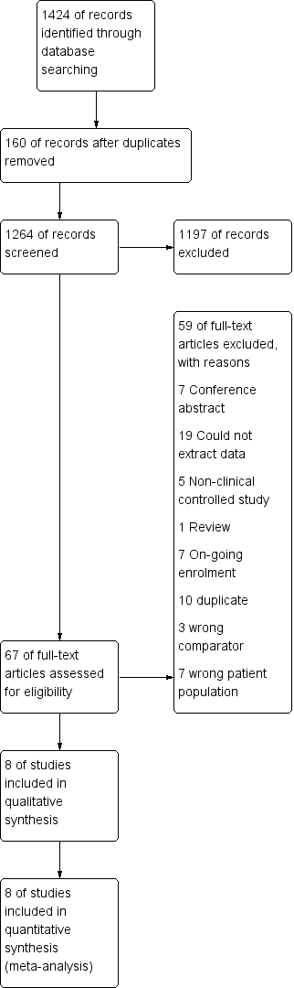
Figure S1. Search and selection of studies for systematic review according to preferred reporting items for systematic reviews and meta-analyses (PRISMA)

A. SF-36 physical component summary
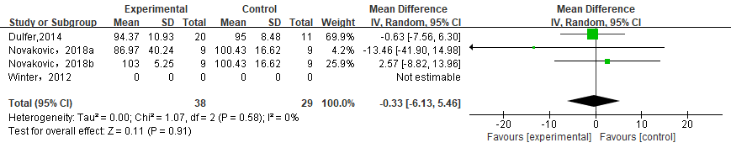
B. SF-36 mental component summary
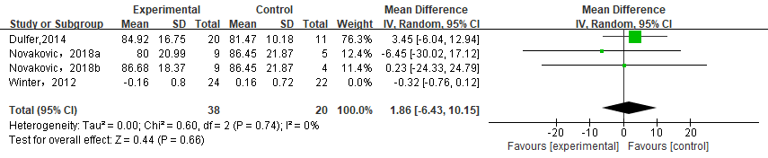
C. CHD-TAAQOL worries score
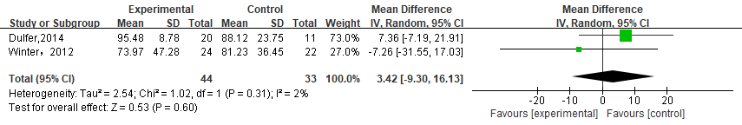
D. CHD-TAAQOL symptoms score
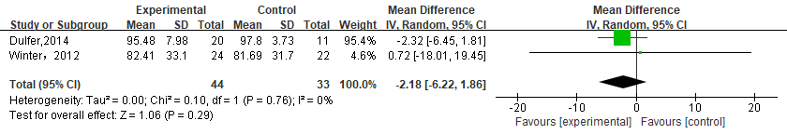
E. CHD-TAAQOL impact score
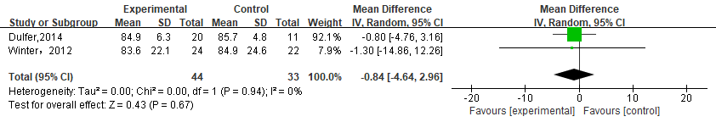

Figure S2. Exercise training versus controls: Quality of life. SF-36, Short Form 36 item; CHD-TAAQOL, CHD-TNO/AZL Adult Quality of Life questionnaire

A. Training duration of 12 weeks 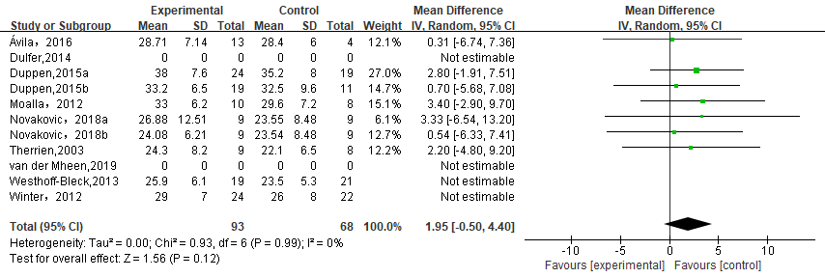
B. Repaired TOF 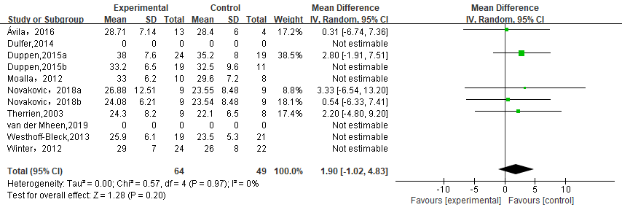
Figure S3. Subgroup Analysis for peak VO2 in training duration and repaired TOF. TOF, Tetralogy of Fallot.

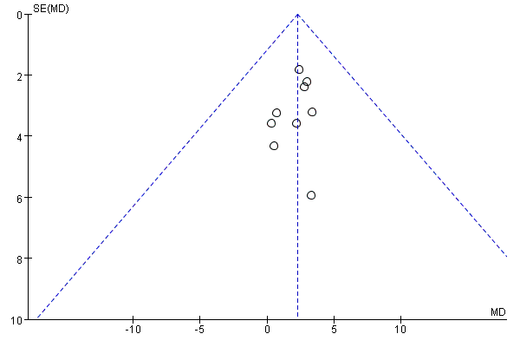
Figure S4. Funnel plot investigating publication bias. Outcome: peak VO2 (P= 0.804)
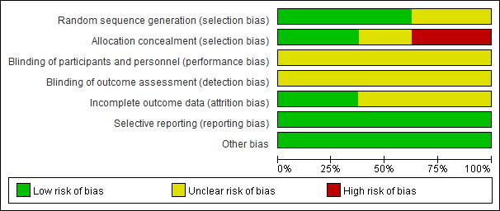
Figure S5. The risk of bias was presented according to the Cochrane Collaboration

