Figure S1. Frequency of use of diuretics and other medications to treat volume overload. N=52.

1=influences my decision a little; 5=influences my decision a lot. See survey question under Supplemental Materials.

Table S1A. Frequency of use of common heart failure medications in percentage of responses.

N=51 | Never | Rarely | Sometimes | Often | Always
Angiotensin Converting Enzyme Inhibitor | 0 | 0 | 4 | 41 | 55
Mineralocorticoid Receptor Antagonist | 0 | 0 | 17 | 62 | 21
Beta Blocker | 2 | 4 | 23 | 52 | 19
Angiotensin Receptor Blocker | 4 | 51 | 35 | 10 | 0
Digoxin | 12 | 40 | 39 | 10 | 0

Table S1B. Use of common heart failure medications based on New York Heart Association or Ross functional class (% selected by respondents).

N=51 | Functional Class I or Above | Functional Class II or Above | Functional Class III or Above | Functional Class IV or Above | Use Not Based on Functional Class
Angiotensin Converting Enzyme Inhibitor | 37 | 16 | 4 | 0 | 43
Mineralocorticoid Receptor Antagonist | 8 | 31 | 14 | 0 | 48
Beta Blocker | 14 | 43 | 6 | 0 | 37
Angiotensin Receptor Blocker | 22 | 14 | 6 | 0 | 57
Digoxin | 2 | 18 | 31 | 7 | 42

Table S1C. Use of common heart failure medications based on American Heart Association/American College of Cardiology stages of heart failure (% of respondents).
N=51 | Stage A or Above | Stage B or Above | Stage C or Above | Only in Stage D | Use Not Based on Stage
Angiotensin Converting Enzyme Inhibitor | 16 | 27 | 6 | 0 | 51
Mineralocorticoid Receptor Antagonist | 6 | 14 | 19 | 0 | 61
Beta Blocker | 0 | 33 | 20 | 0 | 47
Angiotensin Receptor Blocker | 9 | 17 | 6 | 0 | 68
Digoxin | 0 | 11 | 31 | 4 | 54

Figures S2A-K. The frequency of use of various medications and supplements to treat chronic heart failure. N=50.

Figure S2A. Figure S2B.
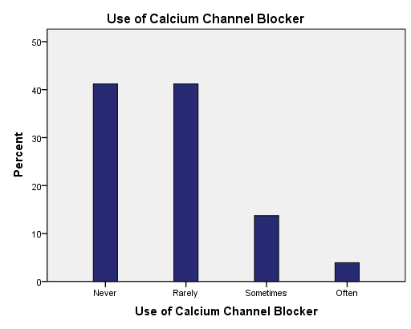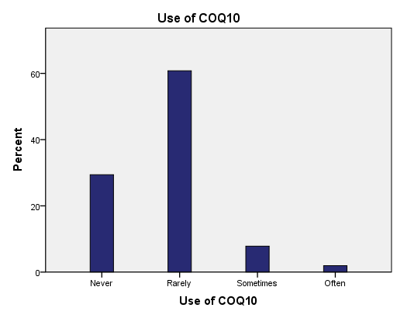

Figure S2C Figure S2D.
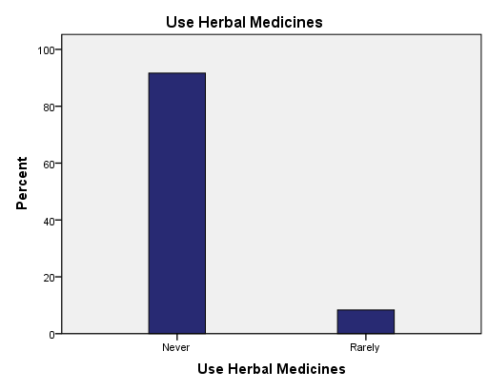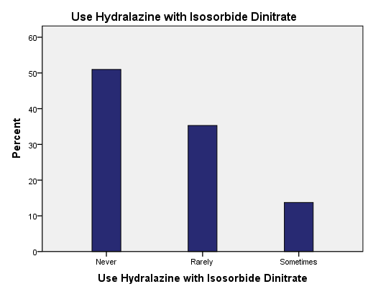

Figure S2E. Figure S2F.
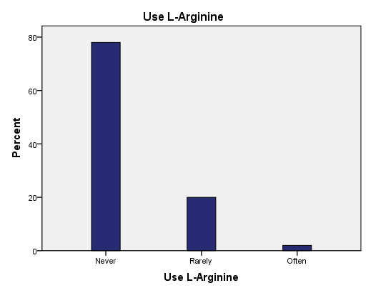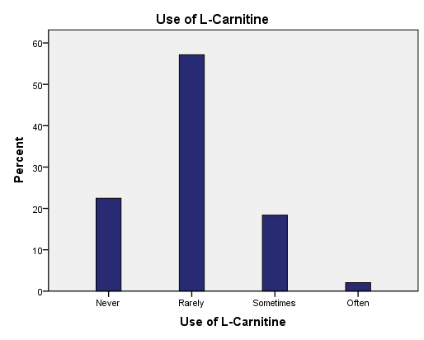

Figure S2G. Figure S2H.
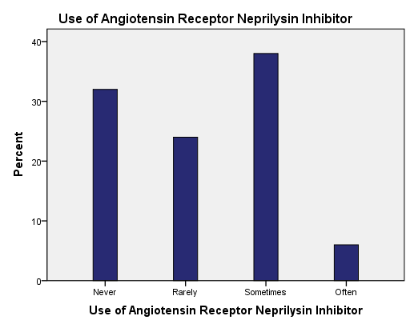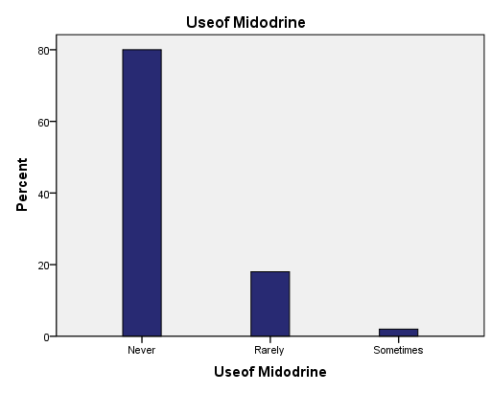

Figure S2I. Figure S2J.
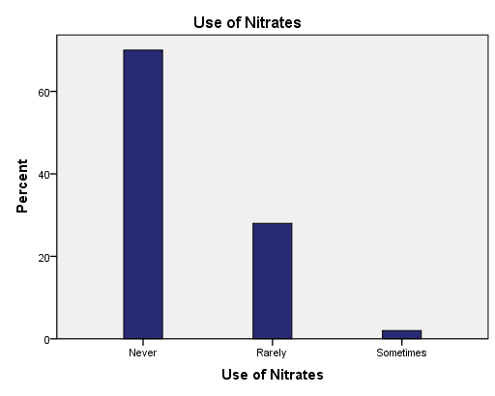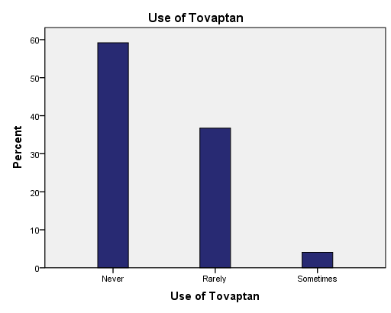

Figure S2K.
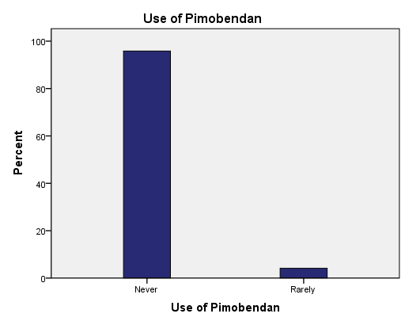
Figure S3. Interventions respondents would routinely recommend (%) for the management of chronic heart failure. N=51.

Table S2. The likelihood (percent) of using adjunctive therapy to manage chronic heart failure. Values in percent for that test. N=52.

 | Never | Rarely | Sometimes | Often | Always
PDE-5-I for secondary pulmonary hypertension | 21 | 23 | 42 | 14 | 0
Fluid Intake Restriction | 8 | 19 | 42 | 27 | 4
Sodium Chloride Intake Restriction | 10 | 23 | 46 | 17 | 4
Cardiac Resynchronization | 8 | 52 | 37 | 4 | 0
Implantable Cardioverter Defibrillator | 4 | 40 | 48 | 8 | 0

PDE-5-I = phosphodiesterase-5 inhibitor.

Table S3. Frequency (%) of use of cardiovascular diagnostic tests to monitor and/or to prognosticate patients with heart failure. Values are in percent. N=52.

 | Never | Rarely | Sometimes | Often | Always
Cardiac Magnetic Imaging | 0 | 15 | 42 | 39 | 4
Cardiopulmonary Exercise Test | 4 | 12 | 47 | 33 | 4
Invasive Hemodynamics | 4 | 42 | 46 | 4 | 4
6 Minute Walk test | 15 | 33 | 33 | 19 | 0
Shape Step Test | 87 | 6 | 8 | 0 | 0

