Supplemental Figure 1: Pre-Session Survey

- How well do you think you understand normal cardiac anatomy?
  - Very well
  - Well
  - Not well at all

- How well do you think you understand the anatomy of simple cardiac lesions such as atrial septal defect and ventricular septal defect?
  - Very well
  - Well
  - Not well at all

- How well do you think you understand the anatomy of complex cardiac lesions such as tetralogy of Fallot, transposition, and common arterial trunk?
  - Very well
  - Well
  - Not well at all

- Do you think your understanding of cardiac anatomy will improve with a two-hour “hands-on” session in which cardiac specimens with specific cardiac lesions are demonstrated?
  - Yes
  - No

- Would you be interested in a two-hour “hands on” session in which cardiac specimens with specific cardiac lesions are demonstrated?
  - Yes
  - No

Supplemental Figure 2: Educational Assessment

Initials:

Year of training (circle one): 1 2 3

Timing of test (circle one): Pre Post

- What feature best defines atrial morphology?
  - The veins returning to it
  - The atrioventricular valve connected to it
  - The pectinate muscles
  - External shape of the atrial appendage

- Which of the following is NOT a type of ventricular septal defect?
  - Perimembranous
  - Muscular
  - Outlet
  - Fibrous

- Which atrium is this morphologically?
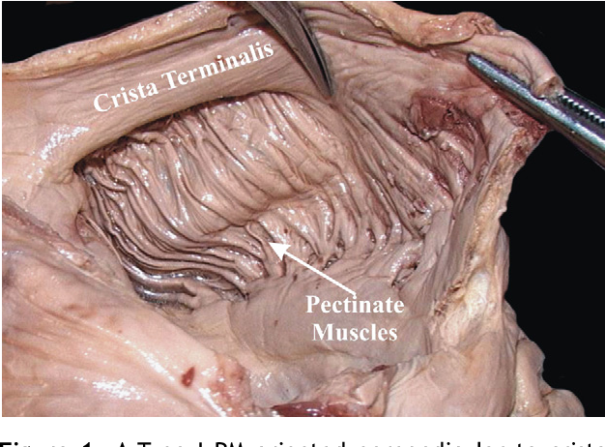
  - Right atrium
  - Left atrium

- Which valve is most likely to help “close” or “cover” a ventricular septal defect?
  - Aortic
  - Pulmonary
  - Tricuspid
  - Mitral

- Which set of valves usually has “continuity” or some degree of “fibrous connection” with each other?
  - Aortic and pulmonary
  - Mitral and aortic
  - Tricuspid and pulmonary
  - Tricuspid and mitral

- What of the following structures does NOT help identify the morphology of the ventricle?
  - Atrioventricular valve
  - Thebesian valve
  - Moderator band
  - Trabeculations

- What structure helps identify the location of the atrioventricular node
  - Atrial septum
  - Triangle of Koch
  - Pulmonary valve
  - Moderator band

- Which of the following valves has septal connections?
  - Tricuspid valve
  - Pulmonary valve
  - Mitral valve
  - Aortic valve

- An outlet type ventricular septal defect is defined by what structure?
  - Thebesian valve
  - Septomarginal trabeculation
  - Aortic valve
  - Pulmonary valve

- How many leaflets does the mitral valve have?
  - 2
  - 3
  - 4

Supplemental Figure 3: Post-Session Survey

- How well do you think you understand normal cardiac anatomy?
  - Very well
  - Well
  - Not Well at all
- How well do you think you understand simple cardiac lesions such as ASD and VSD?
  - Very Well
  - Well
  - Not well at all
- How well do you think you understand complex cardiac lesions such as tetralogy of Fallot and transposition?
  - Very Well
  - Well
  - Not well at all
- Do you think your knowledge of normal and non-normal cardiac anatomy increased with the hands-on session?
  - Yes
  - No
- Do you think the “hands-on” cardiac session was a good use of lecture time?
  - Yes
  - No
- Would you be interested in having this “hands-on” cardiac lecture continue in the future?
  - Yes
  - No

