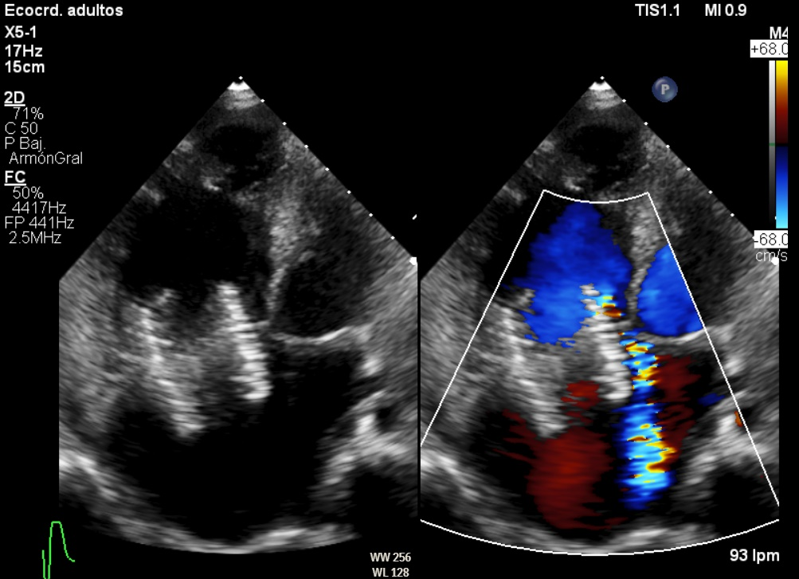Figure 3 (Periprosthetic leak after percutaneous valve implantation )
.
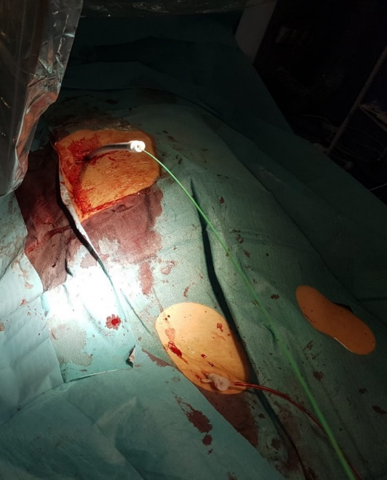
Figure 4 (Transhepatic access needed due to the large right atrium and acute curve from yugular access )

