SUPPLEMENTARY MATERIAL

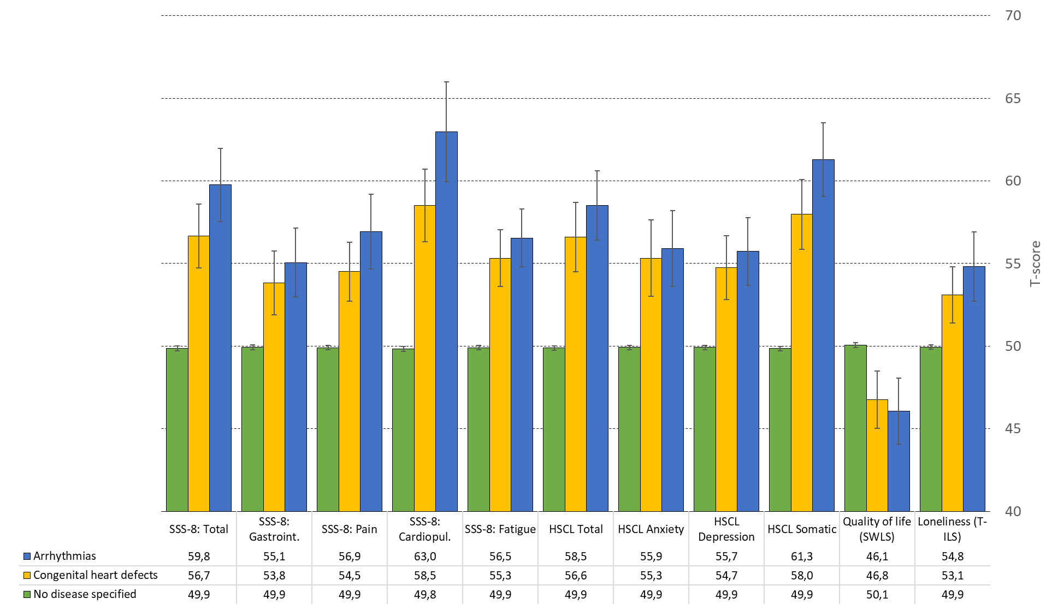
Figure 2. Mental health characteristics in students with congenital heart defects, arrhythmias, and no specified disease in standardized t-scores. Mean scores and 95% confidence intervals. Significant group differences (a,b,c) are indicated for each row in the table using subscript letters, calculated at the 0.05 significance level based on the ANOVA post-hoc tests.

