Supplemental Figure S1: Visual analogue pain scale (VAS)
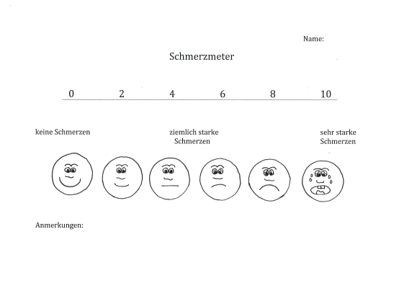
Adopted from ²⁶ and ⁵³

