Supplementary Material

Table S1: Detected mutations in TSC1 (exons 3 to 23) and TSC2 (exons 1 to 41) genes (nonsense, missense, Synonymous, intron and duplication mutations)
Patients | Gene | cDNA Variant | Protein  Variant | Variant Type | 1000 Genomes | ClinVar | Pathogenicity
(Patient.1) | TSC1 | c-7C>T | N/A | Intronic Variant | rs62621221 | RCV000210810.1 | Benign
 |  | c.2626-5_2626-4dup | N/A | Duplication | rs5901000 | RCV000586176.1 | Benign
 | TSC2 | c.4375C>T | p(Arg1459*) | Nonsense | rs45517340 | RCV000190004.2 | Pathogenic
(Patient 2) | TSC1 | c.1142-33A>G | N/A | Intronic Variant | rs6597586 | RCV000254427.1 | Benign
 |  | c.1439-37C>T | N/A | Intronic Variant | rs10901220 | RCV000042031.2 | Benign
 |  | c.2625+68G>A | N/A | Intronic Variant | rs1076160 | RCV000829852.1 | Benign
 | TSC2 | c.226-101C>T | N/A | Intronic Variant | rs144408387 | Not Reported | Not provided
 |  | c.482-3C>T | N/A | Intronic Variant | rs1800720 | RCV000576589.1 | Benign
 |  | c.482-68C>G | N/A | Intronic Variant | rs2516734 | RCV000043225.2 | Not provided
 |  | c.976-100C>G | N/A | Intronic Variant | rs2074968 | RCV000834380.1 | Benign
 |  | c.1600-39C>T | N/A | Intronic Variant | rs45477195 | CV000254340.1 | Benign
 |  | c.5161-10A>C | N/A | Intronic Variant | rs1800718 | RCV000589236.1 | Benign
 |  | c.5202T>C | p.(Asp1734=) | Synonymous  variant | rs1748 | RCV000162957.1 | Benign
 |  | c.5260-49C>T | N/A | Intronic Variant | rs13332221 | RCV000042680.2 | Benign
 |  | c.5260-25C>G | N/A | Intronic Variant | rs13332222 | RCV000576507.1 | Benign
(Patient 3) | TSC1 | c.1142-33A>G | N/A | Intronic Variant | rs6597586 | RCV000254427.1 | Benign
 |  | c.1439-37C>T | N/A | Intronic Variant | rs10901220 | RCV000042031.2 | Benign
 |  | c.2625+68G>A | N/A | Intronic Variant | rs1076160 | RCV000829852.1 | Benign
 |  | c.2626-5_2626-4dup | N/A | Duplication | rs5901000 | RCV000586176.1 | Benign
 | TSC2 | c.482-3C>T | N/A | Intronic Variant | rs1800720 | RCV000576589.1 | Benign
 |  | c.482-68C>T | N/A | Intronic Variant | rs2516734 | RCV000043225.2 | Not provided
 |  | c.1070C>T | p.(Ala357Val) | Missense | rs150195368 | RCV000230505.5 | VUS/ benign*¹
 |  | c.976-16C>T | N/A | Intronic Variant | rs773016098 | Not Reported | Not provided
 |  | c.976-100C>T | N/A | Intronic Variant | Not provided | Not Reported | Not provided
 |  | c.1513C>T | p.(Arg505*) | Nonsense | rs45517179 | RCV000517734.1 | Pathogenic
 |  | c.4569+10G>A | N/A | Intronic Variant | Not provided | Not Reported | Not provided
Patient 4 | TSC1 | c.2503-59C>T | N/A | Intronic Variant | rs930922255 | Not Reported | Benign
 |  | c.2626-5_2626-4dup | N/A | Duplication | rs5901000 | RCV000586176.1 | Benign
 | TSC2 | C.4375C>T | p(Arg1459*) | Nonsense | rs45517340 | RCV000201120.2 | Pathogenic
 |  | 16265C>G | N/A | Intronic Variant | rs2074968 | Not Reported | Benign
(Patiet5) | TSC1 | c.2625+68G>A | N/A | Intronic Variant | rs1076160 | RCV000829852.1 | Benign
 |  | c.2626-5_2626-4dup | N/A | Duplication | rs5901000 | RCV000586176.1 | Benign
 | TSC2 | c.4569+10G>A | N/A | Intronic Variant | Not provided | Not Reported | Not provided
 |  | c.618C>A | p.(Cys206*) | Nonsense | rs45498496 | RCV000043149.2 | Not provided
 |  | c.5331T>C | p.(Pro1777=) | Synonymous  variant | rs370820622 | RCV000574389.1 | Likely benign
 |  | c.465C>T | p.(Tyr155=) | Synonymous  variant | rs45444196 | RCV000569174.1 | Likely benign
 |  | c.1119+23G>A | N/A | Intronic Variant | rs180840428 | RCV000055550.1 | Not provided
 |  | c.1119+64A>G | N/A | Intronic Variant | Not provided | Not Reported | Not provided
 |  | c.1717-55T>C | N/A | Intronic Variant | rs7187438 | RCV000055373.1 | Not provided
*¹ conflicting information about classification as VUS and as benign ( Richards et al., 2015; Nykamp et al., 2017).

Table S2 : TSC1 Primers :
Exon | Forward 5΄- 3΄ | Reverse 5΄- 3΄ | Annealing temperature | Product size
3 | GCATTAGTTTGTCTTGCAGG | TATCAGCAGGATTCTAGTGG | 61°C | 349bp
4 | CTGGATTTTGTGACAGGAAGC | GCTCAGGACAAGTTGCACAG | 65°C | 278bp
5 | AGACAAGACTTGAGAGATTGG | AGCTTCCTTGCTTTAAGTTGC | 62°C | 334bp
6 | TCAGTGTTTAGAGCCTCTTC | ATTCCCTCATCTGTCTGGTG | 62°C | 376bp
7 | GGAGTGAGGTGGGAATATAC | AGTGGCGAGGAAGAAAACTG | 63°C | 402bp
8 | GTTCTCAAGGTTCCATCTGTG | TCCCAAATATACCTCAACAGG | 63°C | 295bp
9 | GCTTGTTCTTTGCTATCAGAG | TAGGAACTGAACTAAGTCTTAC | 61°C | 391bp
10 | CTCTGAAGTGTTACTTTGTCC | GATCCTTAAAAGTGACTCCTG | 62°C | 428bp
11 | CATGGATATAAACCTCGTGGA | CACTTTACACATTCTGAAAGC | 61°C | 336bp
12 | TCAGAATGTGTAAAGTGAACC | TCAAACCCATTGCATTTTAGG | 60°C | 412bp
13 | ATTTGAGAATCACTGCACTCG | CCCAGAATTTCCTTGTTTCCA | 62°C | 275bp
14 | TAAGCAGTTTTACACTTACAGG | GTGAGCAATGGCACAAAATCC | 63°C | 256bp
15A | TCTCCTCTCTCTGAGTGACA | GGGAGTAAAGGCTTGCTTTG | 63°C | 335bp
15B | ACTCGGCAGCCTCCAGTTC | CTTTTGCTTTCTTTAACAGCTC | 63°C | 339bp
15C | CGACGAGAGTGGGCTTTGG | CTGCCTCAAGGTGGGAGTG | 67°C | 336bp
16 | GCCATTGCAGATTTTGACCAC | CTGTTTCCCAGAGGGCACC | 65°C | 255bp
17 | AAGCTAACAACACATGGGAAG | CCAAAGGAGTGGGAAGGAC | 63.5°C | 370bp
18 | TATTCAGATGAAATGTTCGCAG | AACAAGTCAAGGACACCCAG | 62°C | 362bp
19 | AGAAAGTAGAGCCGTTGAGC | CCATGACACAGACACTCAAG | 63°C | 333bp
20 | AACATTGAAATAGTGTGCTCC | CATCAAGCCATTCTCTATGC | 61°C | 317bp
21 | ACTAAAATGCCTTCTCAGTCC | GAAAGATACAGACCAGCCAG | 62°C | 369bp
22 | TCATCAGGAAAGGCTTTTGTG | CCTGTCTAGTCAGCAGTAAC | 62°C | 335bp
23A | AGTGAGTGTCAGTGTAATTCC | CTTCTCCCATAGTCGTCTCC | 63.5°C | 317bp
23B | AGCAGCAGCGAGCTTTCTAC | ACACCCAAGTCTTTGCCCAG | 65°C | 260bp
23C | TTTCGTAATAAGAGCGAGAGC | TTTGAAACGTGCATTCACACC | 62°C | 282bp

Table S3 : TSC2 Primers :
Exon | Forward 5΄- 3΄ | Reverse 5΄- 3΄ | Annealing temperature | Product size
1 | GTCCCCATTCCTGTTTCGTT | TCTCTGCATTTCCCTCTAGC | 63°C | 242bp
2 | TGGAAAATGCAGTGGGAGTC | GCAAACCAGATCATCGGCAG | 63°C | 296bp
3 | GTGGGGCTCTCAGTCACAAG | TAGACCCTGTGCCCAGCAAC | 67°C | 350bp
4 | CTGCACTTCAGGGACTTCTTG | CATCCAGGTTACACTTGATCG | 64°C | 282bp
5 | GACTGATGATGGGGTTTCTG | ACTGCGGAGCTGAACTTAGG | 63°C | 294bp
6 | ACGTCATAGAGTGACTAGACC | CTGAGGCTCAGAGAGACCGA | 66°C | 269bp
7 | TGAAGGAGGTGGGAAGGAAG | AGACAACCATTCATGGGAGAC | 64°C | 299bp
8 | GTCTTTGGGAGGAGATGGTG | GTGTGTGCTTGGCAAGGGAC | 65°C | 295bp
9 | CCTCGGCAACCTCACACATC | TTCCTGCCAGCTCACTGCAC | 67°C | 243bp
10 | ATAAACGTGTGGTGGGCACTG | ATCTTCTGAGTGGGCCGAGC | 67°C | 337bp
11 | GGCTGAGGGTGTCTCCATGC | TTCTGAGGCTCAGAAAGCTGC | 67°C | 330bp
12 | CTGGGCTCTGACAGCAAACC | CTCATCGGGCATCCTGAGAC | 67°C | 298bp
13 | CTCTGTGCCCTGTGTGCCTG | CACGGAGAAATAGCCCTGAGC | 68°C | 257bp
14 | GGTCGGTTCCTGAGGAATTGG | GAGCTCTGGCACGCTAGCAC | 68°C | 286bp
15 | AGGTGTTTGTGGTAGAAAGTG | GGAACAGACTCCAACACAAC | 63°C | 287bp
16 | GTGTTTTGAAGCACGCACTCTA | GGAACCACACCTGCCGAGAC | 66°C | 316bp
17 | GTGTCTGTGTTGGGATGTGG | CCCTCAGACATGCAAACAGC | 65°C | 343bp
18 | GCGCTGTTTGCATGTCTGAGG | AGGCCAGACAGGGAGGGAG | 68°C | 350bp
19 | CTGAGAACAGGGCTCCATAG | CAGAGGCTCGCAGTCTTTTG | 65°C | 316bp
20 | CACTCCCACCACTCCGAAAG | CATCAAGCTCGCCTGTCCTG | 67°C | 338bp
21 | TTCAGGGACTTGCTAAGCCTC | GCACAGGTTACACAGCCCGA | 67°C | 366bp
22 | CGTGGCCTTCTCTCCTCTG | CCTTGGGGACAAAGGCTGC | 67°C | 300bp
23 | CTTTGTCCCCAAGGCCTGAG | CAAAGCAAGCCCTGGCCTAC | 67°C | 257bp
24 | CCTGCAGCTTGTCCCTGG | CTCACTGACTTGGAGGCAC | 65°C | 286bp
25 | CTCTCCATCCTGACCCTGTG | CAGACGATGAGGTCATGCAAG | 66°C | 345bp
26 | CTGTTGGGGTCTTTCCGAGC | ACAGGGAGCGTGAAACCCAG | 67°C | 359bp
27 | CTGGGTTTCACGCTCCCTGT | TTAGTCCCCAGGCTGGTACG | 67°C | 277bp
28 | TGACTGCACCTTCCTTTCCTC | ACACTGGGACCAGCAGCAAC | 66°C | 308bp
29 | TCTGGCTGCCTGTGGCACTA | AAGAGGGCCAAGTCTGCAATC | 66°C | 415bp
30 | TGAGGATTGTGGGAGGGAGC | GCAGAGAGGAGCCACATTGC | 67°C | 408bp
31 | CAGCTTGTAGCTAGCACTGG | ACAGCACCTATGAGGCAGAG | 65°C | 282bp
32 | TGTCCCTCTGGTCAGGAGAAG | AGAGCCCTGCCTCCCCTAAG | 68°C | 285bp
33A | CTGGGATGGAGGACAGATAG | TGACCGGGCCTTAACCTCAG | 67°C | 351bp
33B | CCTCTGTGGACCTCTCCTTC | TACTCTCTTGCCCCTGCGTG | 67°C | 317bp
33C | GTTAAGGCCCGGTCACAGTC | CAAGTGAGGCACCAGGTTCC | 67°C | 319bp
34 | CGGTGGAGTGGGAGATGG | GAGCCCTCTGCAAGCCTG | 66°C | 280bp
35 | GGAGCTCAGGCTTGCAGAGG | ACTTCATGCTGTAGGGGACC | 66°C | 345bp
36 | CTGCTGGAATGGATGGTCTTG | GTAGCAGGACTGGATGGGAG | 66°C | 394bp
37 | CTGGAGTAATCAGGAGGTGC | CGAAGCTCAGGGAGGAGG | 66°C | 318bp
38 | TGCCAGAGGGGAAAGTTCAG | GGGAGACTTGGTGGTCACG | 66°C | 317bp
39 | TGCAGTGCAGGAAAGGTAGG | GTGAGCTCACTATCAGGTGG | 65°C | 281bp
40 | TGGCCAAGATCGTGTCTGAC | GACAGGCAATACCGTCCAAG | 65°C | 583bp
41 | TCACAGGTGCATCATAGCCG | GACAGGCAATACCGTCCAAG | 65°C | 425bp

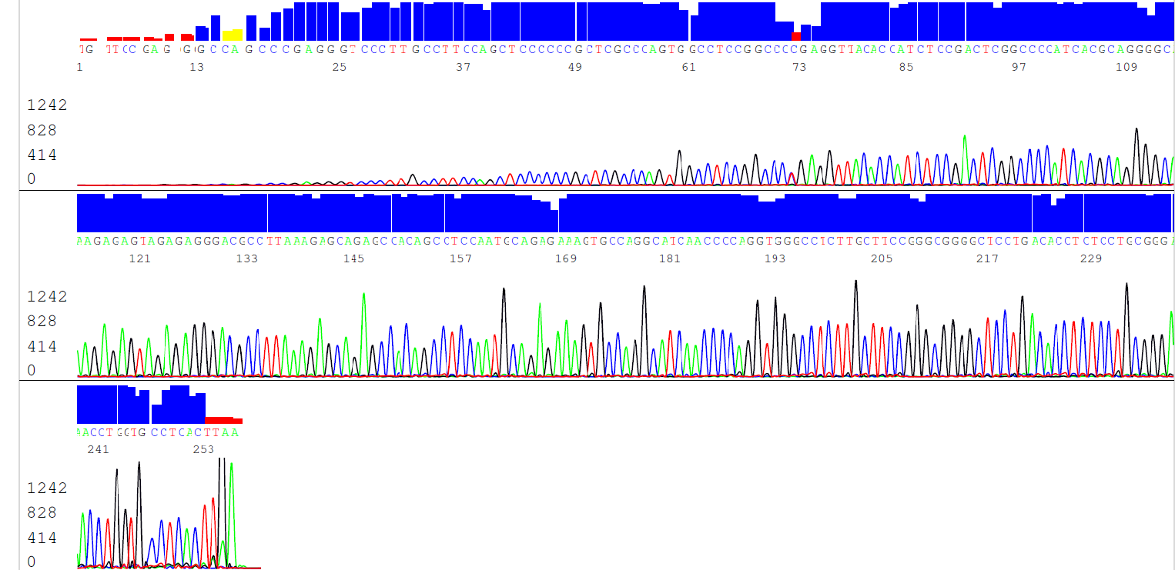
Forward

Reverse
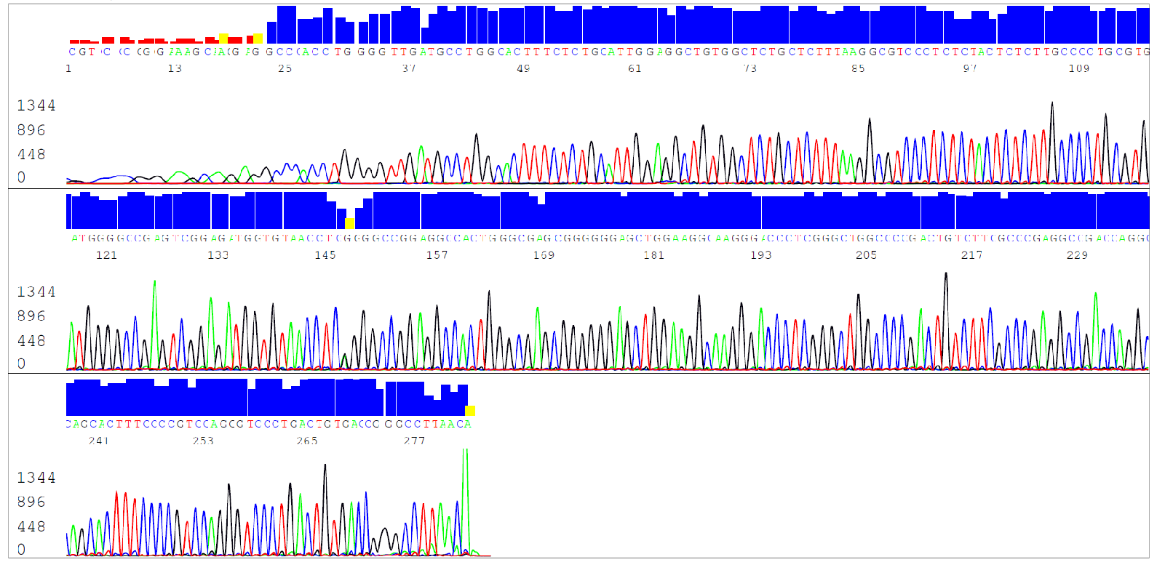

Figure S1 : A full four-color chromatogram showing the results of the sequencing run of Patient 1 (forward and reverse) . Sequence analysis of TSC2 : exon 34, resulting in pathogenic mutations: c.4375C>T mutation.

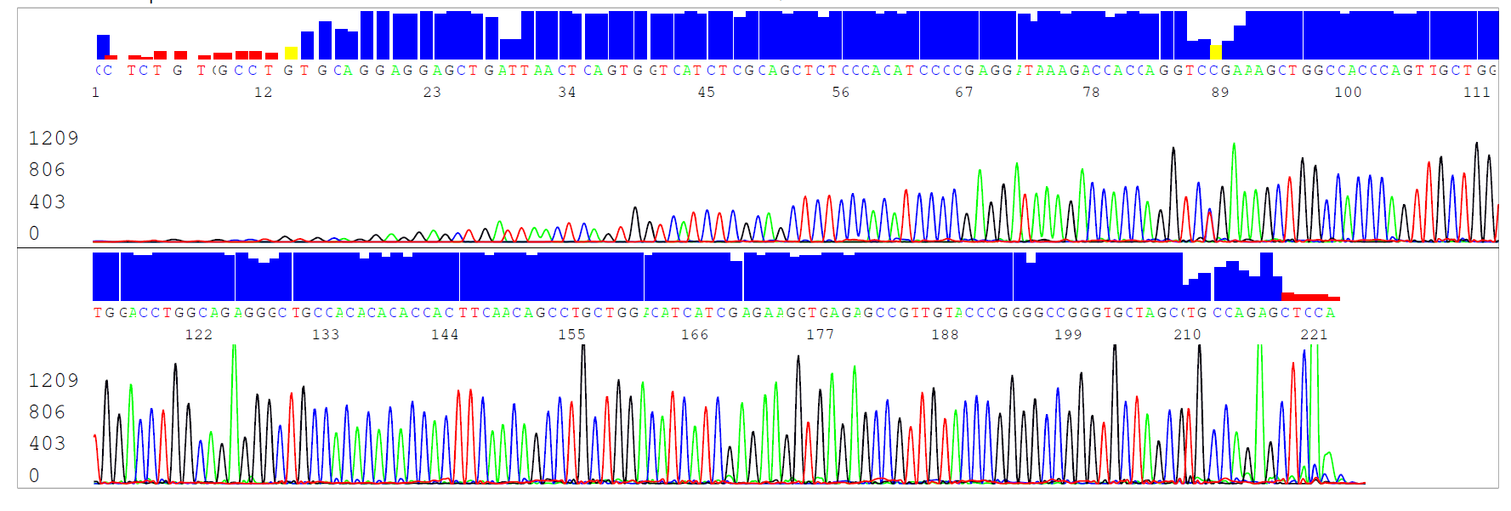
Forward

Reverse
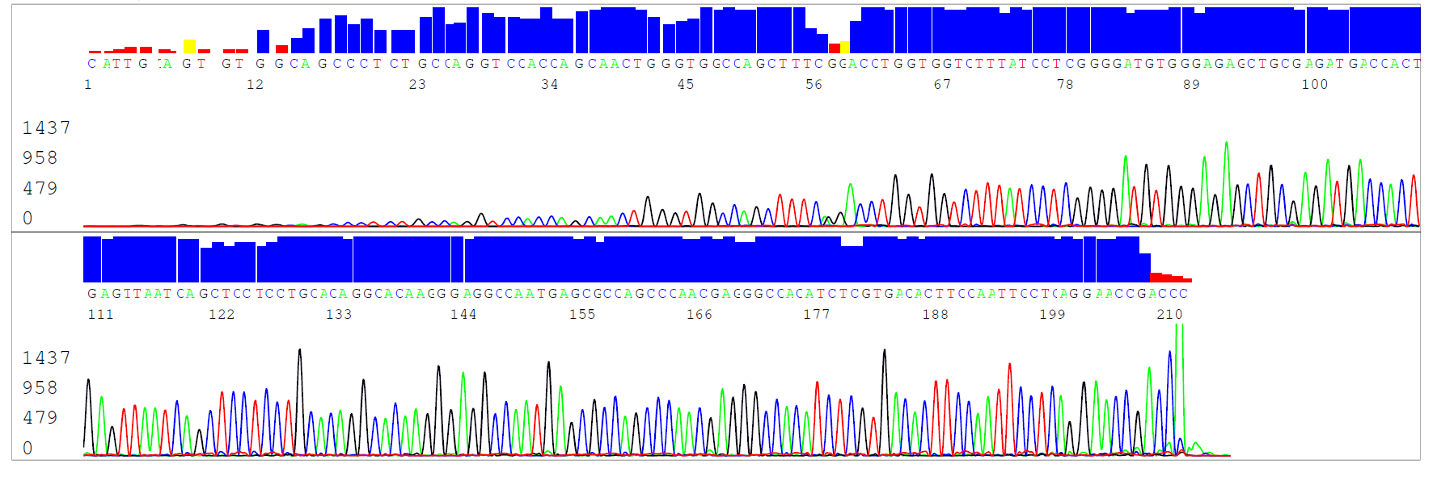
Figure S2 : A full four-color chromatogram showing the results of the sequencing run of Patient 4 (forward and reverse) . Sequence analysis of TSC2 : exon 15, resulting in pathogenic mutations: c.1513C>T mutation.

