Supplement 1. Clinical composite endpoint count

Points | documented IART | acute treatment | long term treatment
0 | none | none | none, betablocker, verapamil, digoxin
1 | non sustained only | 1 ECV | class I, sotalol
2 | 1 sustained | > 2 ECV | class III
3 | incessant | hospitalisation for symtpoms of heart fialure, syncope of cardiac arrest | His, redo ablation
ECV - electrical cardioversion, IART - intra-atrial re-entrant tachycardia
Supplement 2 recurrences and repeat procedures per strategy in AMBA and ESM

Supplement 2 contains a flow chart describing the recurrences and repeat procedures throughout the complete follow-up of patients with activation map based ablation (AMBA) and extensive scar modification (ESM) respectively, thereafter in case of recurrence it shows again the chosen strategy. If this ablation strategy was IART it is specified whether it was AMBA or ESM and if there were recurrences.

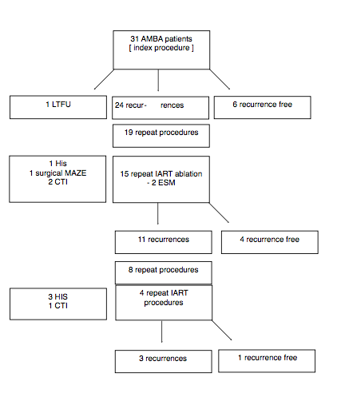
- AMBA

AMBA - activation map based ablation; CTI - cavotricuspid isthmus; ESM - extensive scar modification; His - his bundle ablation; IART - intra-atrial reentrant tachycardia; LTFU - lost-to follow-up; Maze - maze surgical ablation

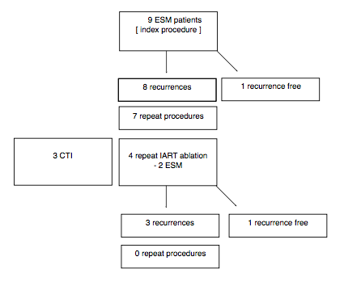
B. ESM

AMBA - activation map based ablation; CTI - cavotricuspid isthmus; ESM - extensive scar modification; His - his bundle ablation; IART - intra-atrial reentrant tachycardia; LTFU - lost-to follow-up; Maze - maze surgical ablation

