Supplementary File S3

Morbidity monitoring tool user guide – version 27/02/2018
UCL Clinical Operational Research Unit

Introduction
This software was developed to facilitate creation of graphical summaries from a set of data about morbidities associated with surgery. The tool is implemented as a Macro-enabled MS Excel spreadsheet (MorbPrototype_27022018.xlsm), containing VBA code, the source dataset and relevant graphical parameters. It automatically produces a set of navigable slides containing graphical summaries obtained from the source dataset and stores them as an MS PowerPoint presentation.
Content of the following sections:
- overview of the structure of the spreadsheet;
- content of the output presentation;
- details about the content of each sheet in the spreadsheet;
- structure of the VBA code.

1. General structure of the MS Excel spreadsheet
The spreadsheet contains:
- a visible “Data” sheet where the source dataset about morbidities is stored;
- a visible “CreatePowerPointSlides” sheet containing an action button enabling the user to run the tool as well as some customisable parameters;
- a hidden “Icons” sheet storing all basic pictures (icons) used in the graphical summaries;
- a hidden “SlideNames” sheet storing identifiers for each slide in the presentation;
- a hidden “Parameters” sheet where all graphical parameters (e.g. icon position/size) are specified.

2. Output content
The output of this tool is a set of navigable slides (see picture below).
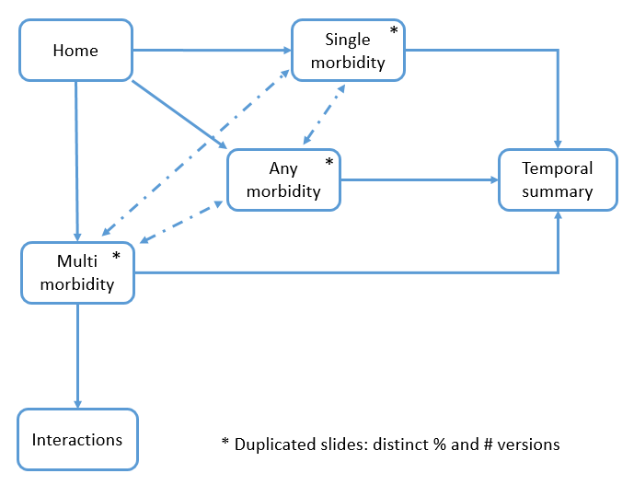

The following table describes the content of each output slide:
Slide | Content
Home | Home page containing a button to start the navigation as well as generic information about source data
Procedures with morbidities (2 slides: one reporting absolute numbers, one reporting percentage) | - Number of procedures considered  - Number of procedures with no morbidity diagnosed  - Number of deaths among all procedures  - Number of procedures with any morbidity diagnosed  - Number of procedures characterised by a single morbidity  - Number of procedures characterised by at least two morbidities  - For each morbidity: number or percentage of procedures (as icon labels) in which that morbidity was diagnosed*
Procedures with single morbidities (2 slides: one reporting absolute numbers, one reporting percentage) | - Number of procedures considered  - Number of procedures with no morbidity diagnosed  - Number of deaths among all procedures  - Number of procedures with any morbidity diagnosed  - Number of procedures characterised by a single morbidity  - Number of procedures characterised by at least two morbidities  - For each morbidity: number or percentage of procedures (as icon labels) in which that morbidity was diagnosed as single morbidity
Procedures with multiple morbidities (2 slides: one reporting absolute numbers, one reporting percentage) | - Number of procedures considered  - Number of procedures with no morbidity diagnosed  - Number of deaths among all procedures  - Number of procedures with any morbidity diagnosed  - Number of procedures characterised by a single morbidity  - Number of procedures characterised by at least two morbidities  - For each morbidity: number or percentage of procedures (as icon labels) in which that morbidity was diagnosed together with other morbidities*
Interactions between morbidities (9 slides: one for each morbidity) | For each morbidity, information about its “accompanying morbidities” is reported: a link is drawn between morbidity icons if the two morbidities were diagnosed following the same procedure, in which case the number of such occurrences is reported as label of the link
Temporal summaries | For each morbidity: a simple graph is drawn to depict the incidence of the morbidity over time, against a “base risk” used as benchmark (this can be specified by the user)

* For each morbidity (except ECLS), procedures where ECLS was diagnosed are not considered.

3. Detailed content of the spreadsheet
3.1. “Data” sheet
Each row in this sheet represents a procedure, except row 1 containing column names (starting from cell A1).
The following data columns need to be present, with column names exactly as they are specified here (including spaces and upper/lower cases), but not necessarily in this order:
Column name | Content
Procedure ID | Procedure identifier – any combination of characters is accepted
Date | Procedure date – format dd/mm/yyyy
Life Status | Whether the patient is still alive – values to be entered: {1.Alive, 2.Dead}. (Any other value will be considered as “1.Alive”)
ANE morbidity? | Whether a morbidity was diagnosed for the patient – values to be entered: {0.No, 1.Yes}. (Any other value will be considered as “0.No”)
Feeding morbidity?
Wound Infection (SSI) morbidity?
ECLS morbidity?
NEC morbidity?
Unplanned reoperation morbidity?
Renal morbidity?
Pleural Effusion (PPE) morbidity?
Major Adverse Event (MAE) morbidity?

No empty columns are allowed. Any other additional piece of information can be added as additional columns (these can be mixed up with the mandatory columns) but will be ignored by this tool.
Entries can be listed in any order (e.g. they do not need to be sorted by procedure date).

3.2. “CreatePowerPointSlides” sheet
The “Create presentation” button runs the VBA code to create a PowerPoint presentation in the same folder as the spreadsheet. A message will appear when the output is ready to be opened. The name of the output file will be “Summary_”, followed by the name of the spreadsheet, followed by anything contained in cell B1.
This sheet also contains a section where, for each morbidity, a “base risk” is reported. The base risk is used as a benchmark to compute temporal summaries. The base risk can be specified by the user. It can also be reset to initial, default values (stored in the “Parameters” sheet) using the “Reset base risk” button.

3.3. “Icons” sheet
This is a hidden sheet containing all icons used (through automatic copying/pasting) throughout the output presentation. Each icon is appropriately named with an identifier used in the VBA code.

3.4. “SlideNames” sheet
This is a hidden sheet containing identifiers for all slides to be included in the output presentation.

3.5. “Parameters” sheet
This is a hidden sheet containing most (mainly graphical) of the parameters used by the VBA code to produce the output presentation:
Parameter type | Content
Object positions in circle (A3:I23) | Each row corresponds to an icon and specifies: i) the name of the icon, ii) its wished size and position in the slides (note that icons appear in the same position and size in all slides), iii) position and size of icon labels appearing in the slides summarising numbers of procedures (any, single, multi).
Name of morbidity data columns (K4:K12) | For each morbidity, the name of the corresponding column (reporting whether the morbidity was diagnosed or not for each procedure) in the “Data” sheet is specified.
Links between morbidities in circle (A40:K112) | For each ordered pair of morbidities, sizes/positions of links and labels are specified for the slides reporting interactions between morbidities
Base risk (A117:B126) | These cells store default values for base risk of each morbidity
Icon position in temporal summary slide (A132:E141) | Position/size of each morbidity icon is specified (the corresponding graphical parameters for the temporal summary graphs are determined in the VBA code relative to icon positions)

All sizes and positions are specified in centimetres.

4. VBA code structure
The VBA code embedded in the Macro-enabled MS Excel file is structured into modules.
The code is activated using the “Create presentation” button in the “CreatePowerPointSlides” sheet. In particular, the button acts on the “Main” module containing a unique function called “Main()” as well. This function is meant to define and assign values to variables representing all needed information used to populate the output slide set.
Main() sequentially calls other functions grouped into other modules:
Module name | Module content
GettingData | All functions reading information from the “Data” sheet, as well as from the table reporting morbidity base risks (in the “CreatePowerPointSlides” sheet).
ResetBaseRisk | A simple function to reset morbidity base risks to default values. Default values are copied from the hidden “Parameter” sheet. The function is activated using the “Reset base risk” button (in the “CreatePowerPointSlides” sheet).
GettingMorbOccurrences | All functions used to compute morbidity-specific occurrences (i.e. number of procedures in which each morbidity was diagnosed as single/multi/any morbidity). These numbers are used to populate slides 2 to 7.
GettingProcNumbers | All function used to compute global statistics (i.e. procedures, deaths, procedures with multi morbidities, etc.). These numbers are used to populate slides 2 to 7.
GettingAccompMorbidities | A function used to compute, for each morbidity, the number of its accompanying morbidities. These numbers are used to populate slides 8 to 16.
VLAD | All functions used to populate graphs in the “Temporal summaries” slide (slide 17). These computations are inspired to VLAD method.
BuildingSlideSet | All functions creating the slide set, using the above outputs as well as graphical parameters:  - a first function creates an empty presentation, with a populated home slide and 16 additional empty slides.  - a second function creates slides 2 to 7 (all having the same layout);  - a third function creates slides 8 to 16 (all having the same layout);  - a fourth function creates slide 17 (temporal summaries) – graphs are first created (invisibly) within spreadsheet and then cut/pasted as small images in the slide.

