Food Group | Servings Consumed | Recommended Servings for Age | Comments
Grain Products | 2.6 | 6 | White rice, cream of wheat
Vegetables and Fruit | 4 | 6 | Vegetables only (spinach & carrot), no fruit
Milk and Alternatives | 1.3 | 3-4 | Homemade yogurt
Meat and Alternatives | 1.3 | 1-2 | Yellow lentils

Table 1: Number of servings of the various food groups and how it compares to the Canadian Food Guide.

Nutrient | % of Calories Consumed | DRI Recommendation
Macronutrient  Carbohydrate  Protein  Fat | 45%  11%  44% | 45-65%  10-30%  25-35%
Micronutrient
B 12  B2  Niacin  Vitamin D  Vitamin E  Calcium  Selenium  Zinc  Omega 3  Omega 6  Panthothenic Acid  Phosphorus | 0.9 mcg  0.78 mg  7 mg  2.25 mcg  4.6 mg  513 mg  27 mcg  4 mg  0.11  0.57  2.61 mg  782 mg | 1.8 mcg  0.9 mg  12 mg  15 mcg  11 mg  1300 mg  40 mcg  8 mg  1.2 g  12 g  4 mg  1250 mg

Table 2: Distribution of nutrients.

 | ADMISSION | DISCHARGE | NORMAL RANGE
Ionized Ca  (mmol/L) | 0.49 | 1.11 | 1.09-1.30
Mg  (mmol/L) | 0.50 | 0.96 | 0.65-1.05
Na  (mmol/L)* | 123 | 133 | 135-145
Hb  (g/L)* | 66 | 96 | 125-160
25 Vit D  (nmol/L) | <10 | 31 | 75-250
Albumin  (g/L) | 28 | 30 | 38-54
Phosphate*  (mmol/L) | 0.85 | 2.41 | 1.1-1.9
Ferritin  Ug/L | 39.9 | 26.5 | 30-400
Iron  (μmol/L) | 6 | 9 (was checked 3 months following discharge) | 8-29

Table 3: Nutritional and Electrolyte Deficiencies in a Patient with Kwashiorkor Malnutrition: These values are the actual laboratory results of this patient’s bloodwork. All admission values are within two days of the patient’s initial admission to hospital, with the exception of his sodium, phosphate and hemoglobin values, which denote the nadir of his anemia, hypophosphatemia, and hyponatremia rather than his admission bloodwork. The discharge results are the most recent values prior to discharge and may not have been drawn on the exact discharge date. The findings show a significant improvement in all categories following refeeding, nutritional supplementation, and medication administration.

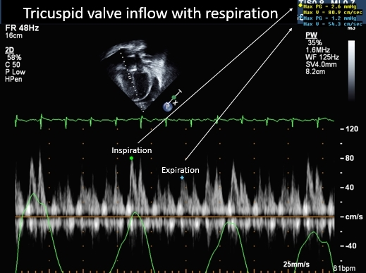
Figure 1. Pericardial effusion (PE) in a Patient with Kwashiorkor: Tricuspid valve inflow during respiration with no evidence of pericardial tamponade
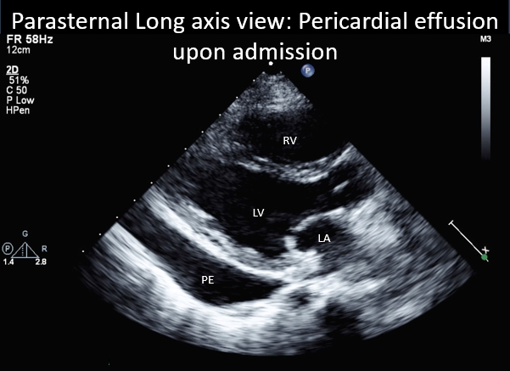
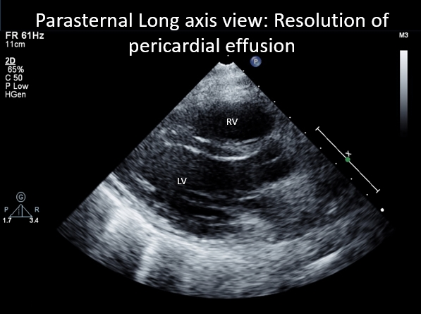

Figure 2. Pericardial Effusion in a Patient with Kwashiorkor: Pericardial effusion on admission (LEFT) with subsequent resolution (RIGHT) following appropriate therapy. The effusion was initially treated with a course of ibuprofen and prednisone, with minimal improvement. It was not until the Kwashiorkor diagnosis and ensuing management targeted at malnutrition that the effusion resolved.

