Online Supplement

Table S1. Recovery of diaphragm thickness fraction in the paralyzed left diaphragm.
Postoperative day |  | 5 | 14 | 26 | 33 | 40 | 47 | 67
Pressure support (cmH₂O) |  | 6 | 6 | 6 | 6 | 6 | 6 | Extubated
Right | DT at inhalation (mm) | 1.68 | 2.72 | 2.65 | 2.11 | 2.35 | 1.18 | 1.43
 | DT at exhalation (mm) | 1.28 | 1.38 | 1.83 | 1.69 | 1.63 | 0.84 | 0.87
 | DTF (%) | 31 | 78 | 45 | 31 | 44 | 42 | 65
Left  (paralyzed) | DT at inhalation (mm) | 0.85 | 1.12 | 0.77 | 1.16 | 1.51 | 1.00 | 2.18
 | DT at exhalation (mm) | 0.85 | 1.07 | 0.73 | 0.82 | 1.07 | 0.82 | 1.33
 | DTF (%) | 0.2 | 4.7 | 1.7 | 29 | 45 | 21 | 65
DT = diaphragm thickness; DTF = diaphragm thickness fraction.

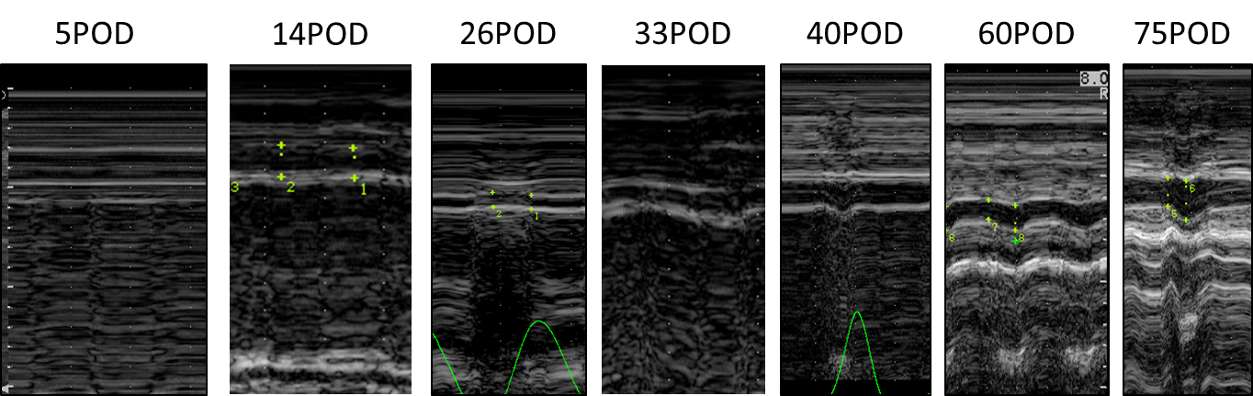
Figure S1. The recovery of diaphragm thickness fraction in the paralyzed left diaphragm. M-mode images of the left paralyzed diaphragm are shown. During mechanical ventilation and continuous positive airway pressure with pressure support (6 cmH₂O), the change in diaphragm thickness could not be detected until postoperative day 26, and the diaphragm’s thickness increased with inhalation on postoperative day 33.
POD = postoperative day.

