Supplementary Table 1: Existing full and screening tests of development and/or cognitive function and whether they fulfil the required criteria for an early recognition tool  Note: Columns represent the predefined criteria against which tests were assessed as either fulfilling (indicated with a √) or not fulfilling (indicated with a x) required criteria. | Predefined criteria (decided by consensus by the BDA Development Group)
Test CHECK AGE RANGES FOR TEST AND REMOVE 5-16 YRS | Age range (0-4.9 years) | Administration (able to be administered by clinicians without expertise in developmental testing – also a proxy for low cost) | Equipment  (no specialist equipment required – also a proxy for low cost); need for some generic equipment acceptable | Observation and parent report (test has both elements) | Time to administer (takes no more than 10 minutes to administer for child of any age) | Time to score (takes no more than 5 minutes to score and does not require any specialist software or equipment – also a proxy for low cost | Domains covered (covers the identified domains of gross motor, fine motor, daily living skills, communication, socialisation and general understanding)
Screening tests
Ages and Stages Questionnaire ¹ | √ | √ | √ | x | √ | √ | √
Batelle Developmental Inventory Screening Test ² | x | √ | x | √ | x | x | √
Bayley-III Screening test ³ | X | x | x | x | x | x | √
Birth to Three Assessment and  Intervention System, 2nd Ed ⁴ | x | √ | √ | x | x | √ | √
Brigance Early Childhood Screens ⁵ | √ | √ | x | √ | x | √ | √
Cognitive Abilities Scale – 2nd Ed ⁶ | x | x | x | x | X | x | x
Cognitive Adaptive Test and Clinical Linguistic and Auditory Milestone Scale ⁷ | x | x | x | √ | x | √ | x
Denver Developmental Screening Test II ⁸ | √ | √ | x | √ | x | x | √
Developmental Activities Screening Inventory-II ⁹ | √ | √ | √ | x | x | x | x
Developmental Assessment of  Young Children ¹⁰ | √ | x | √ | √ | x | x | √
Early Learning Accomplishment  Profile, Learning  Accomplishment Profile, 3rd Ed ^{11, 12} | √ | √ | x | x | √ | √ | √
Infant Development Inventory / Child Development Review ¹³ | √ | √ | √ | x | √ | √ | √
Kaufman Brief Intelligence Test ¹⁴ | √ | x | x | x | x | x | x
Parents’ Evaluation of Developmental Status ¹⁵ | √ | √ | √ | x | √ | √ | √
Parents’ Evaluation of Developmental Status – Developmental milestones ¹⁶ | √ | √ | √ | x | √ | √ | √
Test | Age range (0-4.9 years) | Administration (able to be administered by clinicians without expertise in developmental testing – also a proxy for low cost) | Equipment  (no specialist equipment required – also a proxy for low cost); need for some generic equipment acceptable | Observation and parent report (test has both elements) | Time to administer (takes no more than 10 minutes to administer for child of any age) | Time to score (takes no more than 5 minutes to score and does not require any specialist software or equipment – also a proxy for low cost | Domains covered (covers the identified domains of gross motor, fine motor, daily living skills, communication, socialisation and general understanding)
Parent Report of Children’s Abilities – revised ¹⁷ | x | √ | √ | x | √ | √ | x
Paediatric Cerebral Performance Category ¹⁸ | x | √ | √ | x | √ | √ | x
Schedule of Growing Skills ¹⁹ | √ | x | x | x | x | x | √
Wechsler Abbreviated Scale of Intelligence ²⁰ | x | x | x | x | x | x | x
Full tests
Battelle Developmental Inventory, 2nd Ed ²¹ | √ | x | x | x | x | x | √
Bayley–III Scales of Infant and Toddler Development, 3rd Ed ²² | x | x | x | √ | x | x | √
British Ability Scales ²³ | √ | x | x | x | x | x | x
Developmental Neuropsychological Assessment ²⁴ | √ | x | x | x | x | x | x
Griffiths Mental Development scales ²⁵ | √ | x | x | x | x | x | √
Kaufman Assessment Battery for Children ²⁶ | √ | x | x | x | x | x | x
Mullen Scales of Early Learning ²⁷ | √ | x | x | x | x | x | x
Stanford-Binet Intelligence Scales ²⁸ | √ | x | x | x | x | x | x
Wechsler Preschool and Primary Scale of Intelligence ²⁹ | x | x | x | x | x | x | x
Wechsler Intelligence Scale for Children ³⁰ | x | x | x | x | x | x | x

References – supplementary material
- Squires J, Bricker T and Twombly E. Ages and Stages Questionnaires: Third Edition (ASQ-3). Brookes, Baltimore, MD, 2009.
- Oehler-Stinnett J. Batelle Developmental Inventory Screening Test. Mental Measurement Yearbook.
- Bayley N. Bayley-III Screening Test. PsychCorp, San Antonio, TX, 2005.
- Ammer JJ and Bangs TE. Birth to three assessment and intervention system. Pro-Ed, 2000.
- Brigance A and Glascoe F. Brigance Early Childhood Screen II. North Billerica, MA: Curriculum Associates 2010.
- Bradley-Johnson S and Johnson CM. Cognitive Abilities Scale–Second Edition. PRO-ED, Austin: TX, 2001.
- Accardo PJ and Capute AJ. The Capute Scales: Cognitive Adaptive Test/Clinical Linguistic & Auditory Milestone Scale (CAT/CLAMS). Brookes Pub, 2005.
- Frankenburg WK, Dodds J, Archer P, Shapiro H and Bresnick B. The Denver II: a major revision and restandardization of the Denver Developmental Screening Test. Pediatrics 1992; 89: 91-97.
- Fewell R and Langley M. Developmental Activities Screening Inventory–II. Austin, TX: Pro-ed Inc 1984.
- Voress JK and Maddox T. Developmental assessment of young children (DAYC). Austin, TX: PRO-ED Inc 1998.
- Project. CHOT. The learning accomplishment profile diagnostic standardized assessment examiner’s manual. . Kaplan Press, New York: NY, 1992.
- Project. CHOT. The early learning accomplishment profile edition examiner’s manual and technical report. Kaplan Press, New York: NY, 2001.
- Ireton H. Child Development Inventory. Behavior Science Systems Minneapolis, MN, 1992.
- Kaufman AS and Kaufman NL. K-BIT: Kaufman Brief Intelligence Test. American Guidance Service, 1990.
- Glascoe FP. Parents’ evaluation of developmental status (PEDS). Ellsworth & Vandermeer Press, Ltd 1997.
- Brothers KB, Glascoe FP and Robertshaw NS. PEDS: developmental milestones—an accurate brief tool for surveillance and screening. Clinical Pediatr 2008; 47: 271-279.
- Johnson S, Marlow N, Wolke D et al. Validation of a parent report measure of cognitive development in very preterm infants. Dev Med Child Neurol 2004; 46: 389-397.
- Fiser DH. Assessing the outcome of pediatric intensive care. J Pediatr 1992; 121: 68-74.
- Bellman M, Lingam S and Aukett A. Schedule of Growing Skills (SGS II) manual. UK: NFER-NELSON 1996.
- Wechsler D and Hsiao-pin C. WASI-II: Wechsler Abbreviated Scale of Intelligence. Pearson, 2011.
- Newborg J, Stock JR, Wnek L, Guidubaldi J and Svinicki J. Battelle Developmental Inventory. DLM Allen, Tex, 1988.
- Bayley N and Reuner G. Bayley Scales of Infant and Toddler Development: Bayley-III. Harcourt Assessment, Psych. Corporation San Antonio, Tex, USA, 2006.
- Elliott CD, Smith P and McCulloch K. British Ability Scales (BAS II): Full Age Range. NFER-Nelson, 1996.
- Korkman M, Kirk U and Kemp S. NEPSY-II Neuropsychological Assessment Battery. Pearson, Bloomington, MN, United States, 2007.
- Griffiths R. Griffiths Mental Development Scales. Test Angency, 1976.
- Loomis D, Holt R, Kaufman JC and Kaufman AS. Kaufman Assessment Battery for Children. Corsini Encyclopedia of Psychology 2004.
- Mullen EM. Mullen Scales of Early Learning. AGS Circle Pines, MN, 1995.
- Roid GH. Stanford-Binet Intelligence Scales. Riverside Publishing Itasca, IL, 2003.
- Wechsler D. WPPSI-III administration and scoring manual. Psychological Corporation, 2002.
- Wechsler D. The Wechsler Intelligence Scale for Children—fourth edition. Pearson Assessment, San Antonio, TX, 2004.

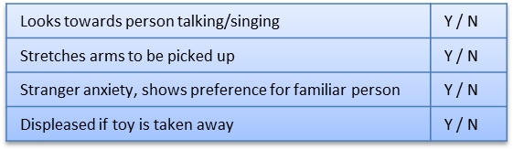
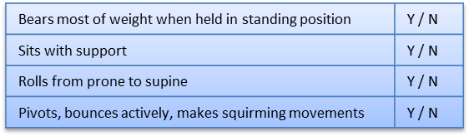
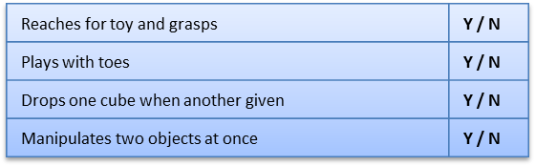
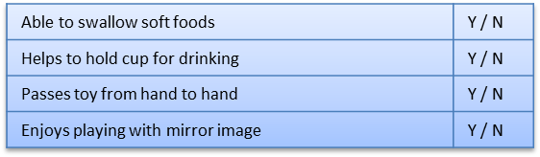
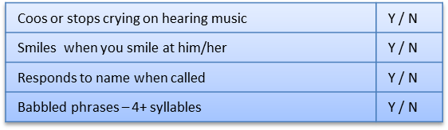
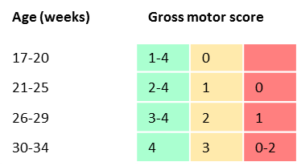
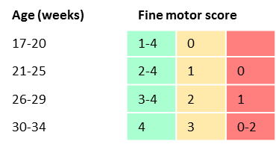
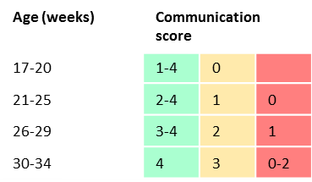
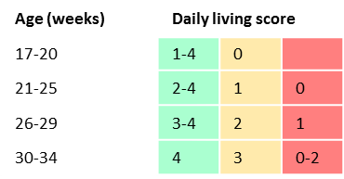
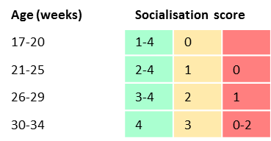
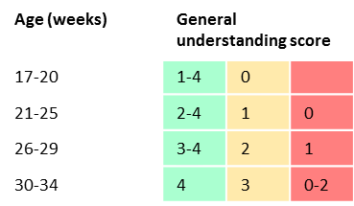
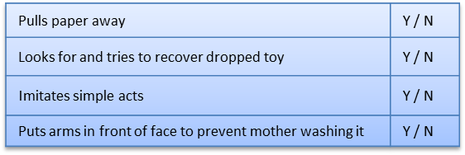
Total
0/4
Supplementary Figure 1: Example of a completed BDA with scoring – this child scored red on 4 domains, suggesting probable developmental abnormality in the areas of gross motor development, daily living, communication and general understanding; amber on one domain suggesting a possible developmental abnormality in the area of fine motor development and green in the domain of socialisation, suggesting that there are no likely concerns in this area of development
Insert Patient sticker here
1. Gross motor skills (score 0-4) Achieved
Developmental Screen – 17-34 weeks (score Y=1; N=0)
2. Fine motor skills (score 0-4) Achieved

3. Daily living skills (score 0-4) Achieved
4. Communication (score 0-4) Achieved
5. Socialisation (score 0-4) Achieved
6. General understanding (score 0-4) Achieved
Do the parents have any concerns about their child?
Movement, feeding, seems “slower” than other babies in the baby group Mum attends
Total
3/4
Total
2/4
Total
2/4
Total
4/4
Total
2/4
Copyright: Great Ormond Street Hospital for Children NHS Foundation Trust - 2013
Date of assessment:___01_/_06__/_2013____

Child’s age: …32. weeks
Child’s corrected age……weeks (if preterm)
Languages spoken at home English
Child’s primary language

