Supplementary Figure 1:
Example of a completed BDA with scoring – this child scored red on 4 domains, suggesting probable developmental abnormality in the areas of gross motor development, daily living, communication and general understanding; amber on one domain suggesting a possible developmental abnormality in the area of fine motor development and green in the domain of socialisation, suggesting that there are no likely concerns in this area of development.

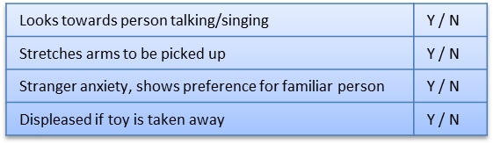
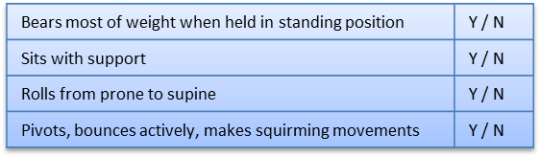
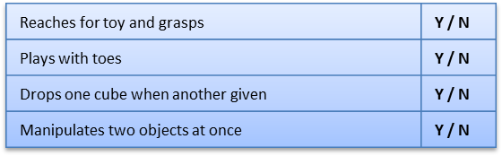
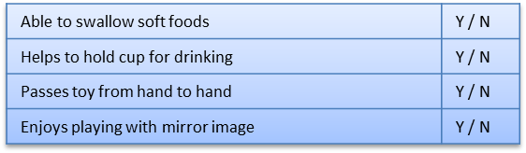
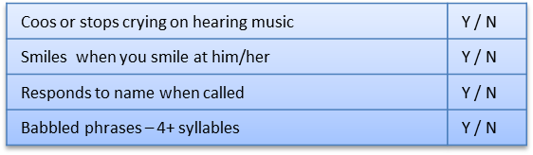
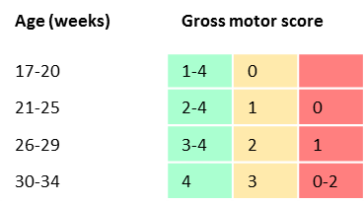
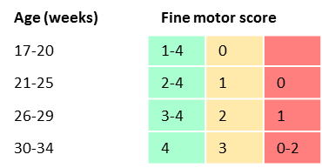
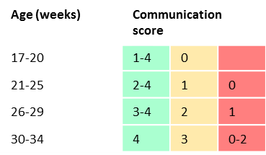
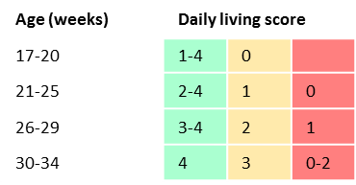
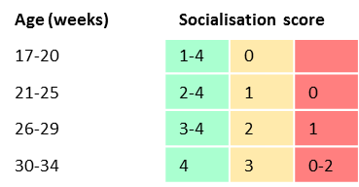
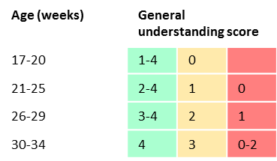
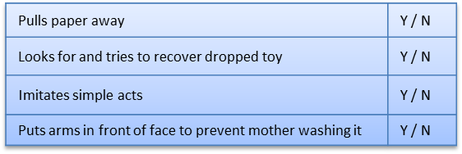
Total
0/4

Insert Patient sticker here
1. Gross motor skills (score 0-4) Achieved
Developmental Screen – 17-34 weeks (score Y=1; N=0)
2. Fine motor skills (score 0-4) Achieved

3. Daily living skills (score 0-4) Achieved
4. Communication (score 0-4) Achieved
5. Socialisation (score 0-4) Achieved
6. General understanding (score 0-4) Achieved
Do the parents have any concerns about their child?
Movement, feeding, seems “slower” than other babies in the baby group Mum attends
Total
3/4
Total
2/4
Total
2/4
Total
4/4
Total
2/4
Copyright: Great Ormond Street Hospital for Children NHS Foundation Trust - 2013
Date of assessment:___01_/_06__/_2013____

Child’s age: …32. weeks
Child’s corrected age……weeks (if preterm)
Languages spoken at home English
Child’s primary language

