Figure. Dendograms Representing the Three Cluster Structure
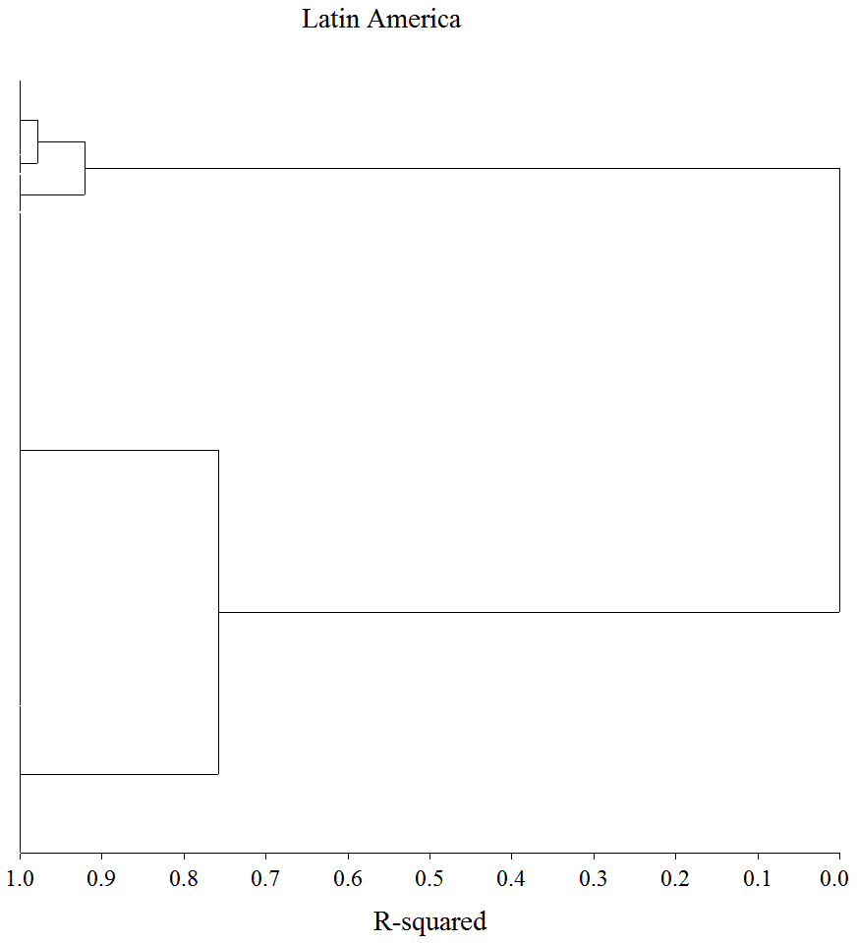  1  2  3 | 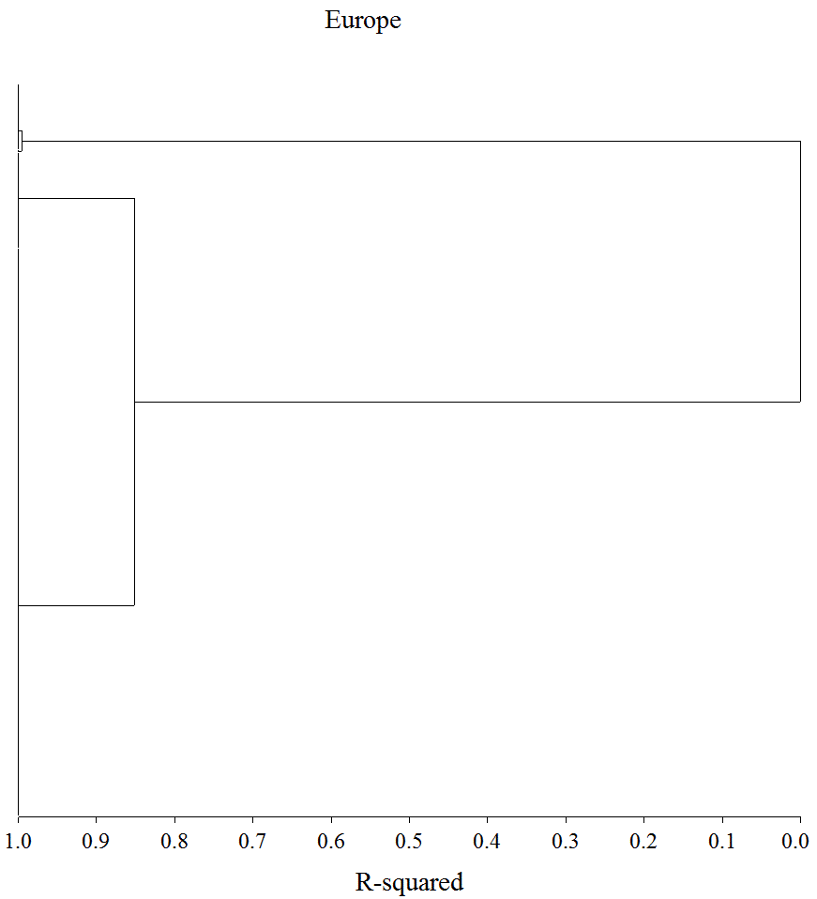  1  2  3
Note, 1 denotes Democracy; 2 denotes Anocracy; 3 denotes Dictatorship.

Contingency Table for the Freedom House and DCC Indices
Freedom House | DCC Index
 | Democracy | Anocracy | Dictatorship | Total
Democracy | 930 | 155 | 16 | 1101
Anocracy | 166 | 129 | 135 | 430
Dictatorship | 0 | 7 | 155 | 162
Total | 1096 | 291 | 306 | 1693

APPENDIX I
Classification of Latin American Countries (1980-2010)

Country | Cluster 1  Democracy | Cluster 2  Anocracy | Cluster 3  Dictatorship | Outliers
Argentina | 1983, 1985-6, 1988-9, 2000-2007, 2009-2010, | 1984, 1987, 2008 | 1980-82 | 1982
Belize | 1982-2010 | 1981
Bolivia | 1982-3, 1996-2004, 2006-7, 2009-10 | 1984-1995, 2005, 2008 | 1980-1
Brazil | 1985, 1988-9, 1991, 1993-2007, 2009-10 | 1980, 1990, 1992, 2008 | 1982-3, 1984, 1986-7 | 1982-3, 1986-7
Chile | 1991-1997, 1999-2002, 2004-10 | 1989-1990, 1998, 2003 | 1980-88 | 1989
Colombia | 1982-3, 1985-6, 1988-9, 1991-7, 1999, 2001-6, 2009-10 | 1980-1, 1984, 1987, 1990, 1998, 2000, 2007-8
Costa Rica | 1980, 1982-3, 1985-6, 1988-9, 1991-2010 | 1981, 1984, 1987, 1990
Dominican Republic | 1980-93, 1995-8, 2000-10 | 1994, 1999
Ecuador | 1980, 1982-89, 1991-2, 1994-8, 2002-2008 | 1981, 1990, 1993, 1999, 2009-10 | 2000-1 | 2000
El Salvador | 1985-6, 1989, 1992-8, 2000, 2002-10 | 1984, 1987-8, 1990-1, 1999, 2001 | 1980-3
Guatemala | 1988-9, 1991-2007, 2009-10 | 1980-1, 1986-7, 1990, 2008 | 1982-5 | 1980-1, 1986-7, 1993-5
Guyana |  | 2009-10 | 1980-2008 | 1986, 1992, 1995, 1999, 2006-8
Haiti |  | 2009 | 1980-2008, 2010 | 1990, 1994-8, 2000-8, 2010
Honduras | 1983, 1985-7, 1990-2007 | 1982, 1984, 1988-9, 2008-10 | 1980-1 | 1981
Jamaica | 1980-96, 1998-2001 | 1997, 2002-10 |  | 1985, 1987-8, 2008
Mexico | 2000-2, 2004 | 2003, 2005-10 | 1980-99 | 1982, 1986, 1989, 1994
Nicaragua | 1991, 1994-2007 | 1984-1990, 1992-3, 2008-10 | 1980-3 | 1984-9, 2008-10
Panama | 1990-2009 | 1989, 2010 | 1980-88 | 1989
Paraguay | 1991, 1994-2005, 2009-10 | 1989-90, 1992-3, 2006-8 | 1980-88 | 1989-91
Peru | 1982-3, 1985-6, 1988-9, 2001-8 | 1980-1, 1984, 1987, 2009-10 | 1990-2000 | 1990-5, 1997-9
Suriname | 1992, 1995, 2002, 2004, 2009-10 | 1988-9, 1991, 1993-4, 1996-2001, 2003, 2005-8 | 1980-7, 1990 | 1982
Trinidad & Tobago | 1980-90, 1992-2007, 2010 | 1991, 2008-9
Uruguay | 1986, 1989, 1991-6, 1998-2010 | 1985, 1987-8, 1990, 1997 | 1980-4 | 1984, 1987, 1990, 1997
Venezuela | 1980-8, 1990-2, 1996, 1998-9, 2001-2, 2006 | 1989, 1993-5, 1997, 2000, 2003-5, 2007-8 | 2009-10 | 2009-10

APPENDIX II
Classification of European Countries (1980-2010)

Country | Cluster 1  Democracy | Cluster 2  Anocracy | Cluster 3  Dictatorship | Outliers
Albania | 1994-5, 1998-9, 2001-4 | 1991-3, 1996-7, 2000, 2005-10 | 1980-90 | 1990-1, 1993, 1996, 2000
Austria | 1980-2, 1984-8, 1990-2010 | 1983, 1989
Belarus |  |  | 1996-2003, 2005-6, 2008-10 | 1992-2010
Belgium | 1980-2010
Bosnia-Herzegovina |  | 2009-10 | 1992-2008 | 1996-2009
Bulgaria | 1991-2, 1997, 1999, 2001-6 | 1990, 1993-6, 1998, 2000, 2007-10 | 1980-9
Croatia | 2001-2, 2004, 2007-9 | 1991-2000, 2003, 2005-6, 2010 |  | 1991-8
Czech Republic | 1993-2010
Czechoslovakia | 1990-2 | 1989 | 1980-8 | 1989
Denmark | 1980-2010
Estonia | 1992-2010 | 1991 |  | 1991
Finland | 1980-2010
France | 1980-2007, 2009-10 | 2008
FRG | 1980-1989
GDR |  |  | 1980-9 | 1989
Germany | 1990-2010
Greece | 1980, 1982-3, 1985-6, 1989, 1991-3, 1996-2005, 2010 | 1981, 1984, 1987-8, 1990, 1994-5, 2006-9
Hungary | 1990-2010 |  | 1980-9 | 1987-9
Ireland | 1980-2010
Italy | 1981-2008, 2010 | 1980, 2009
Latvia | 1992-2007, 2009 | 1991, 2008, 2010 |  | 1991, 2008
Lithuania | 1992-2010 | 1991 |  | 1991
Macedonia | 1993-2004, 2006 | 1991-2, 2005, 2007-10 |  | 2008
Moldova | 1992, 1998, 2000 | 1991, 1993, 1994-7, 1999, 2001-10 |  | 1991-3, 2008-9
Netherlands | 1980-2010
Norway | 1980-2010
Poland | 1990-2008, 2010 | 1989, 2009 | 1980-8 | 1980-3, 1985-6, 1989-90
Portugal | 1980, 1983, 1985-6, 1988-9, 1991-2009 | 1981-2, 1984, 1987, 1990, 2010
Romania | 1991, 1993, 1996, 1998-9, 2001-3 | 1990, 1992, 1994-5, 1997, 2000, 2004-10 | 1980-9 | 1985-6, 1990-1, 1993, 2008
Russia |  | 2010 | 1992-2009 | 1992-2010
Slovakia | 1993, 1998-9, 2001-7, | 1994-7, 2000, 2008-10 |  | 2008
Slovenia | 1992-9, 2001-7, 2009-10 | 1991, 2000, 2008

APPENDIX II—continued

Country | Cluster 1  Democracy | Cluster 2  Anocracy | Cluster 3  Dictatorship | Outliers
Spain | 1980, 1982-3, 1985-6, 1988-9, 1991-2010 | 1981, 1984, 1987, 1990
Sweden | 1980-2010
Switzerland | 1980-2010
Ukraine |  | 1991-2010 |  | 1991-3, 1995
United Kingdom | 1980-2010
USSR |  |  | 1980-91 | 1990-1
Yugoslavia |  |  | 1980-1990 | 1980-7, 1989-90

Federal Republic of Germany
German Democratic Republic

