Supplemental Text A
Thin Section Petrography

VOLCANIC GLASS A

This fabric description is adapted from Howie (2005, 2012) to reflect the variation present in the Baking Pot sample.

Samples: Micrite Present (n=23): 96, 97, 101, 102, 104, 105, 106, 109, 115, 116, 122, 131, 134, 138, 139, 140, 141, 142, 144, 145, 156, 161, 180; Micrite absent from margins (n=3) 112, 114, 148; Micrite completely absent: 100, 119, 120, 121, 123, 124, 125, 127, 128, 129, 130, 136, 143, 149, 150, 152 (n=16)

I. Microstructure
(a) Voids: Few to very few voids - predominantly mesovughs, with fewer mesovesicles.
(b) c/f related distribution: A closed-spaced to single-spaced, porphyric related distribution.
(c) Preferred orientation: A weakly developed preferred orientation of voids and inclusions
parallel to the vessel margins.

II. Groundmass
(a) Homogeneity: Homogenous across the group with respect to the distribution of voids and
inclusions. There is variation in the group with respect to: presence of micrite, uneven distribution of micrite lumps and tuff, distribution of volcanic glass fragments in a few samples (areas containing fewer inclusions), optical activity, and the color of the micromass. Not all samples contain biotite, chert/chalcedony, zircon, and soil features.
(b) Micromass: Slightly optically active with granostriated b-fabric. There are patches of optically inactive micromass throughout the fabric, but the patches are not isolated to a single location. Optically activity varies within a single sample and between samples. All samples have areas of optical inactivity, but the location varies from near the margins, to the interior, to randomly dispersed throughout the fabric. Color: PPL(x40) = greyish brown to brown to dark brown; XPL(x40) = yellowish brown to reddish brown. Some have lighter colored cores or margins.
(c) Inclusions: The size distribution of inclusions is unimodal with an upper size class (>0.0625mm) composed of dominant volcanic glass and tuff, common to few monocrystalline quartz, common to rare lumps of micrite (some with volcanic glass inclusions), very few plagioclase feldspar, very few to rare biotite, and rare to very rare chert/chalcedony. The lower size class (<0.0625mm) is composed of frequent volcanic glass, common to very few quartz, few to rare biotite, and very few plagioclase feldspar. Quartz and feldspar occur as equant to elongated, rounded inclusions and equant to elongated, subangular to angular inclusions. Biotite is lath-like and angular. The largest inclusion is 1.6mm (micrite) and 98% of the inclusions range in size from 0.0625mm (silt) to 1.3mm (coarse sand). The fabric is moderately to well-sorted.

c:f:v _{10µ} : 35: 60: 5

Coarse Inclusions (>0.062 mm)

Dominant (50-70%): VOLCANIC GLASS AND TUFF-The glass fragments are very angular to angular and predominantly display characteristic shapes associated with volcanic ash (sickle, lunate and lath-like). Equant fragments are rare. The tuff fragments are angular to rounded, equant to elongated and contain vacuoles and very angular, lath-like inclusions of quartz, biotite and feldspar. Glass fragments size = 0.062mm (silt) to 0.4mm (medium sand); mode size = 0.16mm (fine sand). Tuff fragments size = 0.1mm (very fine sand) to 1.5 (coarse sand); mode size = 0.24mm (fine sand).

Common (15-30%) to Few (5-15%): MONOCRYSTALLINE QUARTZ- Very angular to subrounded, predominantly equant with few elongated grains. Size = 0.062mm (silt) to 0.26mm (medium sand); mode size = 0.07mm (very fine sand).

Common (15-30%) to Rare (0.5-2%): LUMPS OF MICRITE- Subangular to rounded, predominantly subrounded to rounded, equant to elongated. Micrite lumps commonly contain volcanic glass fragments, crystalline calcite, and rarely feldspar. Size = 0.062mm (silt) to 1.6mm (very coarse sand); mode size = 0.35mm (medium sand).

Very Few (2-5%): PLAGIOCLASE FELDSPAR- Very angular to subrounded, predominantly equant with few elongated grains. Size = 0.062mm (silt) to 0.2mm (fine sand); mode size = 0.1mm (very fine sand). 102 has Few (5-15%) plagioclase feldspar.

Very Few (2-5%) to Rare (0.5-2%): BIOTITE

Rare (0.5-2%) to Very Rare (< 0.5%): CHERT/CHALCEDONY

Fine Inclusions (< 0.062 mm)

Frequent: VOLCANIC GLASS
Common (15-30%) to Very Few (2-5%): QUARTZ
Few (5-15%) to Rare (0.5%-2%): BIOTITE
Very Few (2-5%): PLAGIOCLASE FELDSPAR

III. Textural Concentration Features (Tcf)

Clay pellets - Very few to very rare (>5% of field of view) – Clay pellets are dark brown in PPL (x40) and greyish brown to slightly reddish-brown in XPL (x40). They occasionally contain inclusions of quartz, biotite, micrite and calcite (> 0.14mm). Boundaries are sharp to merging and rounded to well rounded. They are predominantly equant and, rarely, slightly distorted and
have a high optical density. The internal preferred orientation of the pellets is discordant with
surrounding orientation features. Size = 0.16mm (fine sand) to 2.25mm (granule).

IV. Amorphous Concentration Features
Rare iron-rich nodules (> 5% of field of view)- These are orangish-brown in PPL (x40) and rusty-brown in XPL (x40). They are equant, well rounded to subrounded, have a high optical density and sharp boundaries. They are commonly partly surrounded by a channel void. Size = 0.05mm (silt) to 0.15mm (fine sand).

COMMENTS

Paste Technology- These fabrics are characterized by dominant fragments of volcanic glass and tuff, occurring together with inclusions of quartz and a small amount of biotite and feldspar, in a micritic clay matrix containing lumps of micrite. The uneven distribution of the volcanic glass and tuff fragments in some samples provides some evidence that the ash and tuff represent added constituents. The distinguishing characteristic of this fabrics group, apart from the presence of the volcanic glass and tuff fragments, is the common micrite inclusions.

Provenance- The micritic clay suggests a provenance connected to limestone geology. Jordan argues that the Volcanic Ash A fabric group was produced locally in the Belize River Valley. This fabric is the same as Volcanic Ash A (Howie 2005, 2012) and Sunahara’s (2003) Volcanic Ash 1 Petrofabric. Howie suggested that the fabric was produced outside of northern Belize, possibly in the central Peten. Sunahara argued that the fabric was produced in the Guatemala Highlands and whole vessels were imported in the Belize Valley.

Subgroup A-Abundant Quartz Subgroup

Samples: 118, 126 (n=2)

This subgroup is the same as Howie’s (2005, 2012) Volcanic Glass A-mineralogical variant. This subgroup is the same as the Volcanic A fabric group in all respects except there is Frequent to Common (15-30%) monocrystalline and polycrystalline quartz in the course and fine fraction.

Subgroup B-Frayed Biotite Subgroup

Samples: 45, 99, 110, 113, 117, 147, 151, 160 (n=8)

Frequent (30-50%) to Rare (0.5-2%): BIOTITE- Subangular to rounded, frayed laths, many of which exhibit splitting along cleavage planes indicating a sedimentary origin. Size = 0.16mm (fine sand) to 0.4mm (medium sand); mode size = 0.24mm (medium sand).

Sample 117 very similar to the Volcanic Ash-tempered Subgroup B fabric group described by Ting (2013: 399-399). All the samples likely belong to Ting’s previously established Subgroup except they are missing carbonate. The Baking Pot samples were assigned to Subgroup B to maintain consistency between petrographic datasets. The primary distinguishing attribute for this subgroup is the presence of common large, frayed biotite inclusions. The frayed biotite suggests that these inclusions were naturally occurring in the clay. They differ from the thin, lath-like biotite present in the Volcanic Glass A fabric group. The presence of biotite in the clay is indicative of a different provenance. Like other fabrics in the larger Volcanic Glass A fabric group, this subgroup contains samples with carbonate, without carbonate, and with missing carbonate in the margins. Sample 117 very similar to the Volcanic Ash-tempered Subgroup B fabric group described by Ting (2013: 399-399). Sample 117 has a slightly optically active to optically inactive, brown fabric with no calcium carbonate. The rest of the sample contain varying amounts of micrite from isolated micrite lumps to micritic clay throughout. These samples were all placed within this subgroup because they contain large, frayed biotite absent in other samples.

Subgroup C-Carbonate Sand Subgroup

Common (15-30%) Carbonate Sand: 111, 153, 158, 107, 154, 157, 159 (n=7)

Very Few (2-5%) to Rare (0.5-2%) Less Carbonate Sand: 103, 133, 155, 179, 183 (n=5)

Common (15-30%) to Very Few (2-5%): CARBONATE SAND. Rounded, equant. Size = 0.0625mm (silt) to 0.15mm (fine sand) with a mode size of 0.1mm (fine sand).

The primary distinguishing attribute for this subgroup is the presence of carbonate sand. These fabrics are identical in all respects to Volcanic Glass A except they contain carbonate sand in varying amounts. Samples 107, 154, 157, and 159 also contain more abundant naturally occurring quartz and feldspar inclusions than the other samples in the subgroup. All the samples with abundant carbonate sand (Subgroup C1) are polychrome vessels. All the samples with more abundant quartz and feldspar are polychrome vessels. These data suggest that the carbonate sand subgroup represents differences in both provenance and production group.

Subgroup D-Sparry Calcite Subgroup

Samples: 98, 108, 132, 188 (n=4)

Very Rare (< 0.5): SPARRY CALCITE-Fine to medium crystalline mosaics, subangular to rounded, equant. Size = 0.3mm (medium sand) to 1.15mm (very coarse sand).

These samples were assigned to a subgroup (rather than placed in the main group) because they are consistent with Sunahara’s Volcanic Ash 2 Petrofabric. The primary distinguishing attribute for this subgroup is the presence of finely to medium crystalline sparry calcite. These fabrics are identical in all respects to Volcanic Glass A except they contain very rare sparry calcite inclusions. There are only 1-2 sparry calcite inclusions in each sample.

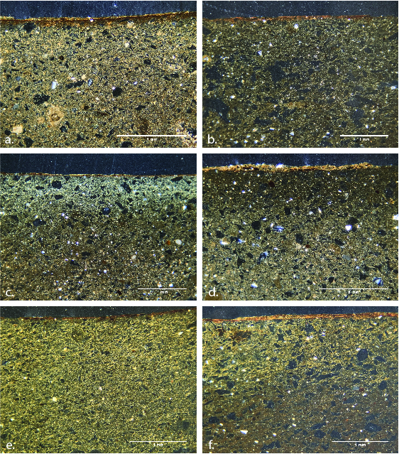

Figure A1. Volcanic Glass A Micrographs (XPL): a. 102, b. 128, c. 114, d. 97, e. 143, f. 125

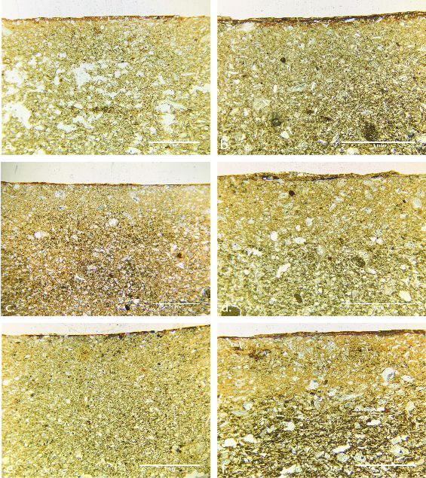

Figure A2. Volcanic Glass A Micrographs (PPL): a. 102, b. 128, c. 114, d. 97, e. 143, f. 125

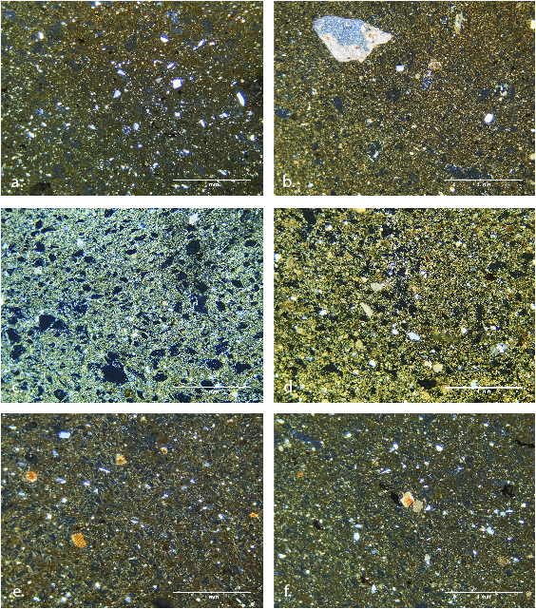

Figure A3. Volcanic Glass A Subgroup Micrographs (XPL): a. 126, b. 108, c. 133, d. 154, e. 117, f. 147

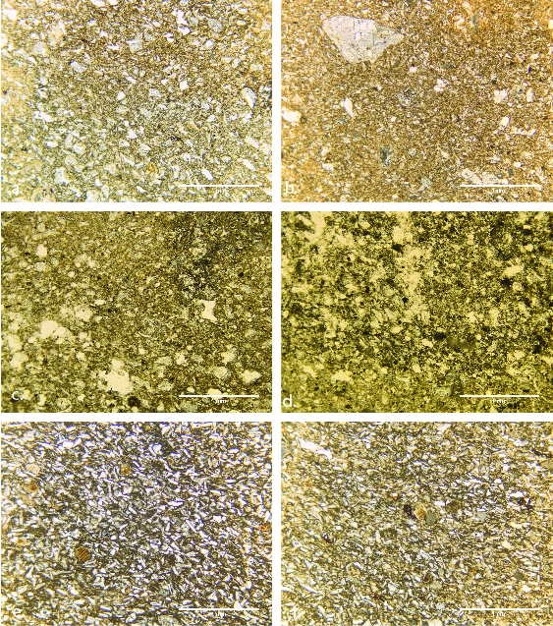

Figure A4. Volcanic Glass A Subgroup Micrographs (PPL): a. 126, b. 108, c. 133, d. 154, e. 117, f. 147.

ID | MURR ID | Lot | Mound | Unit | Level
96 | JOR010 | 1696-1 | 11A | 28 | 5
156 | JOR011 | 1699-4 | 111A | 28 | 7
148 | JOR012 | 1920-3 | 101 | 3 | 1
112 | JOR013 | 3093-4 | 91 | 91-18 | 2
122 | JOR014 | 1670-2 | 100 | 18A | 1
142 | JOR015 | 1911-7 | 101 | 101 Ext 3 | 1
134 | JOR016 | 1907-1 | 101 | 101 Ext 1 | 1
116 | JOR017 | 1656-1 | 100 | 17 | 1
101 | JOR018 | 1462-1 | 91 | 17 | 2
139 | JOR019 | 1911-4 | 101 | 101 Ext 3 | 1
131 | JOR022 | 1962-1 | 100 | 100 Ext 2 | 1
138 | JOR025 | 1911-3 | 101 | 101 Ext 3 | 1
140 | JOR026 | 1911-5 | 101 | 101 Ext 3 | 1
115 | JOR027 | 3093-7 | 91 | 91-18 | 2
144 | JOR028 | 1911-9 | 101 | 101 Ext 3 | 1
161 | JOR029 | 1156-1 | 207 | 7 | 5
97 | JOR030 | 1697-1 | 11A | 28 | 6
141 | JOR031 | 1911-6 | 101 | 101 Ext 3 | 1
109 | JOR032 | 3093-1 | 91 | 91-18 | 2
102 | JOR034 | 1464-1 | 91 | 17 | 2 Ext. B
180 | JOR035 | 1397-3 | 184-A | 10 | 3
114 | JOR038 | 3093-6 | 91 | 91-18 | 2
106 | JOR045 | 1522-2 | 91 | 20 | 1
104 | JOR046 | 1464-3 | 91 | 17 | 2 Ext. B
119 | JOR048 | 1657-1 | 100 | 22 | 1
125 | JOR049 | 1767-2 | 100 | 21 | 1
100 | JOR050 | 2097-1 | 90 | 90-1E | 1
128 | JOR051 | 1778-2 | 100 | 24A | 1
130 | JOR052 | 1913-2 | 100 | 12A | 2
150 | JOR053 | 2005-1 | 109 | 3 | 1
120 | JOR054 | 1663-1 | 100 | 12A | 1
136 | JOR055 | 1911-1 | 101 | 101 Ext 3 | 1
152 | JOR057 | 1887-1 | 111 | 111-22 | 3
124 | JOR058 | 1767-1 | 100 | 21 | 1
149 | JOR059 | 1920-4 | 101 | 3 | 1
121 | JOR060 | 1670-1 | 100 | 18A | 1
127 | JOR061 | 1778-1 | 100 | 24A | 1
129 | JOR062 | 1913-1 | 100 | 12A | 2
143 | JOR063 | 1911-8 | 101 | 101 Ext 3 | 1
123 | JOR064 | 1670-3 | 100 | 18A | 1
145 | JOR067 | 1911-10 | 101 | 101 Ext 3 | 1
118 | JOR065 | 1656-3 | 100 | 17 | 1
126 | JOR066 | 1773-1 | 100 | 21A | 1
98 | JOR024 | 2081-1 | 90 | 90-1 | 1
108 | JOR039 | 1523-1 | 91 | 22 | 1
132 | JOR023 | 1962-2 | 100 | 100 Ext 2 | 1
188 | JOR020 | 1584-1 | 184-A | 21 Ext A | 6B
154 | JOR002 | 1699-2 | 111A | 28 | 7
111 | JOR003 | 3093-3 | 91 | 91-18 | 2
159 | JOR004 | 1398-3 | 181 | 11 | 5
157 | JOR005 | 1398-1 | 181 | 11 | 5
107 | JOR006 | 1522-3 | 91 | 20 | 1
158 | JOR007 | 1398-2 | 181 | 11 | 5
153 | JOR008 | 1699-1 | 111A | 28 | 7
103 | JOR009 | 1464-2 | 91 | 17 | 2 Ext. B
133 | JOR001 | 1547-1 | 101 | 16 Ext G | 4
155 | JOR068 | 1699-3 | 111A | 28 | 7
179 | JOR033 | 1397-2 | 184-A | 10 | 3
183 | JOR047 | 1520-1 | 184-A | 21 Ext A | 4
45 | JOR021 | 1461-1 | 91 | 17 | 1
113 | JOR036 | 3093-5 | 91 | 91-18 | 2
110 | JOR037 | 3093-2 | 91 | 91-18 | 2
117 | JOR040 | 1656-2 | 100 | 17 | 1
147 | JOR041 | 1920-2 | 101 | 3 | 1
99 | JOR042 | 2081-2 | 90 | 90-1 | 1
160 | JOR043 | 1134-1 | 207 | 7 | 1
105 | JOR044 | 1522-1 | 91 | 20 | 1
151 | JOR056 | 1886-1 | 111 | 111-22 | 2

Table A.1. Provenience Information for Ceramic Samples

Sample | Location | Crystalline Calcite | Sparite | Micrite | Quartz | Chert | Chalcedony | Muscovite | Biotite | Poly. Quartz | Quartzite | Perthite | Feldspar | Zircon
1 | Belize River Floodplain | Rare | V. Rare | Freq. | Dom. | Freq. | Rare | Common | Rare | Rare | Rare | V. Rare | V. Rare | V. Rare
2 | Belize River Floodplain |  |  |  | Dom. | Freq. | Few | Common | Rare | Rare | Rare | Rare | Few | V. Rare
6 | Garbutt Creek | Few |  | Dom. | Few | Few | V. Few | V. Rare | V. Rare | V. Few | V. Few | V. Rare | V. Rare | V. Rare
7 | Drainage at Baking Pot |  |  |  | Dom. | Rare | Rare | Few |  | V. Rare | Rare | V. Rare | V. Rare
8 | Drainage at Baking Pot |  |  |  | Dom. | V. Few | V. Few | Few |  | V. Few | V. Few |  | Rare | V. Rare
9 | Aguada at Baking Pot |  |  |  | Dom. | Rare | Rare | Few |  | Rare | Rare | V. Few | V. Rare | V. Rare
10 | Macal River | V. Rare |  | Few | Dom. | Few | V. Few | Common | Few | Rare | Common | Few | Few | V. Rare
11 | Belize River Floodplain |  |  | V. Few | Dom. | V. Few | Rare | Common |  |  | Few | V. Rare | V. Rare | V. Rare
13 | Red Creek | V. Rare |  | V. Few | Pred. | V. Rare | V. Rare | V. Few | V. Rare | Few | V. Rare | V. Few | V. Rare | Rare
14 | Drainage at Cahal Pech | Rare | Rare | Dom. | V. Few | Rare | Rare | V. Rare |  | Rare |  | V. Rare
15 | Belize River Floodplain | Rare |  | Few | Freq. | Few | Few | Dom. | V. Few | V. Rare | Few | V. Rare | V. Rare | V. Rare
16 | Drainage at Cahal Pech | Rare | V. Rare | Common | Rare | V. Rare | V. Rare | V. Rare |  |  |  | V. Rare |  | V. Rare
17 | Mopan River | V. Rare |  | V. Rare | Few | Rare | V. Rare | Rare | V. Few |  |  |  | V. Rare | V. Rare
22 | Barton Creek | V. Rare |  |  | Pred. | V. Rare |  | Few | Rare | Few | Few | Few | Few | V. Rare
23 | Belize River Floodplain |  |  |  | Dom. | Rare | Rare | Common | V. Rare | V. Rare |  | V. Rare | V. Rare | V. Rare
24 | Belize River Floodplain | V. Rare | V. Rare | Common | Dom. | V. Few | V. Few | Common | Rare | V. Few |  | V. Rare | Rare | V. Rare
25 | Belize River Floodplain |  |  |  | Freq. | Rare | Rare | Common | V. Few

Table A.2. Summary of Petrographic Data of the Clay Samples

ANID | BKP ID | Ceramic Type | Sherd Type | Rim Diameter | Type of Vessel | Vessel Form | Rim Form | Lip Form | Slip Color | Paste Color
 | With Carbonate
JOR010 | 96 | Belize Red | Rim | 30 | Dish | Flared sides | Direct | Squared | 10R-5/8 | 10YR-6/6
JOR030 | 97 | Belize Red | Rim | 42 | Dish | Flared sides | Direct | Rounded | 2.5YR-5/8 | 10YR-7/4
JOR018 | 101 | Belize Red | Rim | -- | Dish | Flared sides | Direct | Rounded | 10R-4/6 | 10YR-7/4
JOR034 | 102 | Belize Red | Rim | 18 | Bowl | Incurved sides | Direct | Rounded | 2.5YR-4/6 | 10YR-7/6
JOR046 | 104 | Belize Red | Rim | 38 | Dish | Flared sides | Direct | Rounded | 2.5YR-5/8 | 10YR-6/6
JOR044 | 105 | Platon Punctated-Incised | Body | -- | Body | -- | -- | -- | 10YR-5/8 | 7.5YR-6/6
JOR045 | 106 | Belize Red | Base | -- | Flat | -- | -- | -- | 10R-4/8 | 7.5YR-6/6
JOR032 | 109 | Belize Red | Rim | 24 | Plate | Flared sides | Direct | Rounded | 2.5YR-5/6 | 10YR-6/6
JOR027 | 115 | Belize Red | Base | -- | Bowl/Dish | Ring | -- | -- | -- | 10YR-7/4
JOR017 | 116 | Belize Red | Rim | -- | Bowl | Slightly incurved sides | Direct | Rounded | 2.5YR-5/8 | 10YR-6/4
JOR014 | 122 | Belize Red | Rim | 22 | Bowl | Flared sides | Direct | Rounded | 2.5YR-4/6 | 10YR-7/4
JOR022 | 131 | Platon Punctated-Incised | Base | 18 | Flat Base | -- | -- | -- | 10R-5/6 | 10YR-6/6
JOR016 | 134 | Belize Red | Rim | 28 | Bowl | Slightly incurved sides | Direct | Rounded | 10R-4/6 | 10YR-6/6
JOR025 | 138 | Belize Red | Rim | 18 | Jar | Outcurved Neck | Direct | Rounded | 10R-4/6 | 10YR-6/4
JOR019 | 139 | Belize Red | Rim | -- | Dish | Flared sides | Direct | Rounded | 10R-5/6 | 10YR-6/6
JOR026 | 140 | Belize Red | Base | -- | Bowl/Dish | Ring | -- | -- | -- | 10YR-7/4
JOR031 | 141 | Belize Red | Rim | 42 | Bowl | Slightly incurved sides | Direct | Interior Thickened | 2.5YR-5/6 | 10YR-7/4
JOR015 | 142 | Platon Punctated-Incised | Rim | 28 | Dish | Flared sides | Direct | Rounded | 2.5YR-4/6 | 10YR-6/6
JOR028 | 144 | Belize Red | Rim | -- | Bowl | Slightly incurved sides | Direct | Rounded | 2.5YR-5/6 | 10YR-7/4
JOR067 | 145 | Platon Punctated-Incised | Rim | -- | Bowl | Slightly incurved sides | Direct | Rounded | 2.5YR-5/6 | 10YR-7/3
JOR011 | 156 | Belize Red | Rim | 40+ | Dish | Incurved sides | Direct | Rounded | 2.5YR-4/8 | 10YR-7/4
JOR029 | 161 | Belize Red | Rim | 18 | Bowl | Flared sides | Direct | Rounded | 2.5YR-5/8 | 10YR-7/4
JOR035 | 180 | Belize Red | Rim | -- | Dish | Flared sides | Direct | Rounded | 2.5YR-4/6 | 10YR-6/4
 | Partial or Complete Missing Carbonate
JOR013 | 112 | Belize Red | Rim | -- | Dish | Flared sides | Direct | Rounded | 2.5YR-4/6 | 10YR-6/6
JOR038 | 114 | Belize Red | Rim | 28 | Dish | Flared sides | Direct | Rounded | 10R-4/8 | 10YR-7/4
JOR012 | 148 | Belize Red | Rim | -- | Bowl | Slightly incurved sides | Direct | Rounded | 2.5YR-4/8 | 10YR-6/6
JOR050 | 100 | Belize Red | Rim | 24 | Dish | Flared sides | Direct | Rounded | 2.5YR-4/6 | 10YR-7/4
JOR048 | 119 | Belize Red | Rim | 36 | Dish | Incurved sides | Direct | Beveled In | 2.5YR-4/6 | 10YR-6/4
JOR054 | 120 | Platon Punctated-Incised | Rim | -- | Dish | Flared sides | Direct | Rounded | 2.5YR-5/8 | 10YR-7/4
JOR060 | 121 | Belize Red | Rim | 40 | Dish | Flared sides | Direct | Rounded | 2.5YR-4/8 | 10YR-6/6
JOR064 | 123 | Belize Red | Rim | -- | Dish | Outcuved sides | Direct | Rounded | 2.5YR-5/8 | 10YR-7/4
JOR058 | 124 | Belize Red | Rim | 22 | Bowl | Slightly incurved sides | Direct | Rounded | 2.5YR-5/8 | 10YR-6/6
JOR049 | 125 | Belize Red | Rim | 30+ | Dish | Flared sides | Direct | Rounded | 2.5YR-4/8 | 7.5YR-6/6
JOR061 | 127 | Platon Punctated-Incised | Rim | -- | Dish | Flared sides | Direct | Rounded | 10R-4/6 | 10YR-6/6
JOR051 | 128 | Belize Red | Rim | 34 | Dish | Flared sides | Direct | Rounded | 10R-4/6 | 10YR-6/6
JOR062 | 129 | Belize Red | Rim | -- | Dish | Flared sides | Direct | Rounded | 10R-4/8 | 10YR-6/6
JOR052 | 130 | Belize Red | Rim | 36 | Dish | Flared sides | Direct | Rounded | 10R-4/8 | 10YR-7/4
JOR055 | 136 | McRae Impressed | Flange | -- | Bowl/Dish | -- | -- | -- | -- | 10YR-6/6
JOR063 | 143 | Belize Red | Rim | 32 | Dish | Flared sides | Direct | Beveled In | 10R-4/8 | 10YR-6/6
JOR059 | 149 | Belize Red | Rim | -- | Dish | Slightly incurved sides | Direct | Rounded | 5YR-5/6 | 10YR-6/6
JOR053 | 150 | McRae Impressed | Rim | -- | Dish | Flared sides | Direct | Rounded | 2.5YR-5/6 | 10YR-6/6
JOR057 | 152 | Platon Punctated-Incised | Rim | -- | Dish | Flared sides | Direct | Rounded | 2.5YR-4/6 | 10YR-6/4
 | Subgroup A
JOR065 | 118 | Benque Viejo Polychrome | Body | -- | Bowl/Dish | -- | -- | -- | 2.5YR-6/6 | 10YR-6/6
JOR066 | 126 | Belize Red | Rim | 30 | Dish | Flared sides | Direct | Rounded | 2.5YR-5/8 | 10YR-6/3
 | Subgroup B
JOR021 | 45 | Belize Red | Rim | -- | Bowl | Slightly incurved sides | Direct | Rounded | 2.5YR-5/6 | 10YR-6/4
JOR036 | 113 | Belize Red | Rim | 24 | Dish/Bowl | Flared sides | Direct | Rounded | 5YR-5/6 | 10YR-7/4
JOR037 | 110 | Platon Punctated-Incised | Rim | 20 | Bowl | Slightly incurved sides | Direct | Rounded | 5YR-5/6 | 10YR-7/4
JOR040 | 117 | Platon Punctated-Incised | Rim | 30 | Bowl | Slightly incurved sides | Direct | Rounded | 10YR-6/6 | 10YR-6/3
JOR041 | 147 | Belize Red | Rim | 30 | Bowl | Slightly incurved sides | Direct | Rounded | 5YR-5/6 | 10YR-6/4
JOR042 | 99 | McRae Impressed | Base | -- | Dish? | Notched Apron | -- | -- | 10YR-5/6 | 10YR-6/4
JOR043 | 160 | McRae Impressed | Base | -- | Dish | Notched Apron | -- | -- | 10YR-5/8 | 10YR-6/6
JOR056 | 151 | Belize Red | Rim | 40+ | Dish | Flared sides | Direct | Rounded | 10YR-6/6 | 10YR-6/4
 | Subgroup C
JOR002 | 154 | Xunantunich Black-on-Orange | Base | -- | Base | Flat Base with Solid Nubbin Feet |  |  | 2.5YR-6/6 | 10YR-7/4
JOR003 | 111 | Benque Viejo Polychrome? | Rim | 24 | Dish | Outcurved Sides | Direct | Rounded | 2.5YR-6/6; 2.5YR-4/6 | 10YR-7/4
JOR004 | 159 | Xunantunich Black-on-Orange | Body | -- | Dish? | Outcurved Sides | -- | -- | 2.5YR-6/6 | 10YR-6/4
JOR005 | 157 | Benque Viejo Polychrome | Base | -- | Vase? | Outcurved Sides | -- | -- | 2.5YR-6/6; 2.5YR-4/6 | 10YR-6/4
JOR006 | 107 | Benque Viejo Polychrome | Rim | 24 | Dish/Bowl | Outcurved Sides | Direct | Rounded | 2.5YR-6/6; 2.5YR-4/6 | 10YR-7/6
JOR007 | 158 | Benque Viejo Polychrome? | Rim | -- | Dish | Outcurved Sides | Direct | Rounded | 2.5YR-6/6; 2.5YR-4/6 | 10YR-6/4
JOR008 | 153 | Benque Viejo Polychrome | Rim | -- | Dish | Outcurved Sides | Direct | Rounded | 2.5YR-6/6; 2.5YR-4/6 | 10YR-7/4
JOR009 | 103 | Belize Red | Rim | -- | Bowl | Slightly incurved sides | Direct | Rounded | 10R-5/8 | 10YR-7/4
JOR001 | 133 | Platon Punctated-Incised | Base | -- | Notched Base | -- | -- | -- | 10R-5/8 | 10YR-6/4
JOR068 | 155 | Belize Red | Rim | -- | Dish | Incurved sides | Direct | Rounded | 2.5YR-4/6 | 10YR-6/3
JOR033 | 179 | Belize Red | Body | -- | Dish/Bowl | -- | -- | -- | 2.5YR-5/6 | 10YR-7/4
JOR047 | 183 | Belize Red | Body | -- | Dish/Bowl | -- | -- | -- | -- | 10YR-7/4
 | Subgroup D
JOR024 | 98 | Belize Red | Rim | 24 | Bowl/Dish | Incurved sides | Direct | Rounded | 2.5YR-4/8 | 10YR-6/4
JOR039 | 108 | Platon Punctated-Incised | Rim | 28 | Bowl | Flared sides | Direct | Rounded | 2.5YR-5/6 | 10YR-6/6
JOR023 | 132 | Platon Punctated-Incised | Rim | 26 | Dish | Flared sides | Direct | Rounded | 10R-5/8 | 10YR-7/4
JOR020 | 188 | Belize Red | Rim | 34 | Dish | Incurved sides | Direct | Rounded | 10R-4/3 | 10YR-6/4

Table A.3. Descriptive Data A

 | Micrite | Crystalline Calcite | Quartz | Feldspar | Biotite | Muscovite | Chalcedony/Chert | Amphibole | Grog | Other Volcanic Rocks | Calcareous Clay
Belize River Valley (Jordan et al. 2021)
General Description | ● | ● | ● | ● | ● |  |  |  |  |  | Yes
Belize River Valley (Sunahara 2003)
Volcanic Ash 1 | ● |  | ● | ● | ● |  |  |  |  |  | Yes
Volcanic Ash 2 | ● | ● | ● | ● | ● |  |  |  |  |  | Yes
El Pilar, Belize (Catlin 2008; Ford et al. 2014)
Sample 1902 | ● |  |  | ● |  |  |  |  |  |  | No Data
Sample 1478 | ● |  | ● | ● |  |  |  |  |  |  | No Data
Sample 4513 | ● |  | ● |  |  |  |  |  |  |  | No Data
Sample 9055B |  |  | ● |  |  |  |  |  |  |  | No Data
Sample 16579CE | ● |  | ● | ● |  |  |  |  |  |  | No Data
Sample 16579CF |  |  | ● | ● |  |  |  |  |  |  | No Data
Sample 16578F | ● |  | ● | ● | ● |  |  |  |  |  | No Data
Sample 16270B | ● |  | ● | ● |  |  |  |  |  |  | No Data
16386T | ● |  | ● | ● |  |  |  |  |  |  | No Data
16478 |  |  | ● |  | ● |  |  |  |  |  | No Data
16547B | ● |  | ● | ● |  |  |  |  |  |  | No Data
16548P | ● |  | ● | ● |  |  |  |  |  |  | No Data
16580C | ● |  | ● |  |  |  |  |  |  |  | No Data
16589E | ● |  | ● | ● |  |  |  |  |  |  | No Data
16552B | ● |  | ● | ● | ● |  |  |  |  |  | No Data
16556A | ● |  | ● |  |  |  |  |  |  |  | No Data
16535J | ● |  | ● | ● | ● |  |  |  |  |  | No Data
16535I |  |  | ● |  | ● |  |  |  |  |  | No Data
Rio Frio Cave, Belize (Jones 1984)
General Descriptions |  |  | ● | ● | ● |  |  |  |  |  | No Data
San Jose, Belize (Jones 1984)
General Desrcriptions |  |  | ● | ● | ● |  |  |  |  |  | No Data
San Jose, Belize (Shepard 1939)
General Descriptions | ● | ● | ● | ● | ● |  |  | ● |  | ● | Yes
Lamanai, Belize (Howie 2005, 2012)
Volcanic Glass A | ● | ● | ● | ● | ● |  |  |  |  |  | Yes
Volcanic Glass A Subgroup | ● | ● | ● | ● | ● |  | ● |  |  |  | Yes
Volcanic Glass B |  |  | ● | ● | ● | ● |  | ● |  | ● | No
Volcanic Glass C | ● |  | ● | ● | ● |  | ● |  |  |  | No
Volcanic Glass D |  |  | ● | ● | ● | ● |  |  |  | ● | No
Volcanic Glass E |  | ● | ● | ● | ● |  | ● |  |  |  | Yes
Central/Northern Belize (Ting 2013)
Subgroup A |  |  | ● | ● | ● |  |  |  |  |  | No
Subgroup B |  |  | ● |  | ● |  |  |  |  |  | No
Subgroup C |  |  | ● |  | ● |  |  |  |  |  | No
Lubaantun, Belize (Jones 1984)
General Descriptions |  |  | ● | ● | ● |  |  |  |  |  | No Data
Central Peten Lakes, Guatemala (Moriarty 2012)
Group 1 |  |  | ● | ● | ● |  |  |  |  |  | No Data
Group 2A |  |  | ● | ● | ● |  |  |  |  |  | No Data
Group 2B |  |  | ● | ● | ● |  |  |  |  |  | No Data
Group 2C |  |  | ● | ● | ● |  | ● |  |  |  | No Data
Group 2D |  |  | ● | ● | ● |  | ● |  |  |  | No Data
Group 3 |  |  | ● | ● | ● |  |  |  |  |  | No Data
Uaxactún, Guatemala (Miloš et al. 2015)
Group VA 1 (coarse) | ● |  | ● | ● | ● |  |  | ● |  |  | No Data
Group VA 2 (fine) | ● |  | ● | ● | ● |  |  | ● |  |  | No Data
Uaxactún, Guatemala (Jones 1984)
General Descriptions |  |  | ● | ● | ● |  |  | ● |  |  | No Data
Tikal, Guatemala (Jones 1984)
General Descriptions |  |  | ● | ● | ● |  |  | ● |  |  | No Data
Yaxuná, Yucatán, Mexico (Loya González and Stanton 2014)
General Descriptions | ● |  | ● | ● | ● |  |  |  | ● |  | No Data
Yaxuná, Yucatán, Mexico (Simmons and Brem 1979)
General Descriptions |  |  | ● | ● | ● |  |  | ●
Kiuic, Yucatán, Mexico (Gunn 2012)
General Descriptions |  |  | ● | ● | ● |  |  | ● |  |  | No Data
Chichen Itza, Dzibilchaltun, Xcambo, Yucatán, Mexico (Chung and Song 2014)
Group 1 |  |  | ● | ● | ● |  |  |  |  |  | No Data
Group 2 |  |  | ● | ● | ● |  |  |  |  |  | No Data
Yaxchilan, Bonampak, Las Margaritas, Chiapas, Mexico (Chung and Song 2014)
General Description |  |  | ● | ● | ● |  |  |  |  |  | No Data
Chinikihá, Chiapas, Mexico (Obando et al. 2011; Jiménez Álvarez 2015)
Grupo 2 |  |  | ● | ● | ● | ● |  |  |  |  | No Data

Table A.4 Comparative data for thin section petrography in the Belize Valley and neighboring regions. If the source did not specifically mention calcareous clay, we left it blank to be cautious.

Figure A.5. Soil Suite Map of the Belize Valley (after Wright et al. 1959) with the Location of Clay Samples. Melinda Suite soils form on alluvial parent material Chacalte/Yaxa Suite soils form on limestone parent material. (Map by C. E. Ebert)

Works Cited

Catlin, Brianne Lee
2008 The Source of Volcanic Ash in Late Classic Pottery from El Pilar, Belize. Master’s thesis, Department of Geology, University of California, Santa Barbara.

Chung, Haejoo and Youngson Song
2014 The Meaning of Volcanic Ash Characteristics Found in the Archaeological Pottery of Chichen Itza, Yucatan, Mexico. Mediterranean Archaeology and Archaeometry 14:155–167.

Ford, Anabel, Frank J. Spera, and Connie Christensen
2014 Petrography first: Issues of Identification and Sourcing Volcanic Ash Temper in Maya Pottery. In Integrative Approaches in Ceramic Petrography, edited by Mary F. Ownby, Isabelle C. Druc, and Maria A. Masucci, pp.8-23. University of Utah Press, Salt Lake City.

Gunn, Christopher Michael
2015 Exchange Mechanisms, Consumption, and Household Provisioning Strategies: Maya Economy and the Political Economy in the Kiuic Polity, Yucatán, México. PhD dissertation, Department of Anthropology, University of Kentucky, Lexington.

Howie, Linda
2005 Ceramic Production and Consumption in the Maya Lowlands During the Classic to Postclassic Transition: A Technological Study of Ceramics at Lamanai, Belize. PhD dissertation, Department of Anthropology, University of Sheffield, UK.
2012 Ceramic Change and the Maya Collapse: A Study of Pottery Technology, Manufacture, and Consumption at Lamanai, Belize. BAR International Series 2373. Archaeopress, Oxford.

Jiménez Alvarez, Socorro del Pilar
2015 Consumo, Producción, y Distribución Especializada de los Bienes Cerámicos Durante El Clásico Tardío de Chinikihá, Chiapas, México. Tesis de Doctorado. Instituto de Investigaciones Filológicas. Facultad de Filosofía y Letras. Universidad Nacional Autónoma de México.

Jones, Lea D.
1984 A Petrologic Analysis of Lowland Maya Ceramics. PhD dissertation, Department of Archaeology, University College, London.

Loya González, Tatiana, and Travis W. Stanton
2014 Late Classic Ceramic Technology and Its Social Implications at Yaxuná, Yucatán: A Petrographic Analysis of a Sample of Arena Group Ceramics. In The Archaeology of the Yucatán: New Directions and Data, edited by Travis W. Stanton, pp. 337-362. Archaeopress, Oxford.
Miloš, Gregor, Milan Kováč, and Branislav Kovác
2015 Volcanic Ash in Ancient Maya Ceramics: Mineralogical and Petrographical Characterization of Maya Ceramics from Uaxactún, Guatemala. In Archaeology on Three Continents 2006-2011: 5 Years of the Slovak Archaeological and Historical Institute SAHI, edited by Drahoslav Hulínek, Dominik Bonatz, and Milan Kováč, pp. 157-169. Slovak Archaeological Society, Bratislava, Slovakia.

Moriarty, Ellen Spensley
2012 Classic Maya Ceramic Technology and Political Dynamics in the Central Petén Lakes Region, Guatemala. PhD dissertation, Department of Anthropology, Boston University, Boston.

Obando, Luis. G., Socorro Jiménez, and Siegfried Kussmaul
2011 Estudio petrográfico de cerámicas mayas, Clásico tardío (600-900 D.C.), Chinikihá, Chiapas, México. Revista Geológica de América Central 44:101–118.

Shepard, Anna O.
1939 Appendix B: Technological Notes on the Pottery of San Jose. In Excavations at San Jose, British Honduras, by J. Eric S. Thompson, pp. 251-277. Publication 506. Carnegie Institution of Washington, Washington, DC.

Sunahara, Kay Sachiko
2003 Ancient Maya Ceramic Economy in the Belize River Valley Region: Petrographic Analyses. Ph.D. dissertation, Department of Anthropology, McMaster University, Hamilton.

Ting, Carmen Kayan
2013 Change, Continuity, and the Maya Collapse: Reconstructing the Ceramic Economy in the Eastern Maya Lowlands during the Classic to Postclassic Transition. PhD dissertation, Institute of Archaeology, University College London.

Simmons, Michael P., and Gerald F. Brem
1979 The Analysis and Distribution of Volcanic Ash Tempered Pottery in the Lowland Maya Area. Antiquity 44:79-91.

