**Supplemental Text 2 – Radiocarbon Dates and Bayesian Chronological Modelling**

This supplemental text details the use of Bayesian chronological modelling of radiocarbon dates to estimate the calendrical start, end, and span of the Late Intermediate (1000 – 1450 CE) component of the archaeological site of Quilcapampa, located in the Sihuas Valley, Peru. Results estimate that the use of this component of the site began as early as the 12th century CE and may have lasted well into the 15th century. Specifically, the modelled results estimate that the Late Intermediate use of Quilcapampa began in *1130 – 1280 CE (95.4% probability range)* and ended in *1320 – 1475 CE CE (95.4% probability range)*. The modelled results also estimate that the span of use of this component of the site lasted anywhere between *55 – 305 years (95.4% probability range)*. Branden Rizzuto modelled the dates and authored this report.

**Samples and Methods**

A total of 7 radiocarbon dates were available for Bayesian chronological modelling (Table 1). These radiocarbon dates were obtained from 5 charcoal samples, two carbonized maize samples, and 1 carbonized wood sample excavated from tombs within the Late Intermediate (1000 – 1450 CE) component of Quilcapampa by the *Proyecto de Investigacion Arqueologico Quilcapampa La Antigua* (PIAQ) during the project’s 2015 and 2016 field seasons (Jennings *et al*. 2021). 14C radiometric dating of all samples was conducted using accelerated mass spectrometry (AMS) from samples prepared at the Laval University Centre for Northern Studies Radiochronology Laboratory and analyzed at the Keck Carbon Cycle AMS Facility, University of California, Riverside. δ13C values were also measured at the Center for Applied Isotope Study, University of Georgia, Athens.

**Table 1 – Radiocarbon dates obtained from samples excavated from the Late Intermediate component of Quilcapampa. δ13C values were obtained from the dated material and are not the δ13C values obtained from the accelerated mass spectrometer.**



Bayesian chronological modelling of the radiocarbon dates was performed using OxCal v4.3.2 (Bronk Ramsay 2009a) and the SHCal13 atmospheric radiocarbon calibration curve (Hogg *et al*. 2013). With no observed stratigraphic relationships between the dated tombs, all 7 radiocarbon dates were modelled as a single unbounded phase with a uniform distribution prior. While tomb construction in Quilcapampa’s Late Intermediate component was likely periodic (rather than continuous), the sheer number of tombs in this portion of the site suggests that tomb construction was frequent and simulation modelling has demonstrated that a uniform distribution prior is still an appropriate means for modelling such activity (Bayliss *et al*. 2007). As 5 of the 7 radiocarbon dates were obtained from charcoal, OxCal’s **Charcoal Outlier Model** was integrated into the model to account for temporal offsets created by "old wood effect". The charcoal outlier model was configured to have a 1000-year scaling factory (i.e., maximum offset) and an exponential distribution with a time constant of 1 taken over the range of -10 to 0 (Bronk Ramsey 2009b). Furthermore, Oxcal’s **Span()**function was used to estimate the time interval between the start boundary and end boundary posteriors, thus providing an estimate of the span of Quilcapampa’s Later Intermediate Period use. Lastly, as part of sensitivity analysis and to assess the impact of the charcoal outlier model on the overall model results, the same model was rerun without the use of the charcoal outlier model. The results of this second model were subsequently compared to those obtained from the primary model.

**Results**

The posterior probability ranges produced by the primary Bayesian chronological model are provided in Fig. 1. Overall, the model showed good agreement between the radiocarbon dates and the model structure (Amodel = 93). The results of this model (rounded outwards to the nearest 5-year interval) estimate that the Late Intermediate Period use of Quilcampama began in *1130 – 1280 CE (95.4% probability range; Fig. 2)* and ended in *1320 – 1475 CE (95.4% probability range; Fig. 3)*. The model results also estimate that the span of this use period lasted anywhere between *55 – 305 years (95.4% probability range; Fig. 4)*. The results of the second model (which did not make use of the charcoal outlier model) did not deviate significantly from those obtained from the primary model and also showed good agreement between the radiocarbon dates and the model structure (Amodel = 89.3). In this second model, the estimated start, end, and span associated with Quilcapampa’s Late Intermediate component did not deviate by more than 2 decades at the 95.4% probability range when compared to those results obtained from the primary model. These deviances are relatively small in comparison to the precisions obtained for these estimates, thus demonstrating the robusticity of the primary model and the validity of the results produced.

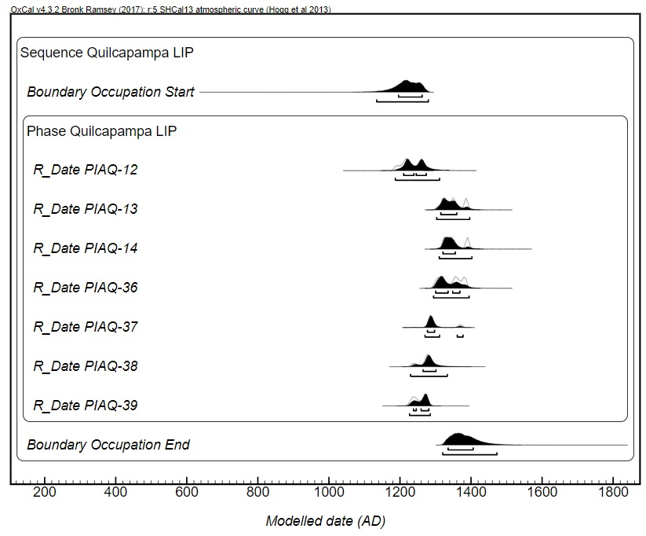

Figure 1 – Posterior probability ranges produced by the primary Bayesian chronological model, with the model structure shown. Modelled probability ranges are shown in solid black, while umodelled probability ranges are shown in grey outline. Both the 68.2% and 95.4% probability ranges are depicted.

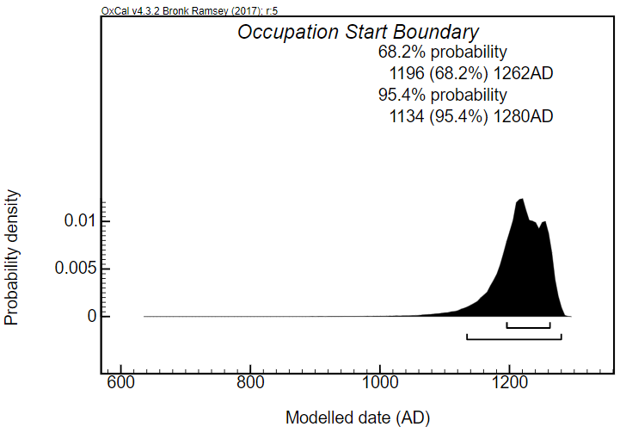

Figure 2 – Posterior probability range corresponding to the start of Quilcapampa’s Late Intermediate Period use as generated by the primary Bayesian chronological model. Both the 68.2% and 95.4% probability ranges are depicted.

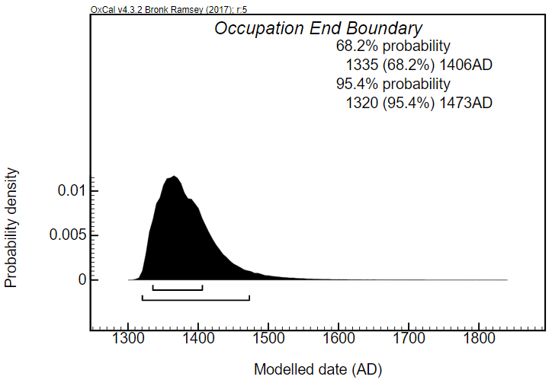

Figure 3 – Posterior probability range corresponding to the end of Quilcapampa’s Late Intermediate Period use as generated by the primary Bayesian chronological model. Both the 68.2% and 95.4% probability ranges are depicted.

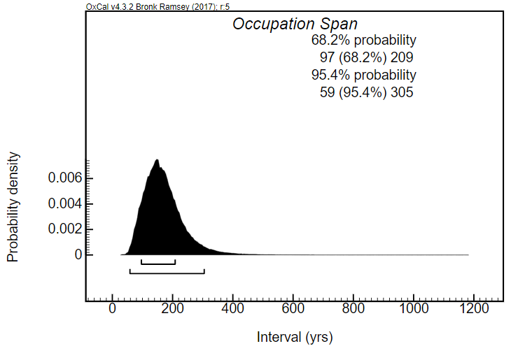

Figure 4 – Posterior probability range corresponding to the span of Quilcapampa’s Late Intermediate Period use as generated by the primary Bayesian chronological model. Both the 68.2% and 95.4% probability ranges are depicted.

**References**

Bayliss, Alex, Christopher Bronk Ramesey, Johannes van der Plicht, and Alasdair Whittle

2007 Bradshaw and Bayes: Towards a Timetable for the Neolithic. *Cambridge Archaeological Journal 17*:1-28.

Bronk Ramsey, Christopher

2009a Bayesian analysis of radiocarbon dates*. Radiocarbon 51*:337-360.

2009b Dealing with outliers and offsets in radiocarbon dating. *Radiocarbon 51*:1023-1045.

Hogg, Alan G., Quan Hua, Paul G. Blackwell, Mu Ni, Caitlan E. Buck, Thomas P. Guilderson, Timothy J. Heaton, Jonathan G. Palmer, Paula J. Reimer, Ron W. Reimer, Christian S. M. Turney, and Susan R. H. Zimmerman

2013 SHCal13 Southern Hemisphere Calibration, 0–50,000 Years cal BP. *Radiocarbon 55*:1889-1903.

Jennings, Justin, Wily J. Yépez Álvarez, and Stefanie L. Bautista (eds.)

2021 *Quilcapampa: A Wari Enclave in Southern Peru*. University Press of Florida, Tallahassee, in press.