Coping with Conflict: Supplemental Materials

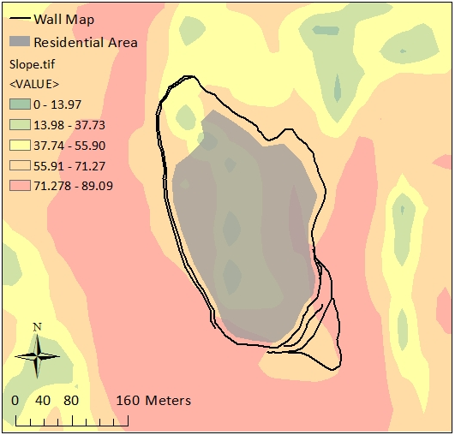Figure 1. Cerro Anamarca, Aja cabezada.

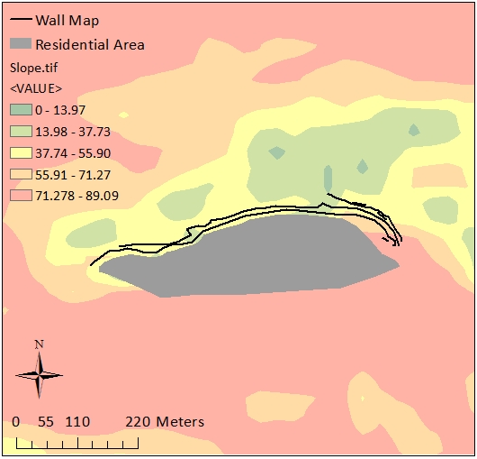Figure 2. Ayapata, Tierras Blancas cabezada.

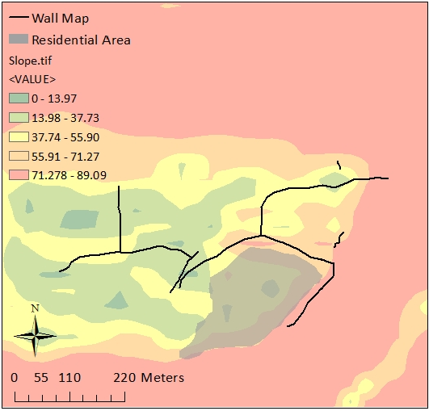Figure 3. Ayapata East, Tierras Blancas cabezada.

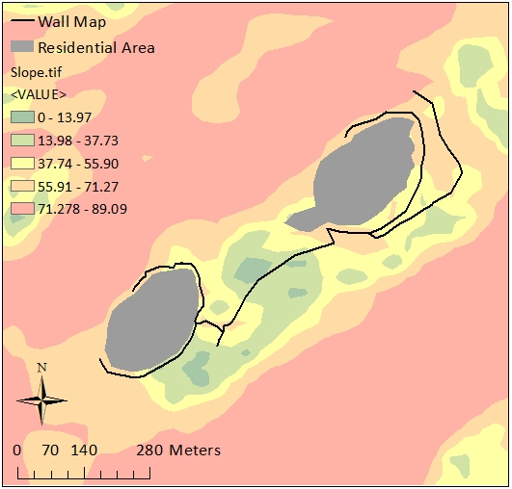Figure 4. Cerro Pucara, Tierras Blancas cabezada.

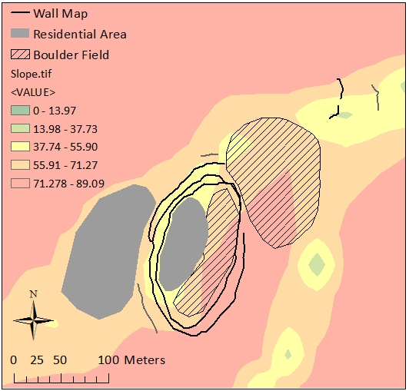Figure 5. Cerro Tarachallyu, Tierras Blancas. cabezada.

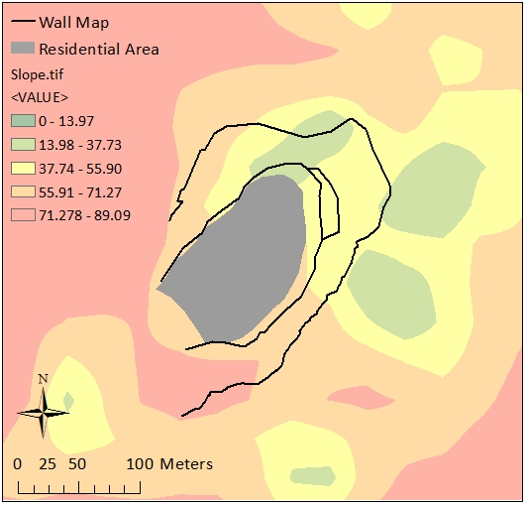Figure 6. Toma, Taruga cabezada.

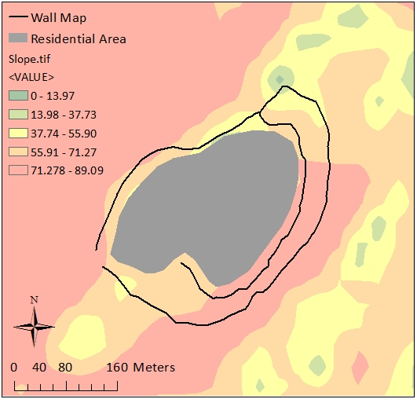Figure 7. Cruz Pata, Taruga cabezada.

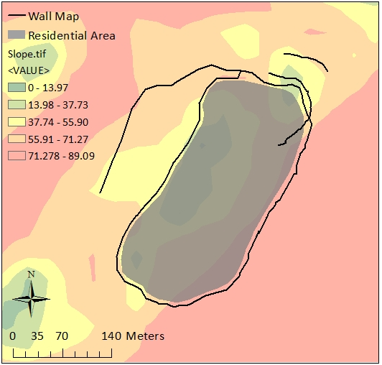Figure 8. Cerro Ayapata, Chauchilla cabezada.

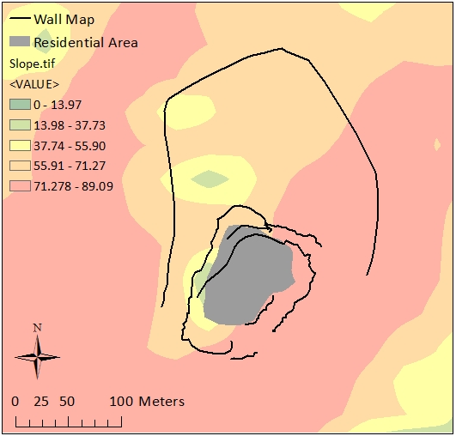Figure 9. Cerro Amayo, Chauchilla cabezada.

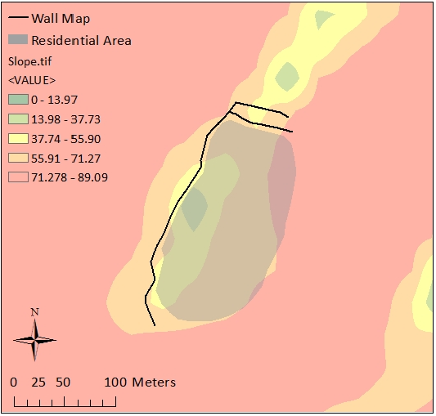Figure 10. Chuluja, Chauchilla cabezada.

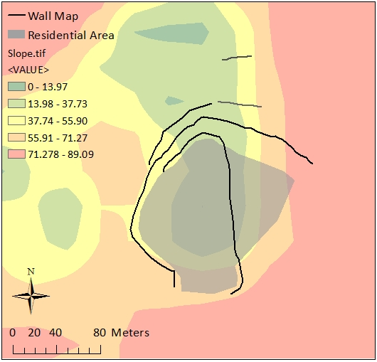Figure 11. Cerro Tribolpata, Las Trancas cabezada.

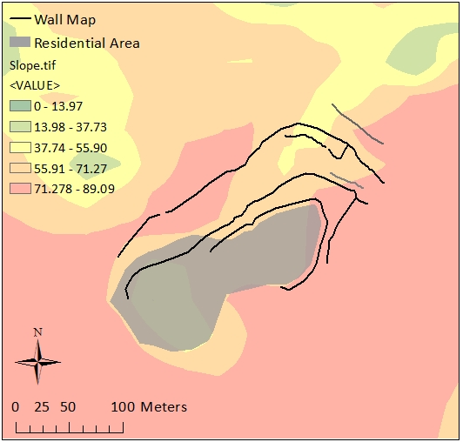Figure 12. Cerro Chillca, Las Trancas cabezada.

Figure 13. OLS Regression of RA and SFS.

Figure . OLS Regression of CSS and SFS.

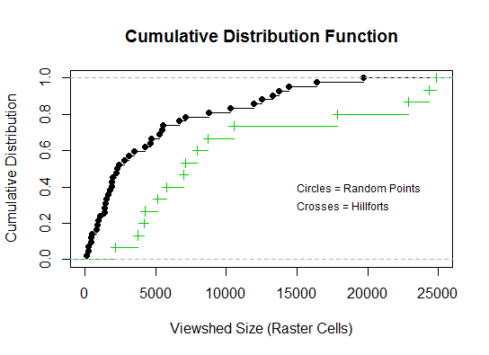Figure . Distribution plot of the KS test for Random Point and Hillfort Viewshed Sizes.