Supplemental Materials to accompany
Identifying Domestic Ceramic Production in the Maya Lowlands: A Case Study from Uxbenká, Belize
Jillian M. Jordan and Keith M. Prufer

Table S1: Ceramic Production Tools
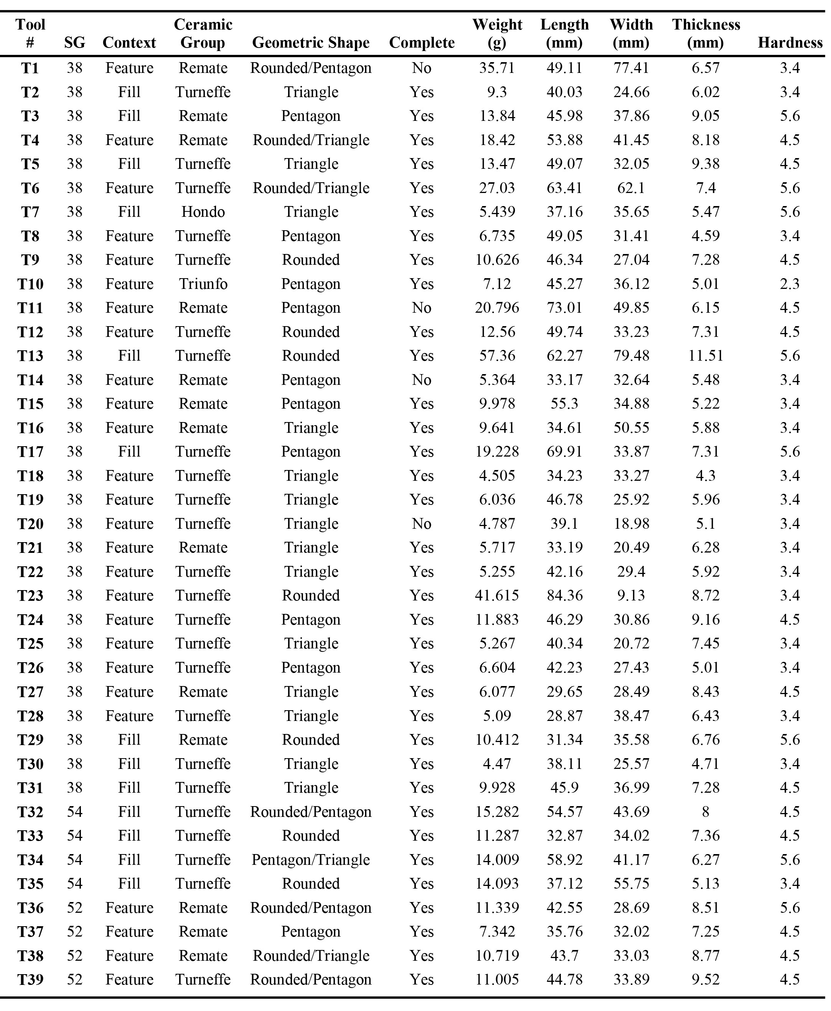
Figure S1: Surface Descriptions for Waterworn Pebble Tools

Table S2: Waterworn Pebble Tools

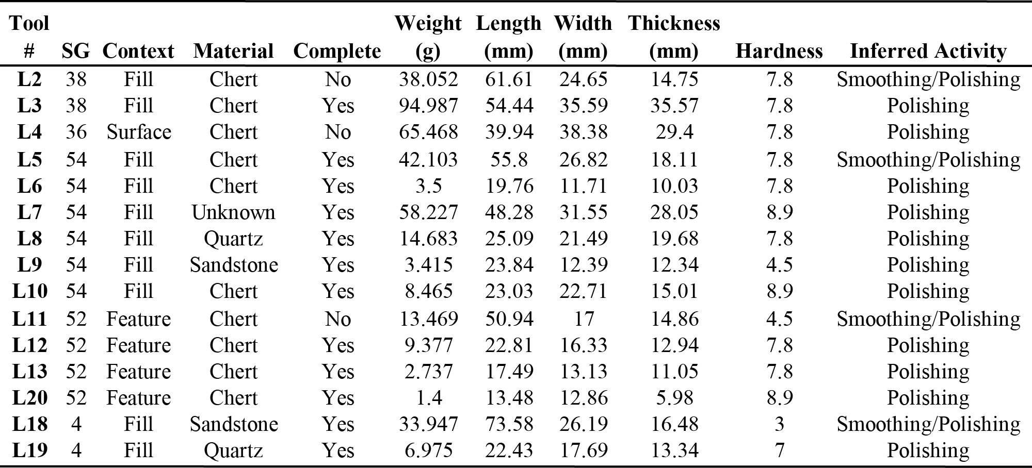

Table S3: Use-Wear on Waterworn Pebble Tools
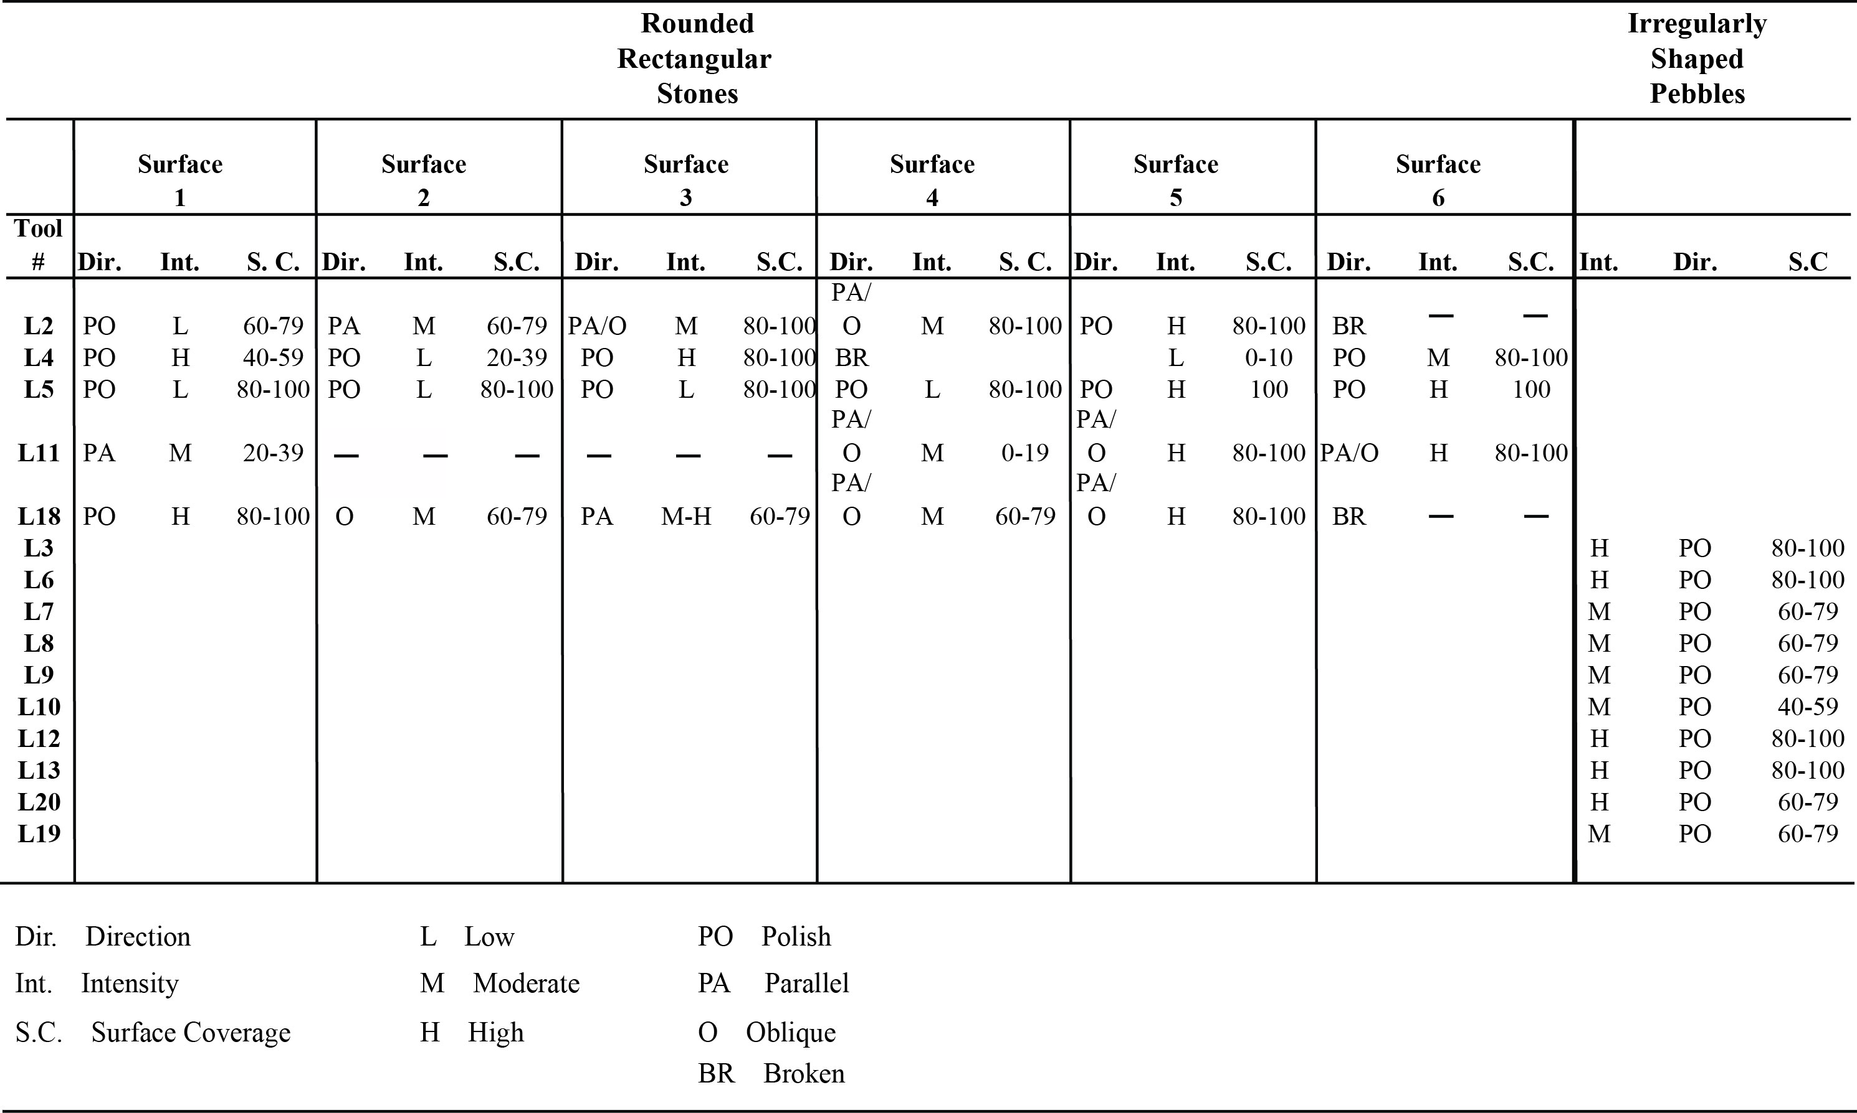

Table S4: Relative Frequencies of Major Ceramic Groups at
Uxbenká, Lubaantun, and Nim Li Punit (%) (Comparative data from Fauvelle et al. 2012: Figure 6 and Hammond 1975)

