Supplemental files
Supplementary Materials and Methods
Supplementary Results
Supplementary References

1 Supplementary Materials and Methods

1.1 Participants and study design
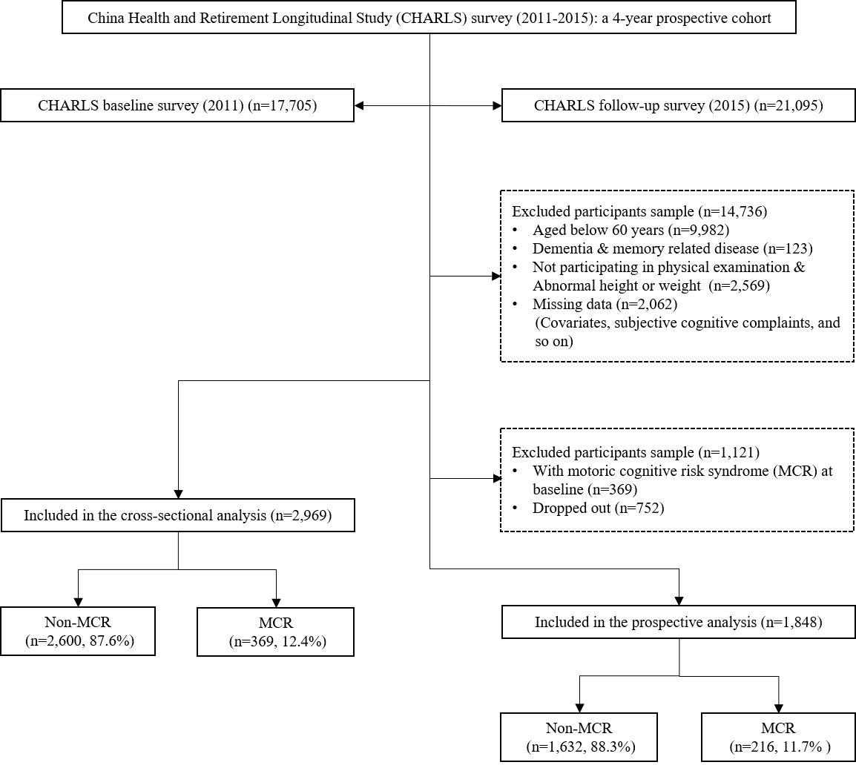
Notes: MCR = motoric cognitive risk syndrome
Supplementary Fig. S1. Inclusion process of study population

1.2 Definition of social connection
Social isolation and loneliness represent the objective and subjective experience of social connection markers.
An index of social isolation was created by combining three elements and utilizing the same methods from earlier studies.¹⁻⁶ Participants received one point if they were single, did not engage in any social activities over the previous month, and had contact with their kids less than once per week (by phone, in person, or by email) (e.g., interacted with friends; played chess or cards; going to the community club; went to a sport, social, or other clubs; did voluntary or charity work).²⁻⁴ Social isolation was rated on a scale from 0 to 3, with higher scores indicating greater social isolation.²⁻⁴
We used the same method as the earlier CHARLS article to measure loneliness, which has confirmed that this indicator is highly correlated with the multi-item loneliness scales.²⁻⁴ In order to gauge loneliness, only one question from the Centre for Epidemiological Studies Depression Scale (CESD) was used at baseline: "In the last week, how often did you feel lonely?" The respondent had four options to choose from, each with a score of 1-4: rarely or none of the time (<1 day), some or a little of the time (1–2 days), occasionally or a moderate amount of the time (3–4 days), most or all of the time (5–7 days).²⁻⁴ It was determined that there were two levels of loneliness: [0 (not lonely) = those who reported feeling lonely rarely or none of the time, and 1 (lonely) = those who felt lonely sometimes, occasionally or most of the time].²⁻⁴

1.3 Diagnosis of MCR
Supplementary Table S1 and S2 includes the methods and slow gait cut scores used in several studies to identify MCR. ⁷
Supplementary Table S1. Criteria for defining low gait speed among Chinese older adults
Variable | Cutoff for defining slowness
 | Baseline | Follow-up
Women
age ≤ 74 years | 0.40 m/s | 0.52 m/s
age 75 - 79 years | 0.35 m/s | 0.42 m/s
age 80 - 84 years | 0.30 m/s | 0.37 m/s
age ≥ 85 years | 0.22 m/s | 0.24 m/s
Men
age ≤ 74 years | 0.45 m/s | 0.62 m/s
age 75 - 79 years | 0.37 m/s | 0.49 m/s
age 80 - 84 years | 0.26 m/s | 0.44 m/s
age ≥ 85 years | 0.22 m/s | 0.38 m/s

Supplementary Table S2. Definition of MCR syndrome
Measure | Categorical cut points
- Subjective cognitive complaints | A self-reported memory loss questionnaire was used to measure subjective cognitive complaints.
- Slow gait speed | Slow gait defined as 1 SD or more below age- and sex-appropriate mean values established within the same cohort.
- Absence of dementia or reduced mobility | Dementia diagnoses were assigned after review of all available clinical and neuropsychological information at consensus case conferences.
Definition criteria | Met all the following three criteria: (1)+(2)+(3)

1.4 Covariates
We investigated any relevant mediators and confounds that would explain or obscure the association of social isolation and loneliness with MCR. Numerous demographic parameters as well as behavioral, psychological, and clinical risk factors were adjusted when doing the studies. Age, sex, level of education, and area of residence (urban/rural) were self-reported. Education level was divided into two categories: less than secondary school and secondary school or higher. Using a standardized procedure, data on health behaviors like current drinkers, current smokers, and physical activity were gathered. Physical activity was measured by the presence of any of the following disorders: vigorous physical activity (VPA), moderate physical activity (MPA) or light physical activity (LPA).⁸ The following inquiry: "Have you been diagnosed by a doctor with conditions listed below?" was used to assess the history of chronic diseases such as hypertension, arthritis (rheumatism), and stomach (digestive) disease.²⁻⁴ Using the CESD-10, depressive symptoms were assessed.²⁻⁴ The loneliness question was left out of the modified CESD scoring, which adds up the other nine items to get a distinct depression score (CESD-9, range 0–27).²⁻⁴ Further details for each variable are available on the CHARLS Website (http://charls.pku.edu.cn/).

1.5 Statistical analysis
Means and standard deviations for continuous data and percentages for categorical data were used to define the overall sample of characteristics at baseline. To examine the association between social isolation, loneliness, and MCR, we used logistic regression and generalized estimating equations (GEE), respectively. The logistic regression was adopted to investigate the cross-sectional association of social isolation and loneliness with MCR at baseline. The longitudinal association between social isolation and loneliness with the risk of MCR at follow-up was evaluated by GEE with an independent working correlation structure, to address the issue of repeated measurements. If the model is correctly specified, one advantage of GEE is that coefficient estimates remain consistent even if the correlation structure is misspecified.^{9, 10} Additionally, GEE makes the best use of the data from each cycle, thus findings are less susceptible to issues with missing replies than with traditional regression approaches.^{9, 10}
Eight different models were estimated, social isolation or/and loneliness served as the independent variable in all models, whereas MCR served as the dependent variable, in cross-sectional analysis and longitudinal analysis, respectively. Model 1A was constructed to examine the associations between social isolation at baseline and MCR by partially adjusting for control variables, including age, sex, education level, and residence. Other control variables, including current drinkers, current smokers, CESD-9, chronic disease, and physical activity were then added to Model 1B. Two similar models were fitted to test the independent associations of loneliness with MCR (Model 2A and B). Two similar models were fitted to test the associations of social isolation and loneliness with MCR (Model 3A and B), by model 3 added both social isolation and loneliness. We tested whether there was an interaction effect between social isolation and loneliness on MCR by including appropriate interaction terms in model 4 (A and B). As the variables under study were measured on several scales, odds ratio (OR) and 95% confidence intervals (CIs) were reported for each model. Analyses were carried out using Stata/SE 15 (StataCorp LLC. Release 15. College Station, TX).

2 Supplementary Results
Supplementary Table S3. Descriptive statistics for study variables at baseline and baseline characteristics by MCR status as follow-up
Variable Mean (SD) or N (%) | Baseline |  | Follow-up
 | Total Sample |  | Total Sample | No new-onset MCR | New-onset MCR
N | 2,969 |  | 1,848 | 1,632 | 216
Age (years) | 68.3 (6.6) |  | 71.0 (6.0) | 71.0 (6.1) | 72.5 (5.6)
Sex (male) | 53.8% (1,607) |  | 56.0% (1,034) | 56.9% (928) | 49.1% (106)
Education level (lower) | 80.7% (2,411) |  | 81.8% (1,511) | 81.0% (1,322) | 87.5% (189)
Residence (rural) | 80.5% (2,404) |  | 85.2% (1,575) | 85.3% (1,392) | 84.7% (183)
Current drinkers (yes) | 32.4% (967) |  | 34.0% (628) | 34.7% (566) | 28.7% (62)
Current smokers (yes) | 46.1% (1,376) |  | 47.3% (874) | 47.4% (774) | 46.3% (100)
CESD-9 | 9.6 (4.5) |  | 9.0 (4.5) | 9.3 (4.4) | 10.8 (4.8)
Chronic disease (yes) ª | 63.3% (1,889) |  | 63.7% (1,178) | 62.9% (1,027) | 69.9% (151)
Physical activity (yes) ^{b} | 69.5% (2,074) |  | 70.6% (1,304) | 71.0% (1,158) | 67.6% (146)
Baseline MCR (yes) | 12.4% (369) |  | — | 0% | 0%
New-onset MCR (yes) | — |  | 11.7% (216) | 0% | 100.0% (216)
Social isolation | 2.0 (0.7) |  | 2.0 (0.7) | 2.1 (0.7) | 2.0 (0.7)
Loneliness | 33.5% (995) |  | 33.1% (611) | 31.3% (511) | 46.3% (100)

Notes: MCR = motoric cognitive risk syndrome; CESD-9 = 9-item Center for Epidemiologic Studies Depression Scale. Values are means (SDs) or percentages (ns).
ª Chronic disease: Hypertension, arthritis (rheumatism) or stomach (digestive) disease.
^{b} Physical Activity: Vigorous physical activity (VPA), moderate physical activity (MPA) or light physical activity (LPA).
Supplementary Table S4. Cross-sectional association of social connections and MCR at baseline
Variables | Model 1 ^{c} |  |  | Model 2 ^{d} |  |  | Model 3 e |  |  | Model 4 ^{f}
 | A [OR (95%CI)]⁺ | B [OR (95%CI)] ⁺ |  | A [OR (95%CI)]⁺ | B [OR (95%CI)] ⁺ |  | A [OR (95%CI)]⁺ | B [OR (95%CI)] ⁺ |  | A [OR (95%CI)]⁺ | B [OR (95%CI)] ⁺
Age (years) | 1.107 (0.994-1.232) | 1.112 (0.998-1.238) |  | 1.119 (1.006-1.245) | 1.127 (1.013-1.255) |  | 1.102 (0.990-1.227) | 1.110 (.997-1.237) |  | 1.103 (0.990-1.228) | 1.111 (0.997-1.237)
Sex (male) | 0.886 (0.705-1.113) | 0.975 (0.723-1.313) |  | 0.878 (0.700-1.103)* | 0.945 (0.703-1.272)* |  | 0.912 (0.724-1.148) | 0.978 (0.726-1.318) |  | 0.913 (0.726-1.150) | 0.981 (0.728-1.322)
Education level (lower) | 0.988 (0.723-1.351) | 0.959 (0.700-1.313) |  | 0.978 (0.716-1.336) | 0.964 (0.704-1.320) |  | 0.972 (0.711-1.329) | 0.956 (0.698-1.310) |  | 0.973 (0.712-1.330) | 0.956 (0.698-1.310)
Residence (rural) | 1.076 (0.797-1.452) | 1.033 (0.763-1.398) |  | 1.021 (0.757-1.377) | 0.997 (0.738-1.348) |  | 1.050 (0.777-1.418) | 1.028 (0.759-1.392) |  | 1.050 (0.778-1.419) | 1.029 (.760 -1.393)
Current drinkers (yes) | — | 0.990 (0.763-1.284) |  | — | 0.979 (0.754-1.269) |  | — | 0.990 (0.763-1.285) |  | — | 0.989 (0.763-1.284)
Current smokers (yes) | — | 1.006 (0.759-1.333) |  | — | 1.000 (0.755-1.325) |  | — | 1.004 (0.758-1.331) |  | — | 1.004 (0.758-1.331)
CESD-9 | — | 1.291 (1.156-1.441)*** |  | — | 1.267 (1.126-1.426)*** |  | — | 1.276 (1.134-1.437)*** |  | — | 1.276 (1.133-1.436)***
Chronic disease (yes) ª | — | 0.949 (0.752-1.199) |  | — | 0.947 (0.750-1.196) |  | — | 0.945 (0.748-1.194) |  | — | 0.946 (0.749-1.196)
Physical activity (yes) ^{b} | — | 1.041 (0.817-1.328) |  | — | 1.037 (0.813-1.322) |  | — | 1.039 (0.814-1.325) |  | — | 1.038 (0.814-1.324)
Social isolation | 0.821 (0.707-0.953)* | 0.819 (0.705-0.951)** |  | — | — |  | 0.835 (0.719-0.970)* | 0.823 (0.707-0.957)* |  | 0.815 (0.670-.990)* | 0.804 (0.660-0.978)*
Loneliness | — | — |  | 1.321 (1.052-1.660)* | 1.107 (0.864-1.419) |  | 1.284 (1.021-1.616)* | 1.068 (0.832-1.371) |  | 1.149 (0.630-2.096) | 0.963 (0.522-1.778)
Social isolation * Loneliness | — | — |  | — | — |  | — | — |  | 1.061 (0.788-1.429) | 1.057 (0.784-1.425)

Notes: MCR = motoric cognitive risk syndrome; CESD-9 = 9-item Center for Epidemiologic Studies Depression Scale; OR = odds ratio; 95% CI = 95% confidence interval.
ª Chronic disease: hypertension, arthritis (rheumatism) or stomach (digestive) disease.
^{b} Physical Activity: vigorous physical activity (VPA), moderate physical activity (MPA) or light physical activity (LPA).
^{c} Model 1: social isolation as predictor.
^{d} Model 2: loneliness as predictor.
^{e} Model 3: both social isolation and loneliness as predictors.
^{f} Model 4: Model 3 + social isolation * loneliness interaction.
⁺ All Models A were adjusted for age, sex, education level, and residence; All Models B is Model A plus the inclusion of current drinkers, current smokers, CESD-9, chronic disease, and physical activity.
* p < 0.05, ** p < 0.01, *** p < 0.001.

3 Supplementary references
1. Zhao Y, Hu Y, Smith JP, et al. Cohort profile: the China Health and Retirement Longitudinal Study (CHARLS). Int J Epidemiol 2014; 43: 61-68. 2012/12/18. DOI: 10.1093/ije/dys203.
2. Guo L, An L, Luo F, et al. Social isolation, loneliness and functional disability in Chinese older women and men: a longitudinal study. Age Ageing 2021; 50: 1222-1228. 2020/12/23. DOI: 10.1093/ageing/afaa271.
3. Yu B, Steptoe A, Chen Y, et al. Social isolation, rather than loneliness, is associated with cognitive decline in older adults: the China Health and Retirement Longitudinal Study. Psychological medicine 2021; 51: 2414-2421. 2020/04/28. DOI: 10.1017/s0033291720001014.
4. Yu B, Steptoe A, Niu K, et al. Social Isolation and Loneliness as Risk Factors for Grip Strength Decline Among Older Women and Men in China. J Am Med Dir Assoc 2020; 21: 1926-1930. 2020/07/30. DOI: 10.1016/j.jamda.2020.06.029.
5. Glei DA, Goldman N, Ryff CD, et al. Social relationships and inflammatory markers: an analysis of Taiwan and the U.S. Soc Sci Med 2012; 74: 1891-1899. 2012/04/10. DOI: 10.1016/j.socscimed.2012.02.020.
6. Steptoe A, Shankar A, Demakakos P, et al. Social isolation, loneliness, and all-cause mortality in older men and women. Proceedings of the National Academy of Sciences of the United States of America 2013; 110: 5797-5801. 2013/03/27. DOI: 10.1073/pnas.1219686110.
7. Liang H and Fang Y. Longitudinal association between falls and motoric cognitive risk syndrome among community-dwelling older adults. Geriatr Nurs 2022; 49: 1-7. 20221115. DOI: 10.1016/j.gerinurse.2022.11.003.
8. Ding M, Jia N, Zhou Y, et al. The Dose-Response Relationships of Different Dimensions of Physical Activity with Daily Physical Function and Cognitive Function in Chinese Adults with Hypertension: A Cross-Sectional Study. Int J Environ Res Public Health 2021; 18 2021/12/11. DOI: 10.3390/ijerph182312698.
9. Odueyungbo A, Browne D, Akhtar-Danesh N, et al. Comparison of generalized estimating equations and quadratic inference functions using data from the National Longitudinal Survey of Children and Youth (NLSCY) database. BMC Med Res Methodol 2008; 8: 28. 2008/05/10. DOI: 10.1186/1471-2288-8-28.
10. McIntyre L, Wu X, Kwok C, et al. The pervasive effect of youth self-report of hunger on depression over 6 years of follow up. Social psychiatry and psychiatric epidemiology 2017; 52: 537-547. 2017/03/13. DOI: 10.1007/s00127-017-1361-5.

