Supplementary Appendix

Supplementary Table 1: Unit cost values of resource utilization, in 2021 US$
Drug | American unit cost | Reference | Canadian unit cost | Reference
20 mg methylphenidate | 0.24 | 1 | 0.36 | 9
Inpatient Hospital
Geriatric ward | 5324.06 | 2 | 518.96 | 10
Psychiatric ward | 5324.06 |  | 518.96
Internal medicine ward | 5324.06 |  | 518.96
Surgery ward | 5324.06 |  | 518.96
Neurology ward | 5324.06 |  | 518.96
General ward | 5324.06 |  | 518.96
Cardiology Ward | 5324.06 |  | 518.96
ER | 111.60 | 3 | 63.40
Outpatient Hospital
General Practitioner | 53.96 | 3 | 70.48 | 11
Geriatrician | 78.20 |  | 149.70
Neurologist | 40.95 |  | 145.86
Psychiatrist | 85.39 |  | 176.12
Physiotherapist | 29.09 |  | 119.25 | 10
Occupational therapist | 31.31 |  | 55.94 | 12
Social worker | 80.97 |  | 48.90 | 10
Psychologist | 115.21 |  | 208.72 | 13
Additional Resource Utilization
Certified Registered Nurse | 154.51 (per visit) | 4 | 32.05 (hourly) | 14
Home Care Aid | 12.79 (hourly) | 5 | 94.59 (daily) | 15
Meals on Wheels | 8.00 | 6 | 6.13 | 16
Day care (daily) | 83.15 | 7 | 20.05 | 17
Round trip transportation | 22.27 | 8 | 3.76 | 18
Informal Care | 9.39 | 19 | 8.59 | 20

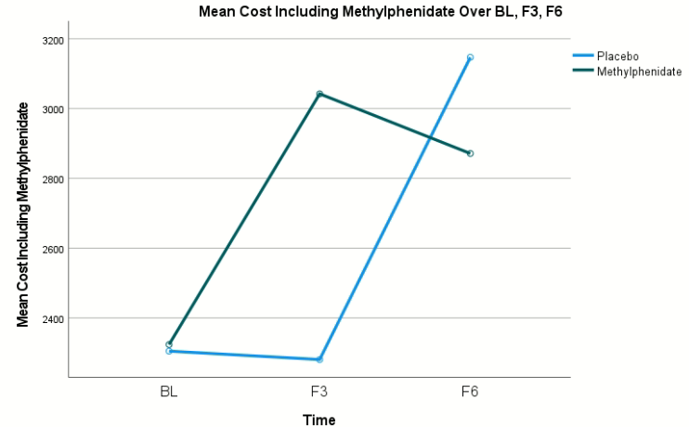
Supplementary Figure 1: Mean cost at BL, F3, and F6 by treatment group, excluding the cost of methylphenidate.

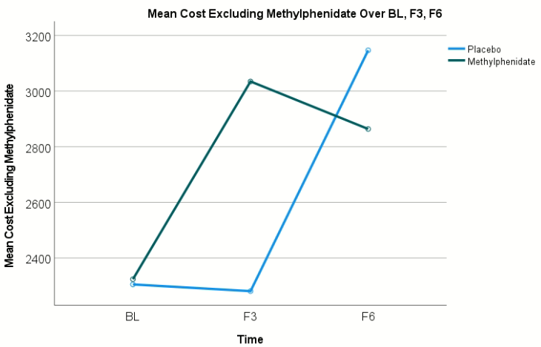
Supplementary Figure 2: Mean cost at BL, F3, and F6 by treatment group, including the cost of methylphenidate.

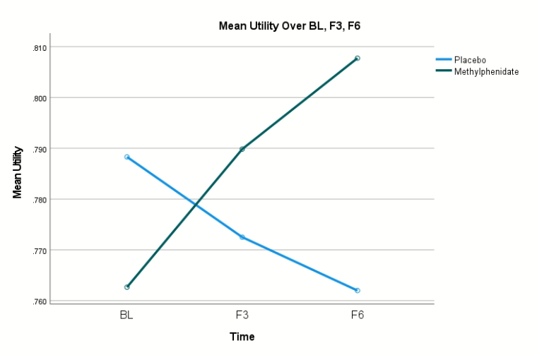
Supplementary Figure 3: Mean utility at BL, F3, and F6 by treatment group.

