Figure S2. Predicted average depressive symptoms over distribution of physical performance scores using multiply-imputed data.

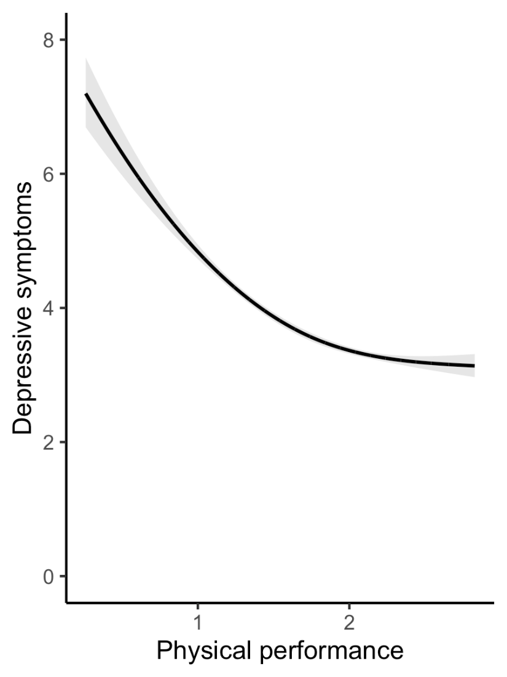
Note. Shading reflects 95% confidence interval.

