Figure S3. Predicted average depressive vulnerability over distribution of household income (panel A), educational attainment (panel B), physical activity (panel C), and structural social network (panel D) using multiply-imputed data.
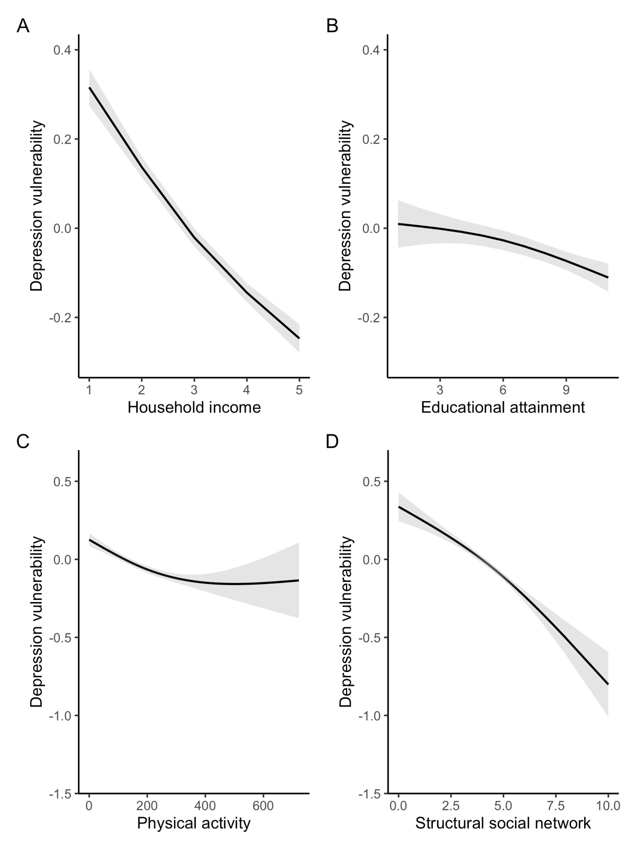
Note. Shading reflects 95% confidence interval.

