Figure S4. Predicted average physical activity over distribution of household income (panel A) and educational attainment (panel B), and predicted average structural social network over distribution of household income (panel C) and educational attainment (panel D) using multiply-imputed data.
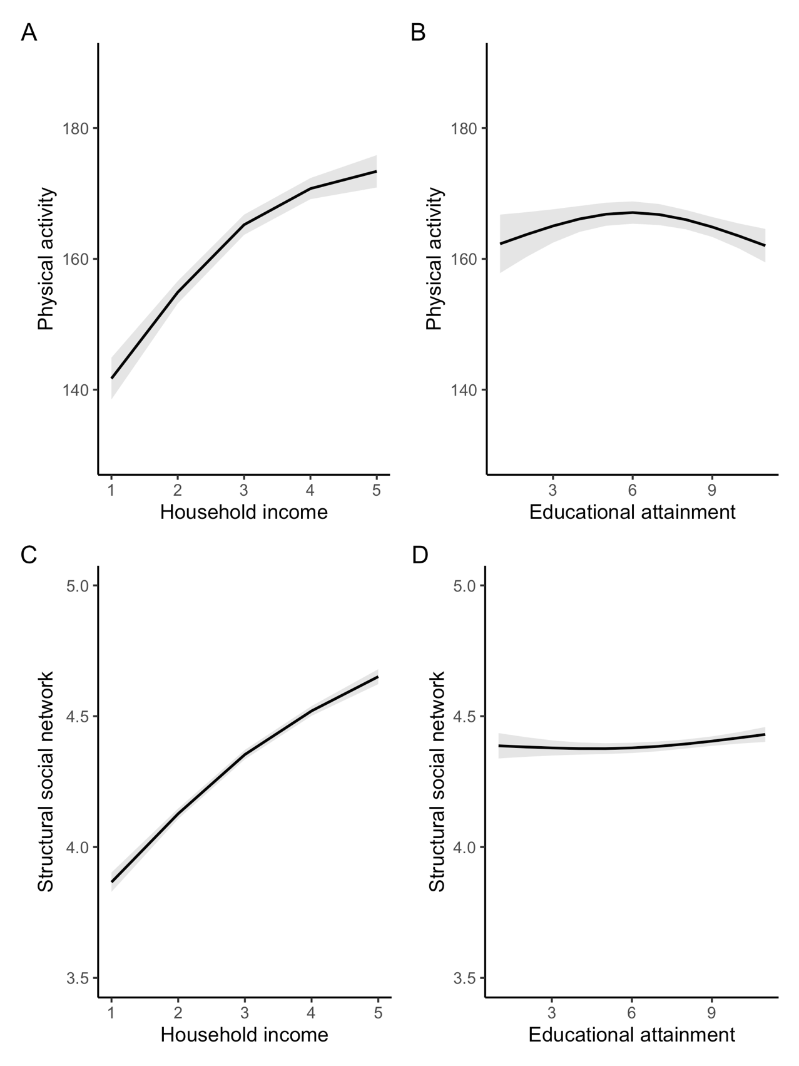
Note. Shading reflects 95% confidence interval.

