Supplementary Results
When controlling for years of education, the pattern of MD results varied slightly. We found significance in 10 clusters, together containing 22523 voxels (Supplementary Figure 1). See Supplementary Table 1 for voxel counts and peak MNI coordinates by cluster. The spatial extent of the clusters again represented the centers of the major WM tracts.

Supplementary Figure 1. Regions of significant between-groups difference in MD (red: LLD-Frail > CG), overlaid onto the mean FA skeleton (green), when controlling for years of education. Ten cluster emerged representing several WM tracts, including the corpus callosum, anterior and superior corona radiata, internal capsule, and superior longitudinal fasciculus. (LLD+Frail > Never-depressed+Robust) in MD measures. Abbreviations: FA = fractional anisotropy; FWER = family-wise error rate; CG = Never-depressed+Robust; LLD-Frail = depressed, frail; MD = mean diffusivity

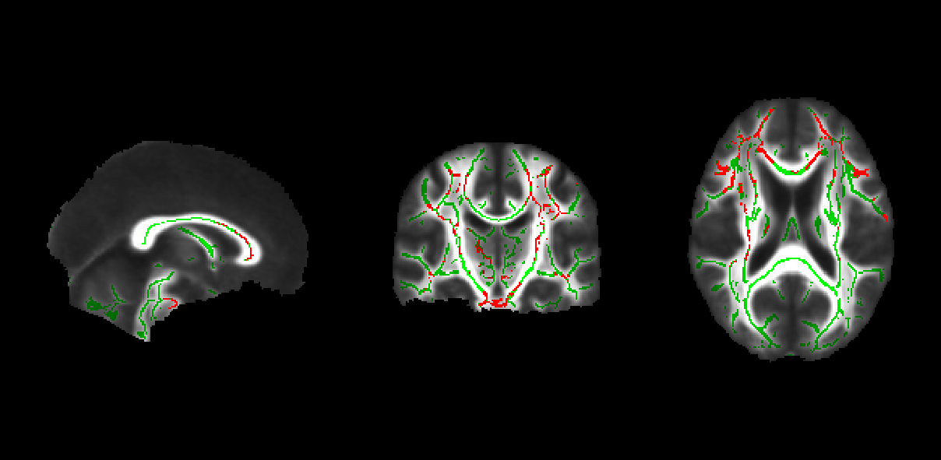

Supplementary Table 1. Voxel counts and peak MNI coordinates for each of the 10 clusters showing significant between-groups difference in MD (LLD-Frail > CG).

cluster | voxel count | pFWER | peak voxel x | peak voxel y | peal voxel z
1 | 19548 | 0.017 | -26 | -3 | 42
2 | 734 | 0.024 | 25 | -16 | 45
3 | 733 | 0.023 | -30 | 8 | -34
4 | 638 | 0.024 | 8 | -1 | 8
5 | 456 | 0.024 | 25 | -30 | 48
6 | 256 | 0.024 | 49 | -23 | -19
7 | 114 | 0.025 | 1 | -25 | -12
8 | 28 | 0.025 | 10 | -41 | 63
9 | 12 | 0.025 | 38 | -35 | -19
10 | 4 | 0.025 | -18 | -29 | 1

