Supplemental Figure 1
Sociodemographic Differences in Social Connection During COVID-19
- Structural aspect
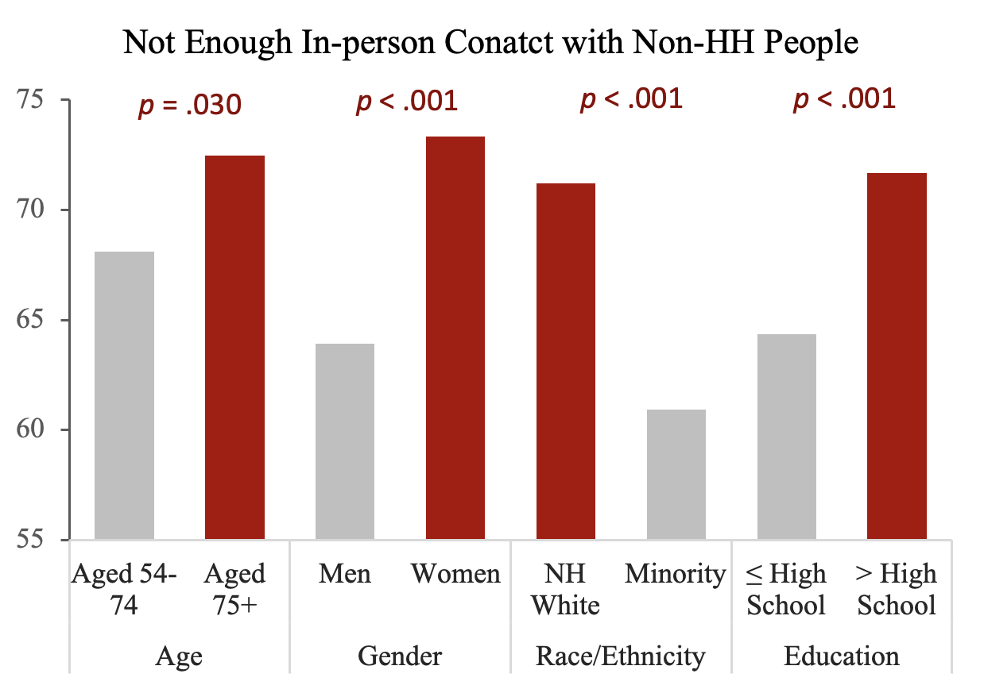 | 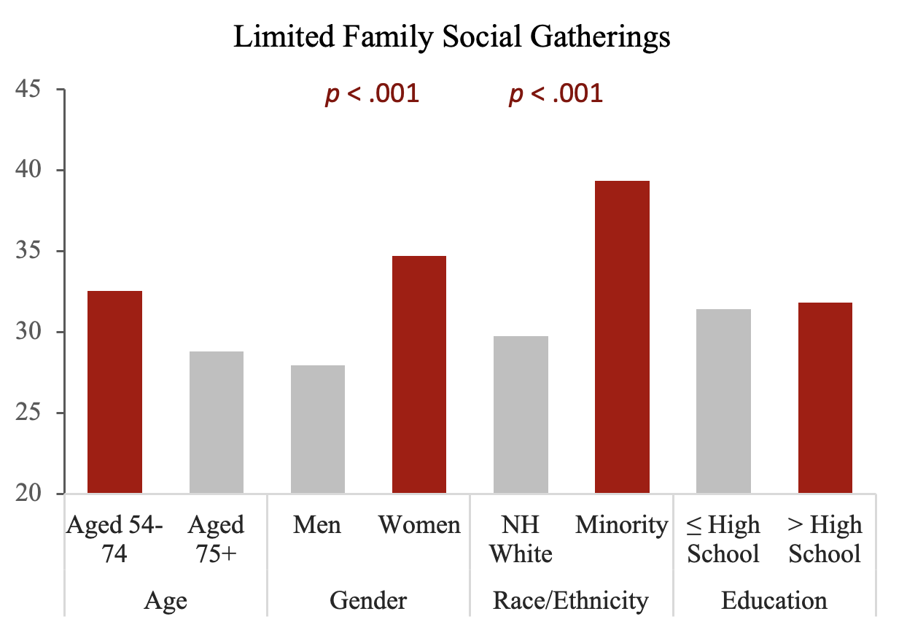
- Functional aspect
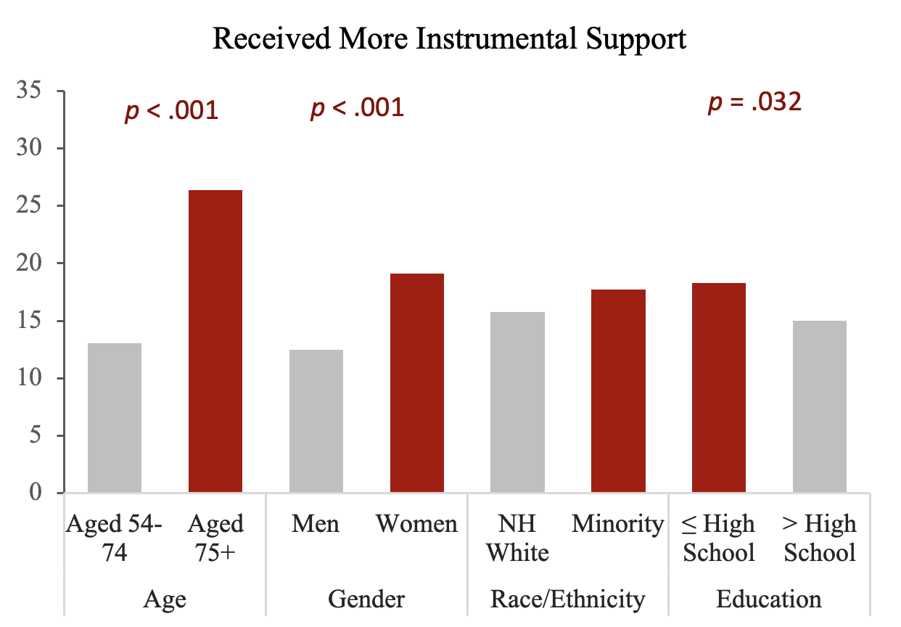 | 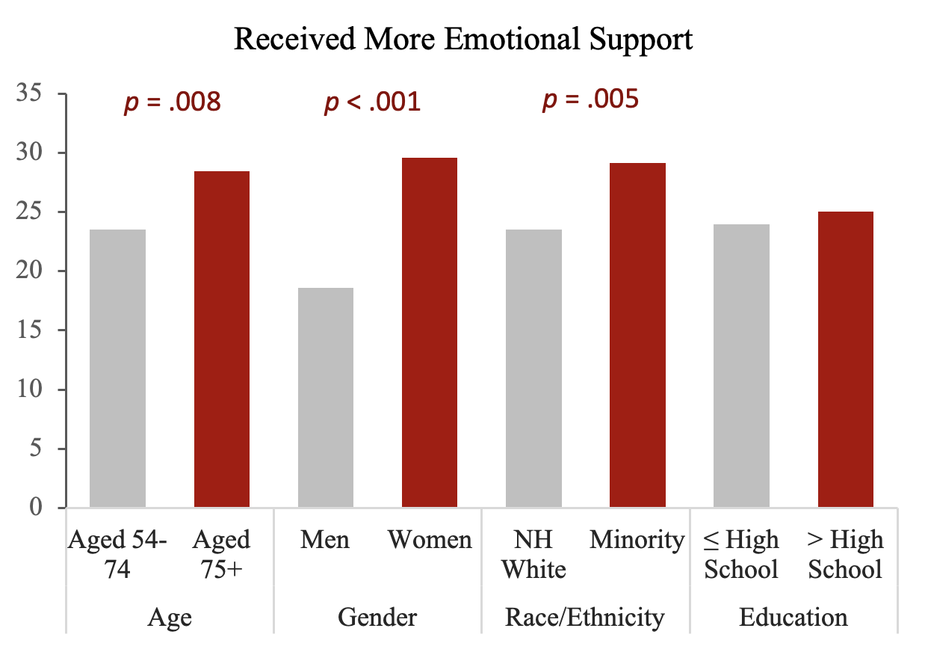
- Quality aspect
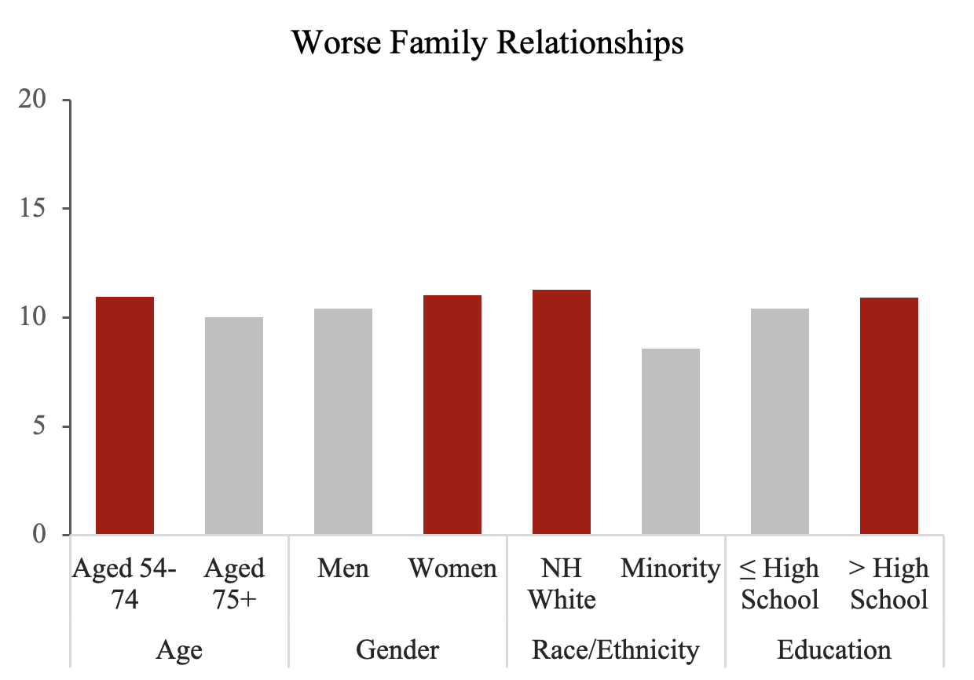 | 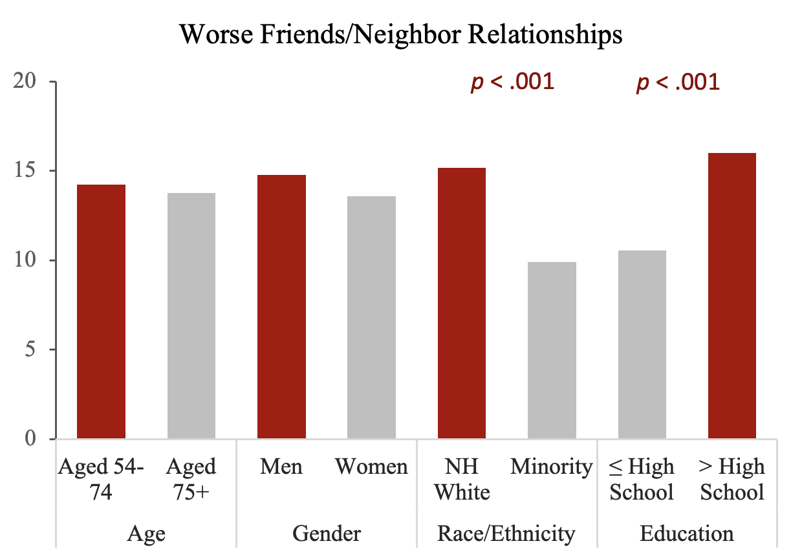

Supplemental Table 1
Logistic Regressions Predicting Increased Loneliness During the COVID-19 Pandemic (N=3,804)
 | OR | 95% CI | p
Sociodemographic factors
Aged 75+ (ref: Aged 54−74) | 0.75 | (0.60,0.95) | .019
Women | 1.55 | (1.23,1.94) | <.001
Racial/ethnic minority (ref: Non-Hispanic White) | 0.70 | (0.54,0.91) | .006
Education of some college or above (ref: High school or less) | 1.30 | (1.05,1.61) | .017
Marital status (ref: Married/partnered)
Separated/divorced | 1.44 | (1.09,1.90) | .011
Widowed | 1.40 | (1.04,1.87) | .025
Never married | 0.99 | (0.60,1.61) | .957
Changes in social connection during COVID-19
Structural aspect
Number of limited family social gatherings (range: 0−5) | 1.06 | (0.98,1.14) | .120
Not enough in-person contact with people outside household | 10.07 | (6.88,14.74) | <.001
Functional aspect
Received instrumental support from anyone (ref: No changes)
Not needed | 1.31 | (0.95,1.80) | .095
Less often | 0.85 | (0.42,1.73) | .646
More often | 1.42 | (0.99,2.04) | .053
Received emotional support from anyone (ref: No changes)
Not needed | 0.88 | (0.66,1.16) | .355
Less often | 2.28 | (1.13,4.59) | .021
More often | 2.00 | (1.53,2.61) | <.001
Quality aspect
Worse quality of relationships with family members | 1.69 | (1.23,2.32) | .001
Worse quality of relationships with friends/neighbors | 1.44 | (1.09,1.91) | .012
Note. Estimates are weighted.
Supplemental Table 2
Logistic Regressions Predicting Increased Loneliness During the COVID-19 Pandemic (N=3,804)
 | OR | 95% CI | p
Structural aspect
Number of limited family social gatherings (range: 0−5) | 1.23 | (1.16,1.31) | <.001
Not enough in-person contact with people outside household | 12.67 | (8.78,18.27) | <.001
Functional aspect
Received instrumental support from anyone (ref: No changes)
Not needed | 1.03 | (0.78,1.36) | .829
Less often | 1.29 | (0.66,2.53) | .464
More often | 1.87 | (1.35,2.57) | <.001
Received emotional support from anyone (ref: No changes)
Not needed | 0.68 | (0.54,0.87) | .002
Less often | 2.33 | (1.29,4.22) | .005
More often | 2.41 | (1.88,3.09) | <.001
Quality aspect
Worse quality of relationships with family members | 2.61 | (1.99,3.43) | <.001
Worse quality of relationships with friends/neighbors | 2.33 | (1.81,2.99) | <.001
Note. Estimates are weighted. A series of separate models were examined for each indicator, with controlling for sociodemographic covariates (not shown for simplicity).

Supplemental Figure 2
The Effects of Changes in Social Connection on Increased Loneliness
- Structural aspect
- Functional aspect
- Quality aspect
Note. The models examined each variable separately, controlling for sociodemographic factors
Supplemental Table 3
Logistic Regressions Predicting Increased Loneliness During the COVID-19 Pandemic by Previous Loneliness Groups
 | Previously  Not Lonely  (n = 2,375) |  |  | Previously  Lonely  (n = 696)
 | OR | 95% CI | p | OR | 95% CI | p
Lonely the same, more, or less often than before COVID-19?
Structural aspect
Number of limited family social gatherings (range: 0−5) | 1.07 | (0.97,1.18) | .196 | 1.07 | (0.92,1.26) | .385
Not enough in-person contact with people outside household | 7.68 | (4.78,12.35) | <.001 | 20.14 | (6.26,64.86) | <.001
Functional aspect
Received instrumental support from anyone (ref: No changes)
Not needed | 1.48 | (0.98,2.23) | .062 | 1.75 | (0.89,3.45) | .104
Less often | 0.98 | (0.33,2.87) | .971 | 1.06 | (0.30,3.69) | .926
More often | 1.86 | (1.17,2.96) | .009 | 1.77 | (0.83,3.74) | .137
Received emotional support from anyone (ref: No changes)
Not needed | 0.79 | (0.55,1.13) | .195 | 0.84 | (0.45,1.57) | .582
Less often | 2.12 | (0.85,5.28) | .106 | 1.88 | (0.52,6.77) | .333
More often | 1.80 | (1.29,2.52) | <.001 | 2.03 * | (1.10,3.74) | .024
Quality aspect
Worse quality of relationships with family members | 1.88 | (1.22,2.90) | .004 | 1.71 | (0.95,3.08) | .076
Worse quality of relationships with friends/neighbors | 1.04 | (0.72,1.49) | .837 | 2.70 | (1.43,5.10) | .002
Note. Estimates are weighted. A series of separate models were examined by the groups, with controlling for sociodemographic covariates (not shown for simplicity). The scores for previous loneliness were obtained from the respondents’ response in the prior wave (2016), those with the score of 6 or higher were categorized as ‘lonely.’

