Supplement Figures
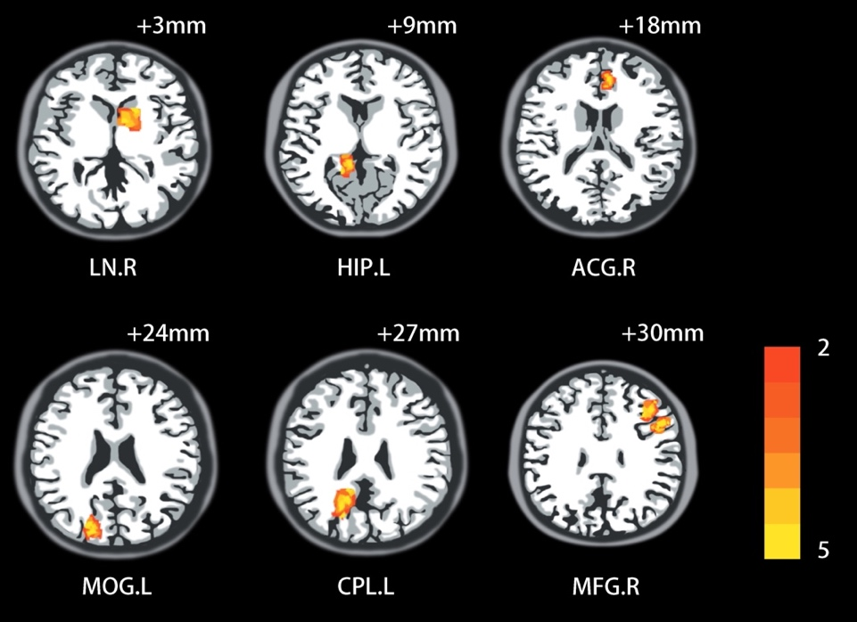
Supplement Figure 1. Regional brain activation changes caused by the Creative expression program. Axial slices display significant group difference after intervention. All clusters shown in red indicate the FC increased; blue colors indicate that FC Decreased. LN.R, right lentiform nucleus; HIP.L, left hippocampus ;ACG.R, right anterior cingulate gyrus; MOG.L, left middle occipital gyrus; CPL.L, left cerebellum posterior lobe; MFG.R, right medial frontal gyrus.

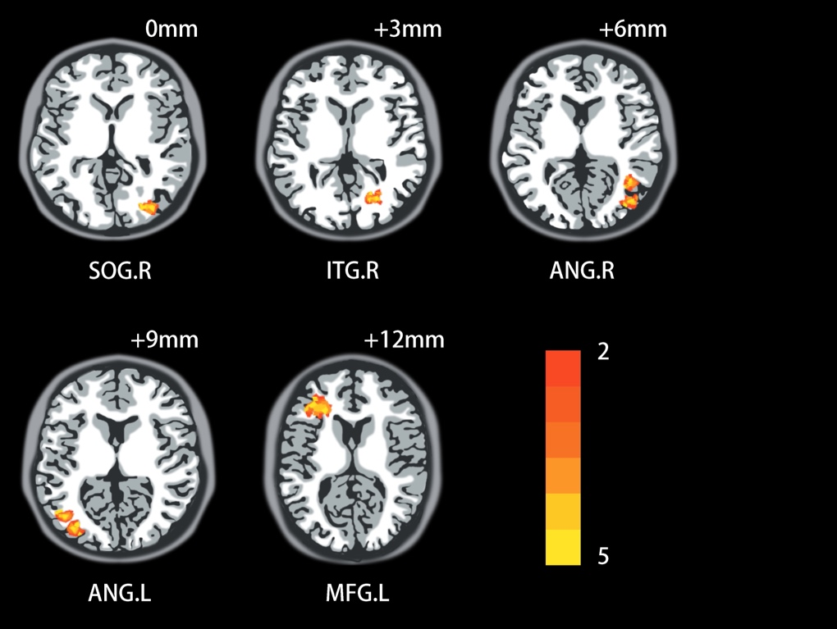

S

Supplement Figure 2. Functional connectivity change based on the seed of the hippocampus which was altered by the creative expression intervention. All clusters shown in red indicate increases in the creative expression intervention group. SOG.R, right occipital gyrus; ITG.R, right inferior temporal gyrus; ANG.R, right angular gyrus; ANG.L, left angular gyrus; MFG.L, middle frontal gyrus.

