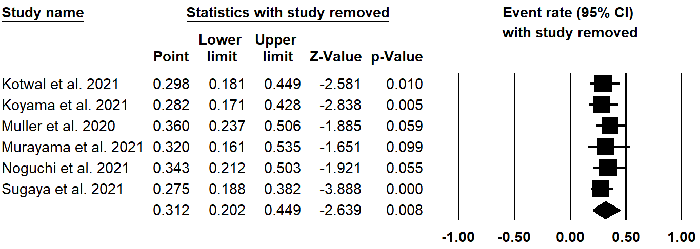
Overall estimate
Figure S2. Sensitivity analysis verifying the robustness of the results on the prevalence of social isolation by removing one study at a time.

