Overall estimate
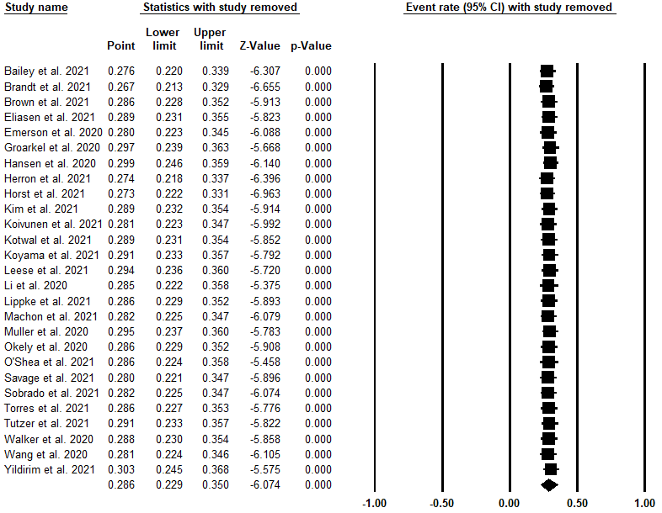
Figure S1. Sensitivity analysis verifying the robustness of the results on the prevalence of loneliness by removing one study at a time.
Overall estimate

