Appendices
Appendix A: The Sampling Flowchart
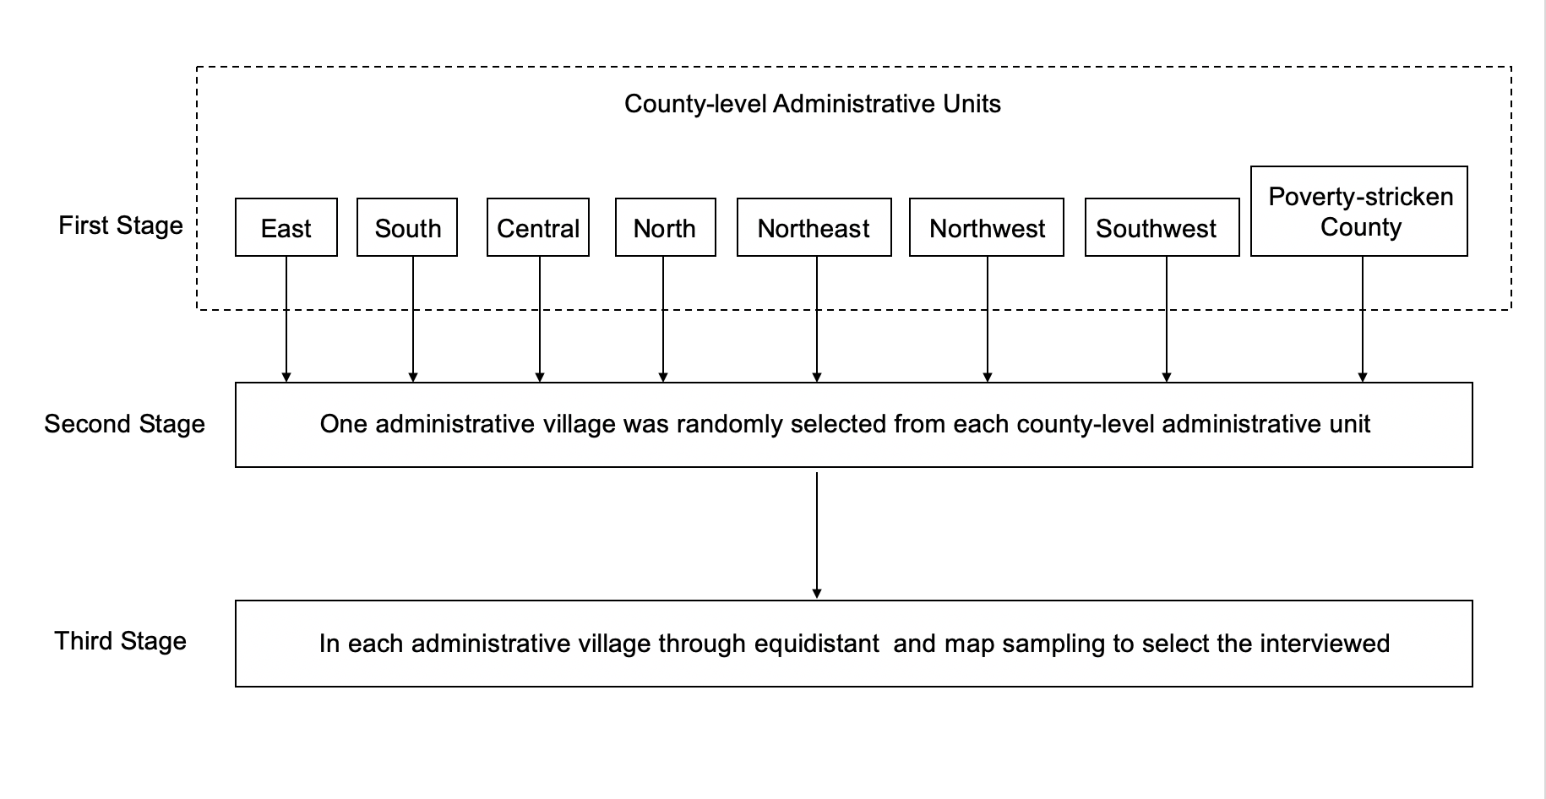

Appendix B: DASS21-Depression Subscale
Please read each of the following items carefully and choose the degree of conformity with your own situation in each item according to the past week.
Item | did not apply to me at all | ………………… |  | applied to me very much
1. I felt downhearted and blue. | 0 | 1 | 2 | 3
2. I felt that I had nothing to look forward to. | 0 | 1 | 2 | 3
3. I felt that life was meaningless. | 0 | 1 | 2 | 3
4. I felt I wasn't worth much as a person. | 0 | 1 | 2 | 3
5. I was unable to become enthusiastic about anything. | 0 | 1 | 2 | 3
6. I couldn't seem to experience any positive feeling at all. | 0 | 1 | 2 | 3
7. I found it difficult to work up the initiative to do things. | 0 | 1 | 2 | 3

Appendix C: The Satisfaction with Life Scale
The following are some of your views on yourself. Please read the following statements carefully to determine how much you agree or disagree and draw a “√” on the corresponding number. The higher the score, the more you agree with the items.
Item | Strongly disagree | ……………………………… |  |  |  |  | Strongly agree
1. In most ways my life is close to my ideal. | 1 | 2 | 3 | 4 | 5 | 6 | 7
2. The conditions of my life are excellent. | 1 | 2 | 3 | 4 | 5 | 6 | 7
3. I am satisfied with my life. | 1 | 2 | 3 | 4 | 5 | 6 | 7
4. So far, I have gotten the important things I want in life. | 1 | 2 | 3 | 4 | 5 | 6 | 7
5. If I could live my life over, I would change almost nothing. | 1 | 2 | 3 | 4 | 5 | 6 | 7

Appendix D: Ostracism Experience Scale
For each of the statements below, please consider your personal feelings. Determine how often, in general, the following experiences happen to you. Just give your gut response. Use the scale: 1 = Hardly ever to 7 = Almost always. Please read each statement carefully.
Item | Hardly ever | ……………………………………… |  |  |  |  | Almost always
1. Others treat me as if I were invisible. | 1 | 2 | 3 | 4 | 5 | 6 | 7
2. Others give me the cold shoulder treatment. | 1 | 2 | 3 | 4 | 5 | 6 | 7
3. Others physically turn their backs to me when in my presence. | 1 | 2 | 3 | 4 | 5 | 6 | 7
4. Others ignore me during conversation. | 1 | 2 | 3 | 4 | 5 | 6 | 7

