Appendix A
Demographics of the two Subsamples (N = 356 and N = 353)
 | N = 356 |  |  |  | N = 353
Characteristics | Frequency | Percentage |  |  | Frequency | Percentage
Age
15-18 | 46 | 12.92 |  | 35 |  | 9.92
19-40 | 200 | 56.18 |  | 196 |  | 55.52
41-65 | 89 | 25.00 |  | 101 |  | 28.61
66-92 | 21 | 5.90 |  | 21 |  | 5.95
Gender
Men | 80 | 22.50 |  | 74 |  | 21.00
Women | 276 | 77.50 |  | 279 |  | 79.00
First Language
English | 332 | 93.30 |  | 333 |  | 94.30
Other | 24 | 6.70 |  | 20 |  | 5.70
Education level completed
0-10 years | 12 | 3.40 |  | 14 |  | 4.00
11-12 years | 61 | 17.10 |  | 55 |  | 15.60
13-14 years | 110 | 30.90 |  | 95 |  | 26.90
15-16 years | 104 | 29.20 |  | 118 |  | 33.40
17-18 years | 35 | 9.80 |  | 36 |  | 10.20
19-20 years | 21 | 5.90 |  | 23 |  | 6.50
21+ | 13 | 3.70 |  | 12 |  | 3.40
Retired
Yes | 24 | 6.70 |  | 30 |  | 8.50
No | 332 | 93.30 |  | 323 |  | 91.50
Note. Completion of year 12 = 12 years of education.

Appendix B
The SAWS Five Factor Correlation Matrix (N = 353)
Factor | 1 | 2 | 3 | 4 | 5
- Reminiscence/ Reflection | 1.00
- Humor | .34 | 1.00
- Emotional Regulation | .36 | .50 | 1.00
- Experience | .37 | .42 | .43 | 1.00
- Openness | .40 | .56 | .50 | .43 | 1.00
Note. Extraction Method: Maximum Likelihood.
Rotation Method: Promax with Kaiser Normalization

Appendix C
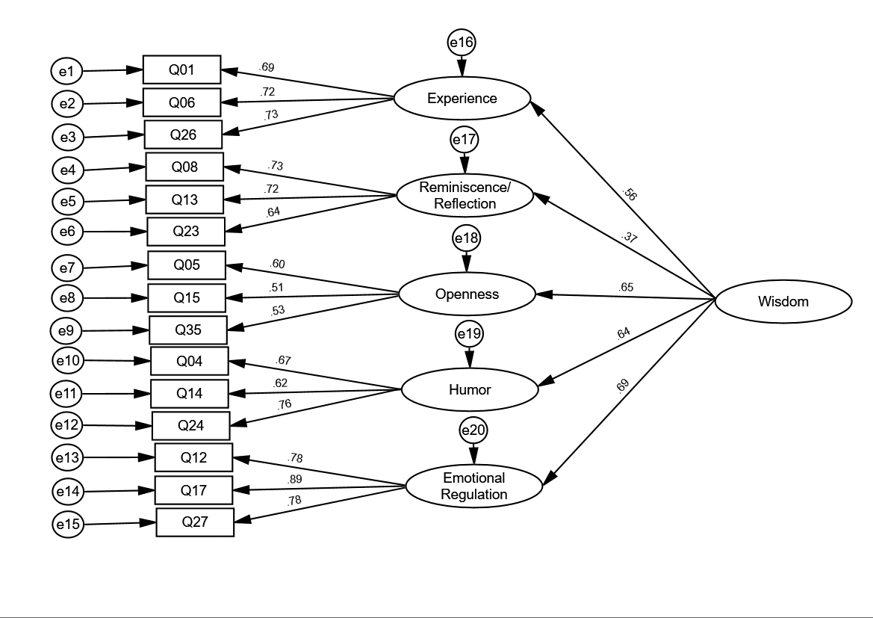
Note. Self-Assessed Wisdom Scale-15 higher order measurement model with standardized parameter estimates for a confirmatory factor analysis. Ovals represent latent variables, circles represent error terms, and rectangles represent observed variables.

