Supplementary Document
Table S1 The recoding method for education, leisure activities and health status.
Variables | Definition | Recoding method in SPSS
 |  | Used for the description of baseline characteristics | Used for the Multinomial Logistic Regression Analysis
Education | Years of schooling. | 0 = "without schooling" | 0 = “without schooling education”
 |  | 1 = "1-6 years" | 1 = “having schooling education”
 |  | 2 = "≥ 6 years"
Frequency of leisure activity | The frequency of leisure activity defined as two categorical (low and high). The sum score of the eight activities ranges from 8 to 40, with a low score representing a high frequency. The high frequency was defined as “being scored at 40th percentile or below”, and low frequency as “being scored over 40th percentile”. | 0 = "low frequency leisure activity" | Same as descriptive data
 |  | 1 = "high frequency leisure activity"
Health Status
BMI | Body mass index, calculated as weight in kilograms divided by height in meters squared. | 0 = "underweight (< 18.5 kg/m²)" | 1="underweight"
 |  | 1 = "normal (18.5 - 23.9 kg/m²)" | 2="normal"
 |  | 2 = "overweight (24 - 27.9 kg/m²)" | 0="combined overweight & obese "
 |  | 3 = "obese (≥28 kg/m²)"
CVDs | Includes four diseases: cardiovascular diseases, hypertension, diabetes heart disease, cerebrovascular disease. | 0 = "CVDs (+), having at least one CVD" | Same as descriptive data
 |  | 1 = "CVDs (-), without CVD"
Other chronic diseases (non-CVDs) | Includes eight diseases: bronchitis, emphysema, pneumonia, asthma; tuberculosis; cancer; gastric or duodenal ulcer and arthritis. | 0 = "non-CVDs (+), having at least one non-CVD" | Same as descriptive data
 |  | 1 = "non-CVDs (-), without non-CVD"

Table S2 Average Posterior Probabilities of Group Assignment and Bayesian Information Criterion (BIC) Statistics of Model Fit
 | Group 1 | Group 2 | Group 3 | Group 4 | Group 5 | BIC  (N=9311) | BIC (N=2038)
2 groups | 0.94 | 0.99 |  |  |  | -23947.48 | -23939.89
3 groups | 0.93 | 0.86 | 0.97 |  |  | -23778.93 | -23767.54
4 groups | 0.92 | 0.90 | 0.80 | 0.97 |  | -23579.13 | -23563.94
5 groups | 0.92 | 0.91 | 0.81 | 0.89 | 0.97 | -23479.75 | -23460.76

Table S3 The Maximum Likelihood Estimates from the Censored Normal Model
Parameter | Estimate |  | Standard  Error |  | T for H0:  Parameter=0
Intercept | 27.989 |  | 0.285 |  | 98.104***
Linear | -0.746 |  | 0.285 |  | -2.621**
Quadratic | -0.176 |  | 0.064 |  | -2.759**
Cubic | 0.014 |  | 0.004 |  | 3.887***
Intercept | 28.179 |  | 0.499 |  | 56.518***
Linear | -3.119 |  | 0.647 |  | -4.823***
Quadratic | 0.885 |  | 0.193 |  | 4.593***
Cubic | -0.096 |  | 0.014 |  | -6.761***
Intercept | 29.526 |  | 0.114 |  | 259.623***
Linear | -0.333 |  | 0.047 |  | -7.163***
Quadratic | 0.016 |  | 0.004 |  | 4.097***
Sigma | 4.555 |  | 0.042 |  | 108.158***
Group membership
Group 1 (%) |  | 14.0 |  | 1.061 |  | 13.227***
Group 2 (%) |  | 4.5 |  | 0.512 |  | 8.821***
Group 3 (%) |  | 81.5 |  | 1.120 |  | 72.741***
BIC=-23774.7 (N=9311) BIC=-23764.1 (N=2038) |  |  |  |  | AIC=-23724.8
* P < 0.05, ** P < 0.01, *** P < 0.001.

Figure S1 Trajectories of Mini-Mental State Examination (MMSE) scores with different groups: 2 groups (A), 4 groups (B) and 5 groups (C). The solid lines represent estimated values, and the dotted lines show the 95% confidence intervals.

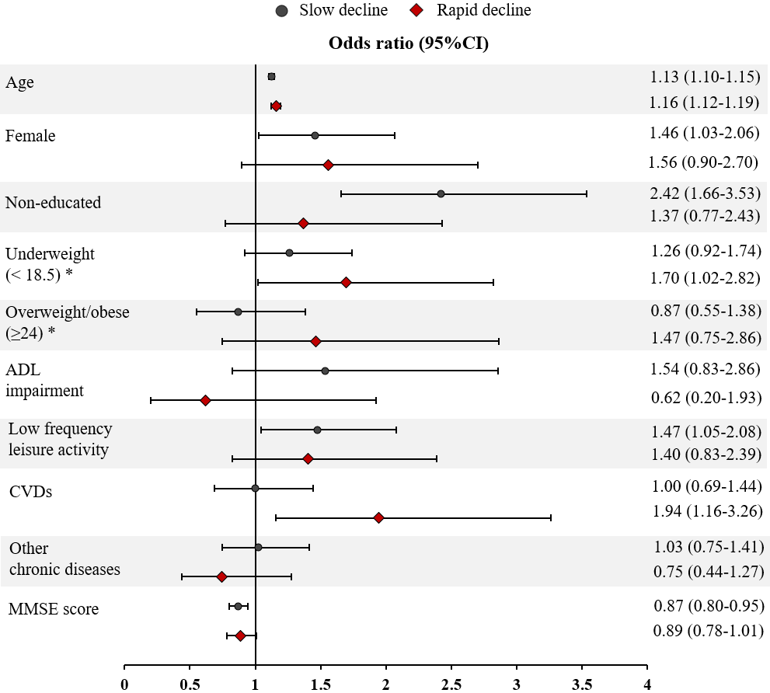
Figure S2 Odds Ratios and 95% Confidence Intervals (CIs) for the Association Between Baseline Variables and Cognitive Trajectory Groups After Logistic Regression Analysis. *Normal weight as reference. ADL, activities of daily living; CVD, cardiovascular diseases; MMSE, Mini-Mental State Examination.

Figure S3 Trajectories of Mini-Mental State Examination (MMSE) Scores with the Attrition Extension.

