Appendix Table A1. Internal Consistency and Dimensionality Estimates for the Perceived Stress Scale (PSS) by Wave of the Interview

|  |  |  |  |  |
| --- | --- | --- | --- | --- |
|  | *N* | Ordinal alpha | McDonald's omega total | Explained common variance (ECV) |
| PSS baseline | 453 | 0.902 | 0.904 | 68.335 |
| PSS first follow-up | 343 | 0.894 | 0.897 | 63.067 |
| PSS second follow-up | 301 | 0.901 | 0.904 | 73.397 |
| PSS third follow-up | 219 | 0.901 | 0.904 | 73.397 |

All analyses were based on polychoric correlations.

|  |  |  |  |
| --- | --- | --- | --- |
| Appendix Table A2. Perceived Stress Scale (PSS) Eigenvalues  Across Age, Education, and Language Subgroups | | | |
| Statistic | Component 1 | Component 2 | Ratio |
| Component 1/ Component 2 |
| Total sample (*n* = 453) | | |  |
| Eigenvalues | 5.374 | 1.114 | 4.8 |
| Explained variance | 53.7% | 11.1% |
| Age 19 to 59 (*n* = 255) | | |  |
| Eigenvalues | 5.677 | 1.037 | 5.5 |
| Explained variance | 56.8% | 10.4% |
| Age 60 to 92 (*n* = 197) | | |  |
| Eigenvalues | 5.010 | 1.248 | 4.0 |
| Explained variance | 50.1% | 12.5% |
| Education: High school or less (*n* = 244) | | |  |
| Eigenvalues | 5.372 | 1.169 | 4.6 |
| Explained variance | 53.7% | 11.7% |
| Education: Post high school (*n* = 201) | | |  |
| Eigenvalues | 5.394 | 1.145 | 4.7 |
| Explained variance | 53.9% | 11.5% |
| Language of the interview: English (*n* = 154) | | |  |
| Eigenvalues | 5.602 | 1.045 | 5.4 |
| Explained variance | 56.0% | 10.5% |
| Language of the interview: Spanish (*n* = 299) | | |  |
| Eigenvalues | 5.267 | 1.167 | 4.5 |
| Explained variance | 52.7% | 11.7% |

Appendix Table A3. Item Loadings / Factor Structure (λ) from the Unidimensional and Two-Factor EFA/ CFA Solutions After Rotation (MPlus)

|  |  |  |  |  |
| --- | --- | --- | --- | --- |
| Item name | Item description | Total sample (*n* = 453) | | |
| One fact.*  λ (*SE*) | Two factor solution  factor structure | |
| F1 λ (*SE*) | F2 λ (*SE*) |
| pss1 | In the last month, how often have you been upset because of something that happened unexpectedly? | 0.74 (0.02) | 0.82 (0.06) | 0.43 (0.08) |
| Pss2 | In the last month, how often have you felt that you were unable to control the important things in your life? | 0.77 (0.03) | 0.75 (0.05) | 0.62 (0.06) |
| Pss3 | In the last month, how often have you felt nervous and stressed? | 0.82 (0.02) | 0.82 (0.04) | 0.64 (0.05) |
| Pss4R‡ | In the last month, how often have you felt confident about your ability to handle your personal problems? | 0.57 (0.03) | 0.42 (0.06) | **0.66 (0.05)** |
| Pss5R | In the last month, how often have you felt that things were going your way? | 0.62 (0.03) | 0.50 (0.06) | **0.64 (0.06)** |
| Pss6 | In the last month, how often have you felt that you could not cope with all the things you had to do? | 0.68 (0.03) | 0.65 (0.06) | 0.57 (0.06) |
| Pss7R | In the last month, how often have you been able to control irritations in your life? | 0.59 (0.03) | 0.44 (0.06) | **0.66 (0.05)** |
| Pss8R | In the last month, how often have you felt that you were on top of things? | 0.71 (0.03) | 0.52 (0.01) | **0.82 (0.03)** |
| Pss9 | In the last month, how often have you been angered because of things that happened that were outside of your control? | 0.74 (0.02) | 0.78 (0.02) | 0.50 (0.004) |
| pss10 | In the last month, how often have you felt difficulties were piling up so high that you could not overcome them? | 0.80 (0.02) | 0.78 (0.05) | 0.66 (0.06) |

* Geomin (oblique) rotation

‡ R in the item name indicates the reversal of the original response categories to align their direction with the rest of the items measuring perceived stress

Appendix Table A4. Distribution of the Summary Score Mapped to the Perceived Stress Estimate Theta (θ; IRTPRO) (*N* = 453)

|  |  |  |  |  |  |  |  |
| --- | --- | --- | --- | --- | --- | --- | --- |
| Summed score | Frequency | Percent | Cumulative percent | θestimate | θ *SD* | Modeled proportion | Cumulative modeled percent |
| 10 | 9 | 2.0% | 2.0% | -2.291 | 0.509 | 1.2% | 1.2% |
| 11 | 5 | 1.1% | 3.1% | -1.939 | 0.431 | 1.4% | 2.5% |
| 12 | 9 | 2.0% | 5.1% | -1.746 | 0.411 | 1.8% | 4.3% |
| 13 | 8 | 1.8% | 6.8% | -1.556 | 0.378 | 2.0% | 6.3% |
| 14 | 11 | 2.4% | 9.3% | -1.400 | 0.360 | 2.2% | 8.5% |
| 15 | 8 | 1.8% | 11.0% | -1.256 | 0.344 | 2.4% | 11.0% |
| 16 | 17 | 3.8% | 14.8% | -1.126 | 0.332 | 2.6% | 13.6% |
| 17 | 13 | 2.9% | 17.7% | -1.003 | 0.323 | 2.8% | 16.4% |
| 18 | 12 | 2.6% | 20.3% | -0.887 | 0.317 | 3.0% | 19.4% |
| 19 | 10 | 2.2% | 22.5% | -0.775 | 0.313 | 3.2% | 22.7% |
| 20 | 14 | 3.1% | 25.6% | -0.666 | 0.310 | 3.4% | 26.1% |
| 21 | 14 | 3.1% | 28.7% | -0.560 | 0.309 | 3.6% | 29.7% |
| 22 | 8 | 1.8% | 30.5% | -0.455 | 0.309 | 3.8% | 33.5% |
| 23 | 12 | 2.6% | 33.1% | -0.351 | 0.309 | 4.0% | 37.4% |
| 24 | 14 | 3.1% | 36.2% | -0.248 | 0.310 | 4.1% | 41.6% |
| 25 | 21 | 4.6% | 40.8% | -0.144 | 0.311 | 4.3% | 45.8% |
| 26 | 14 | 3.1% | 43.9% | -0.041 | 0.312 | 4.4% | 50.2% |
| 27 | 22 | 4.9% | 48.8% | 0.062 | 0.313 | 4.4% | 54.6% |
| 28 | 20 | 4.4% | 53.2% | 0.166 | 0.314 | 4.4% | 59.0% |
| 29 | 24 | 5.3% | 58.5% | 0.270 | 0.315 | 4.3% | 63.3% |
| 30 | 25 | 5.5% | 64.0% | 0.374 | 0.315 | 4.1% | 67.4% |
| 31 | 21 | 4.6% | 68.7% | 0.478 | 0.315 | 3.9% | 71.4% |
| 32 | 26 | 5.7% | 74.4% | 0.583 | 0.314 | 3.7% | 75.0% |
| 33 | 22 | 4.9% | 79.2% | 0.687 | 0.314 | 3.4% | 78.4% |
| 34 | 17 | 3.8% | 83.0% | 0.792 | 0.313 | 3.1% | 81.4% |
| 35 | 13 | 2.9% | 85.9% | 0.898 | 0.312 | 2.8% | 84.2% |
| 36 | 11 | 2.4% | 88.3% | 1.004 | 0.312 | 2.5% | 86.7% |
| 37 | 10 | 2.2% | 90.5% | 1.110 | 0.313 | 2.2% | 88.9% |
| 38 | 11 | 2.4% | 92.9% | 1.218 | 0.314 | 2.0% | 90.8% |
| 39 | 13 | 2.9% | 95.8% | 1.327 | 0.317 | 1.7% | 92.6% |
| 40 | 5 | 1.1% | 96.9% | 1.439 | 0.321 | 1.5% | 94.1% |
| 41 | 4 | 0.9% | 97.8% | 1.554 | 0.327 | 1.3% | 95.4% |
| 42 | 5 | 1.1% | 98.9% | 1.673 | 0.334 | 1.1% | 96.5% |
| 43 | 1 | 0.2% | 99.1% | 1.797 | 0.344 | 0.9% | 97.4% |
| 44 | 3 | 0.7% | 99.8% | 1.929 | 0.356 | 0.8% | 98.2% |
| 45 | 0 | 0.0% | 99.8% | 2.068 | 0.370 | 0.6% | 98.8% |
| 46 | 0 | 0.0% | 99.8% | 2.219 | 0.387 | 0.5% | 99.3% |
| 47 | 0 | 0.0% | 99.8% | 2.379 | 0.406 | 0.3% | 99.6% |
| 48 | 0 | 0.0% | 99.8% | 2.563 | 0.433 | 0.2% | 99.8% |
| 49 | 0 | 0.0% | 99.8% | 2.754 | 0.455 | 0.1% | 100.0% |
| 50 | 1 | 0.2% | 100.0% | 3.034 | 0.507 | 0.0% | 100.0% |
| Total | 453 | 100.0%% | 100.0% |  |  | 100.0% | 100.0% |

NOTE: The item and sum scores are in the direction of a higher score reflecting higher levels of stress.

Appendix Figure A1. Test Information Function (IRTPRO)

Total Sample (*N* = 453)



Appendix Figure A2. Item Information Functions (IRTPRO)

Total Sample (*n* = 453)



Appendix Figure A3. Items Identified with DIF by *lordif*

Total Sample (*N* = 453)

Item 5: “In the last month, how often have you felt that things were going your way?”

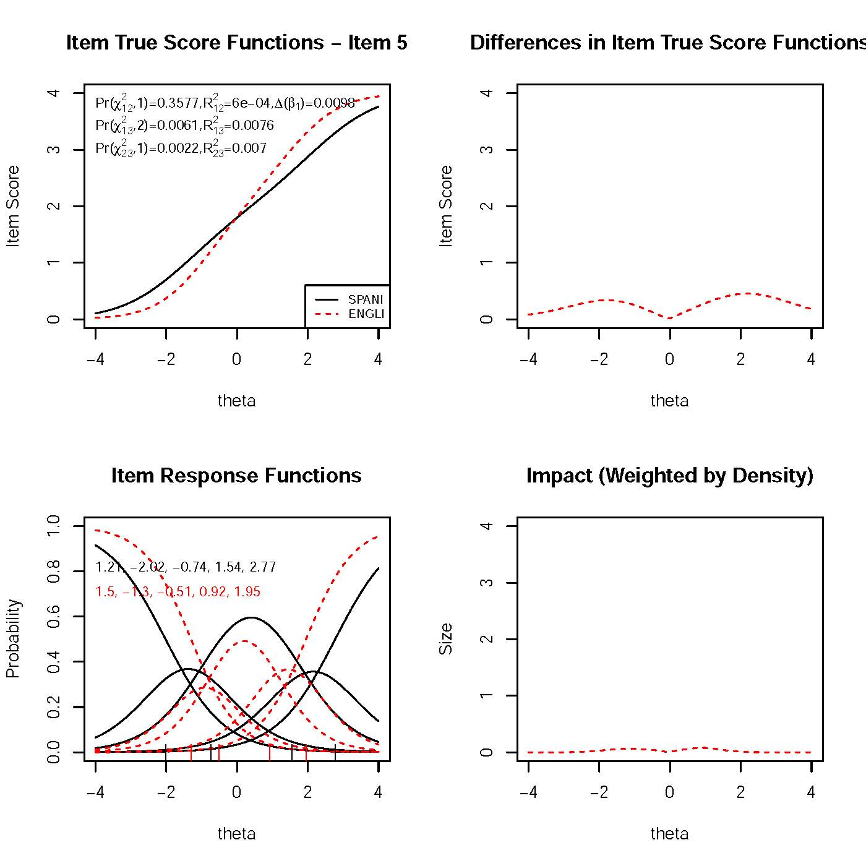

Item 8: “In the last month, how often have you felt that you were on top of things?” 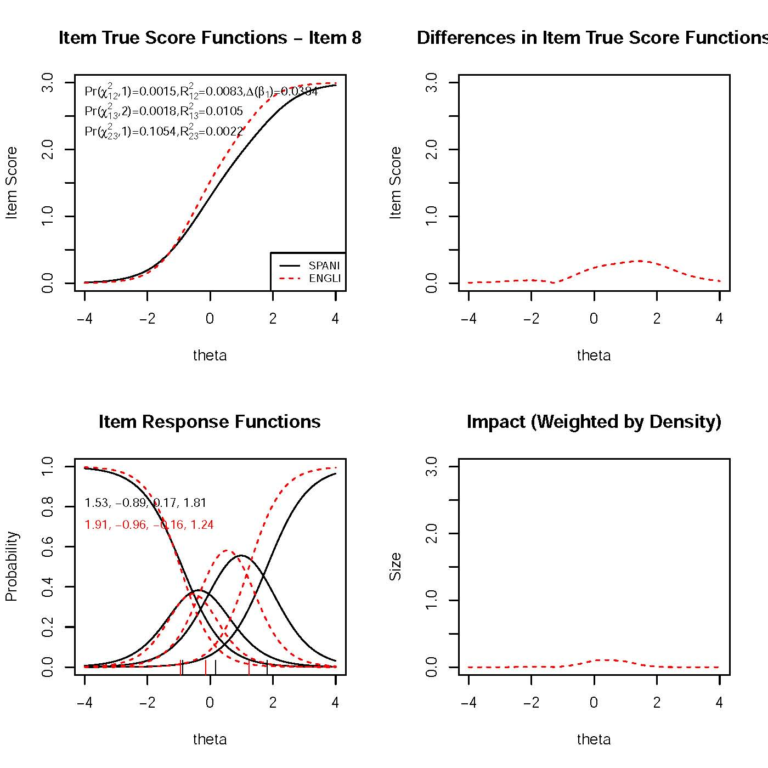

Item 10: “In the last month, how often have you felt difficulties were piling up so high that you could not overcome them?”

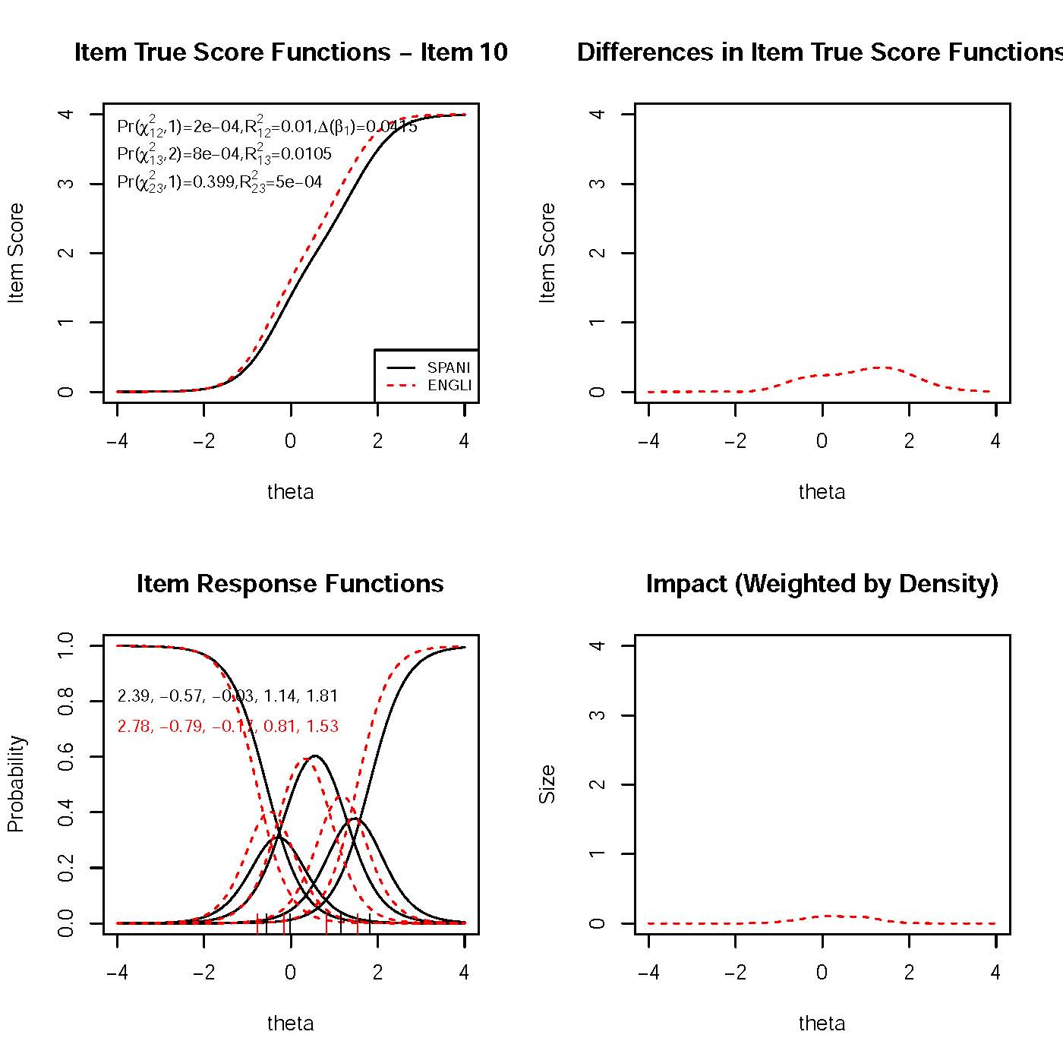

Appendix Figure A4. Perceived Stress Scale (PSS) Trait Distributions for the Language of the Interview Groups Estimated by *lordif*  (Total Sample N = 453)

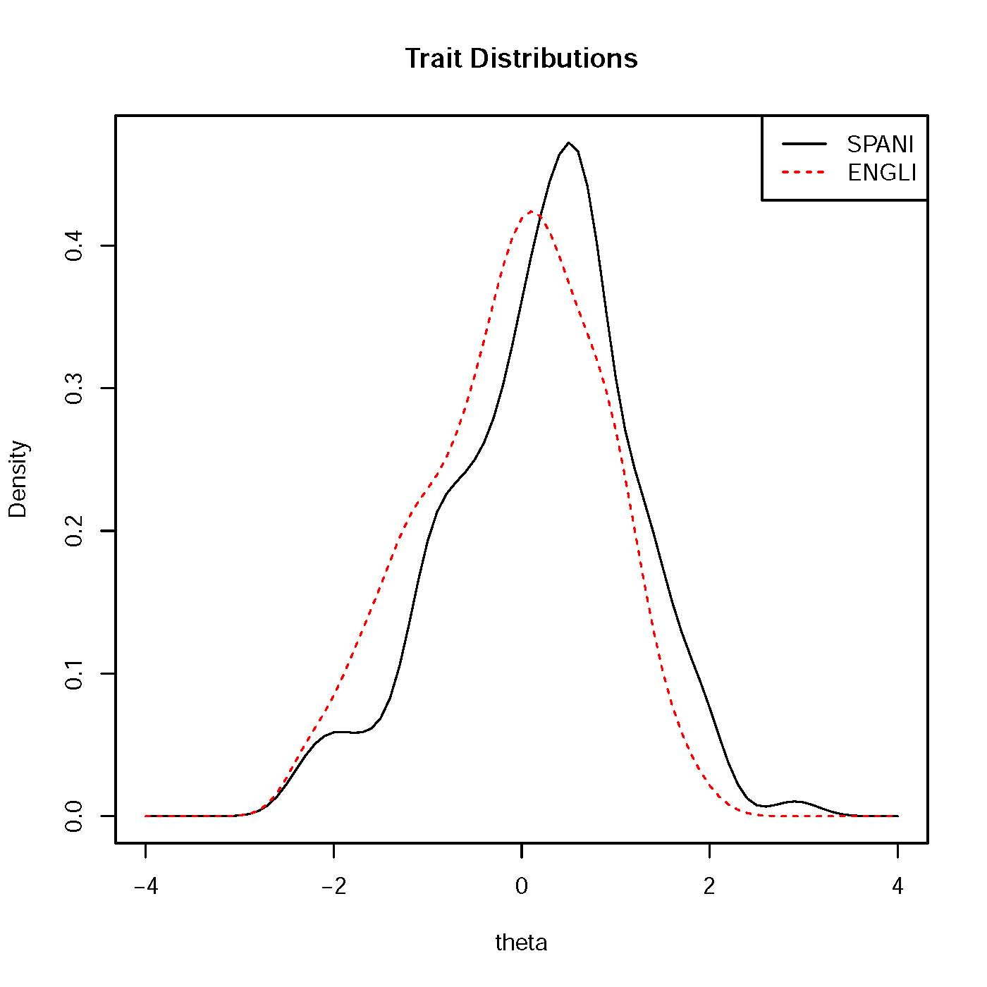

Appendix Figure A5. Impact of DIF Identified by *lordif*

Total Sample (*N* = 453)

