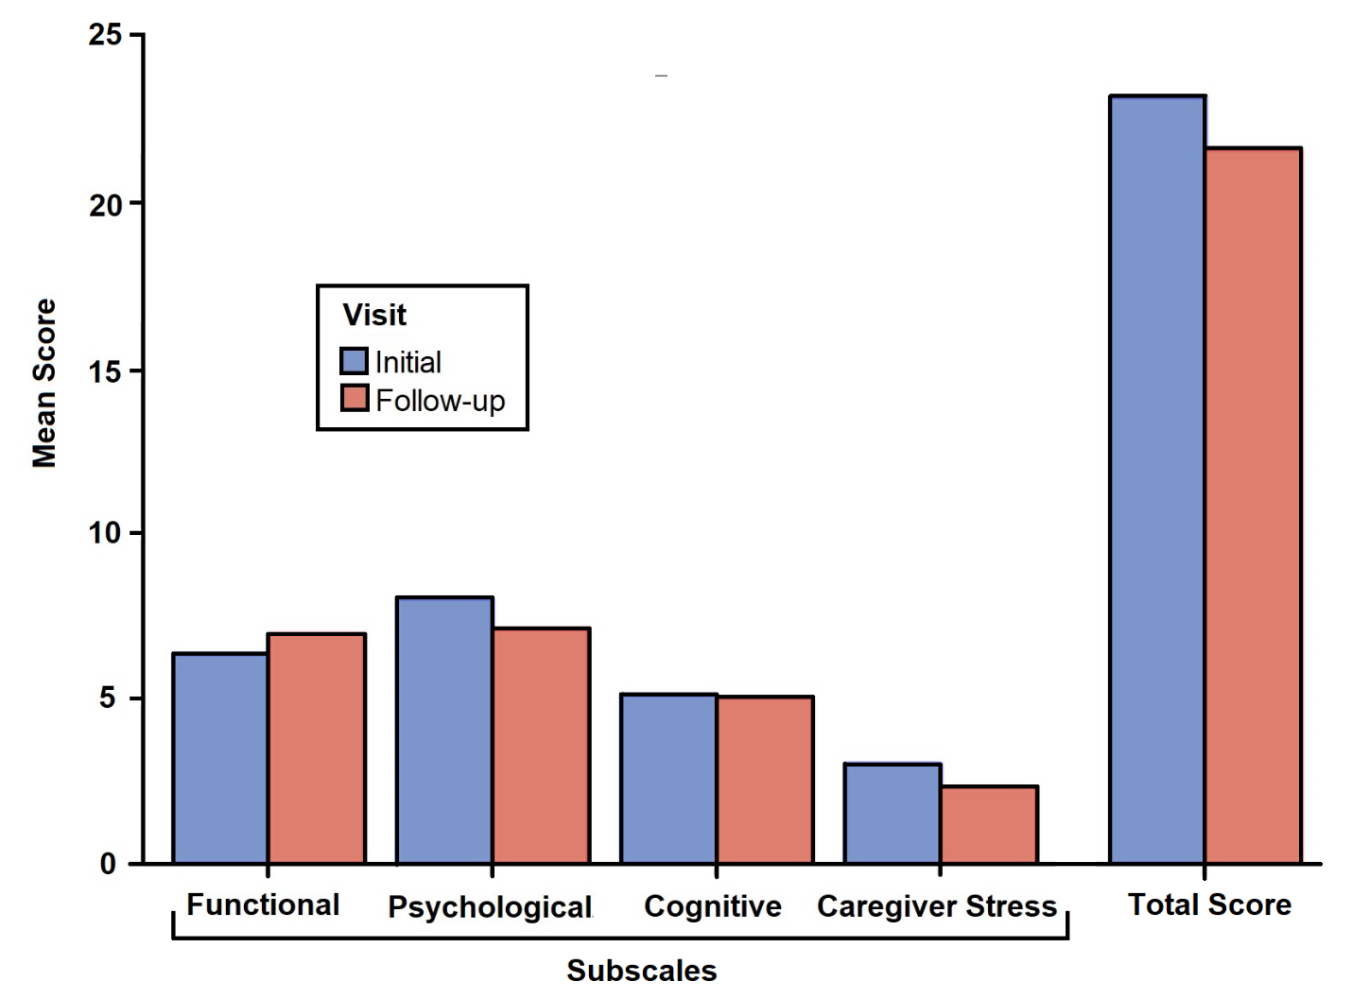 Supplementary Figure 1. Longitudinal monitoring of patients’ symptoms (n = 35) utilizing the Healthy Aging Brain Center Monitor Caregiver Version (HABC-M CG)

The maximum scores for cognitive, functional, psychological, and caregiver stress subscales are 18, 33, 30, and 12 respectively. The maximum total score for the HABC-M CG is 93. Higher numbers for the 4 subscales and the total score correlate with higher severity of symptoms.
Higher scores indicate higher severity of symptoms.

