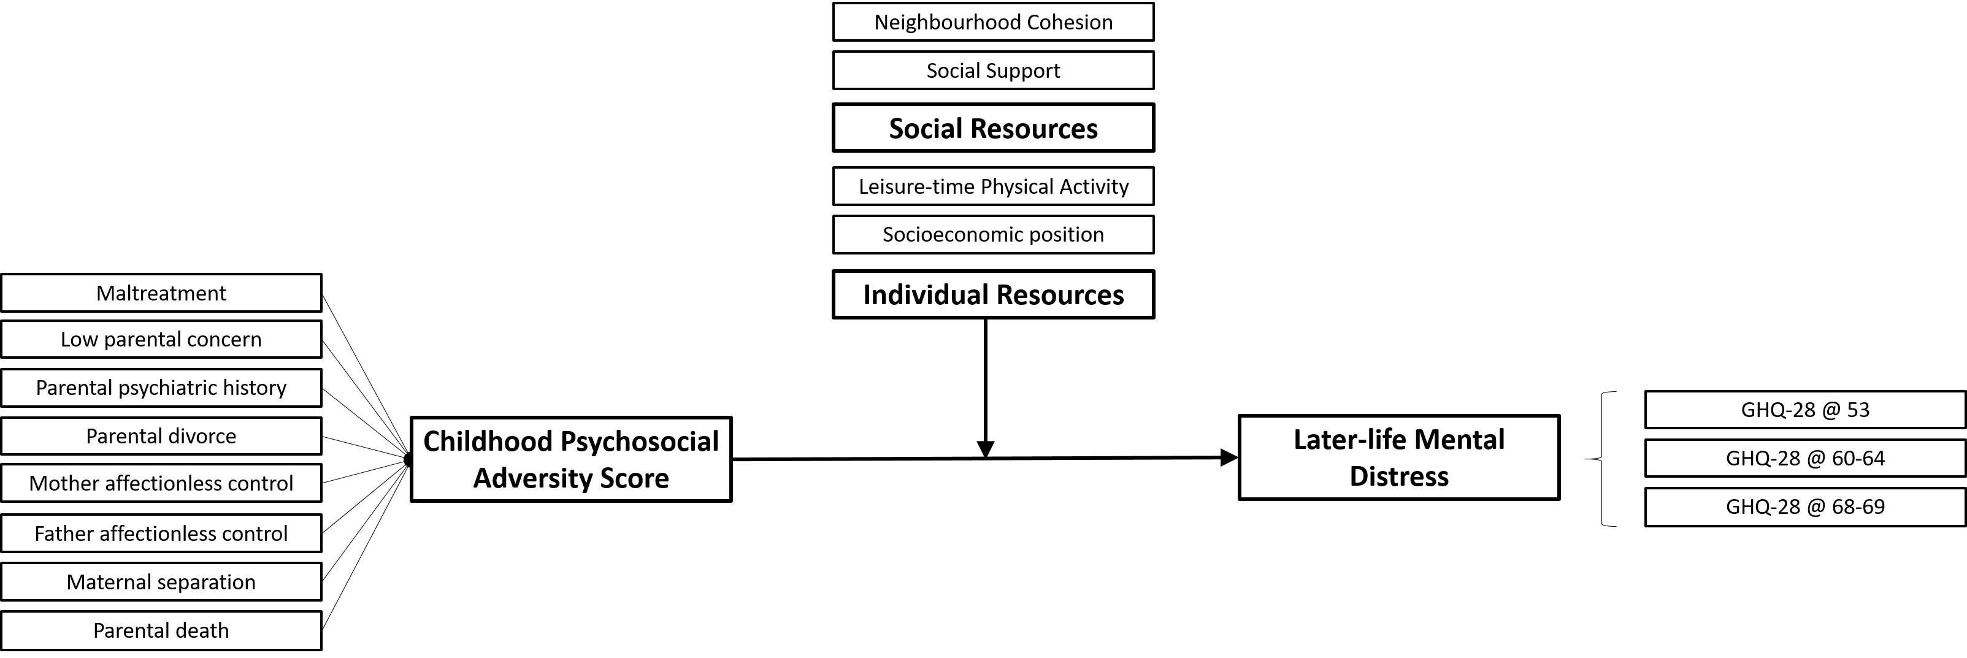

Supplementary Figure 1: Directed acyclic graph of the moderation of childhood psychosocial adversity score and later-life mental distress (at ages 53, 60-64, and 68-69) by individual and social resources

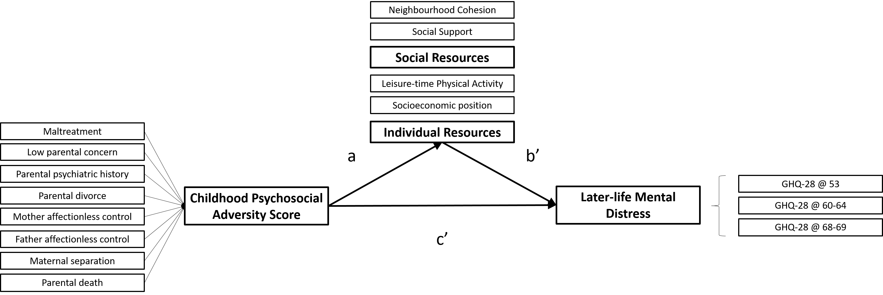

Supplementary Figure 2: Directed acyclic graph of the mediation of childhood psychosocial adversity score and later-life mental distress (at ages 53, 60-64, and 68-69) by individual and social resources

