Appendix A3.
Publication Bias Funnel Plots for Anxiety, Depression, Burden and Distress Meta-Analyses
Note. Displays observed (outlined) and imputed studies (filled)

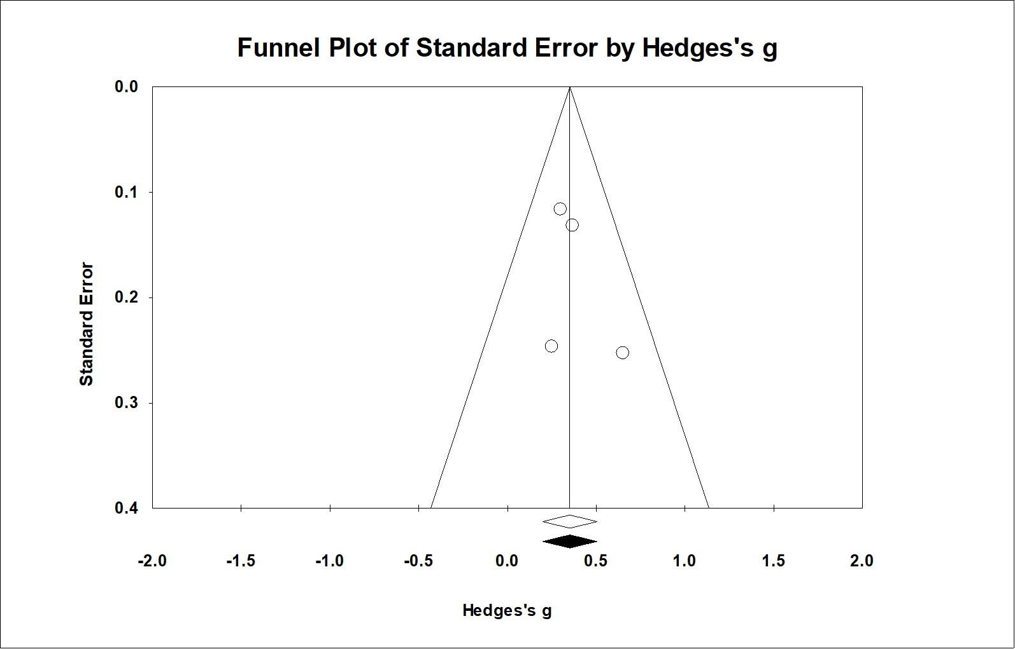
Anxiety

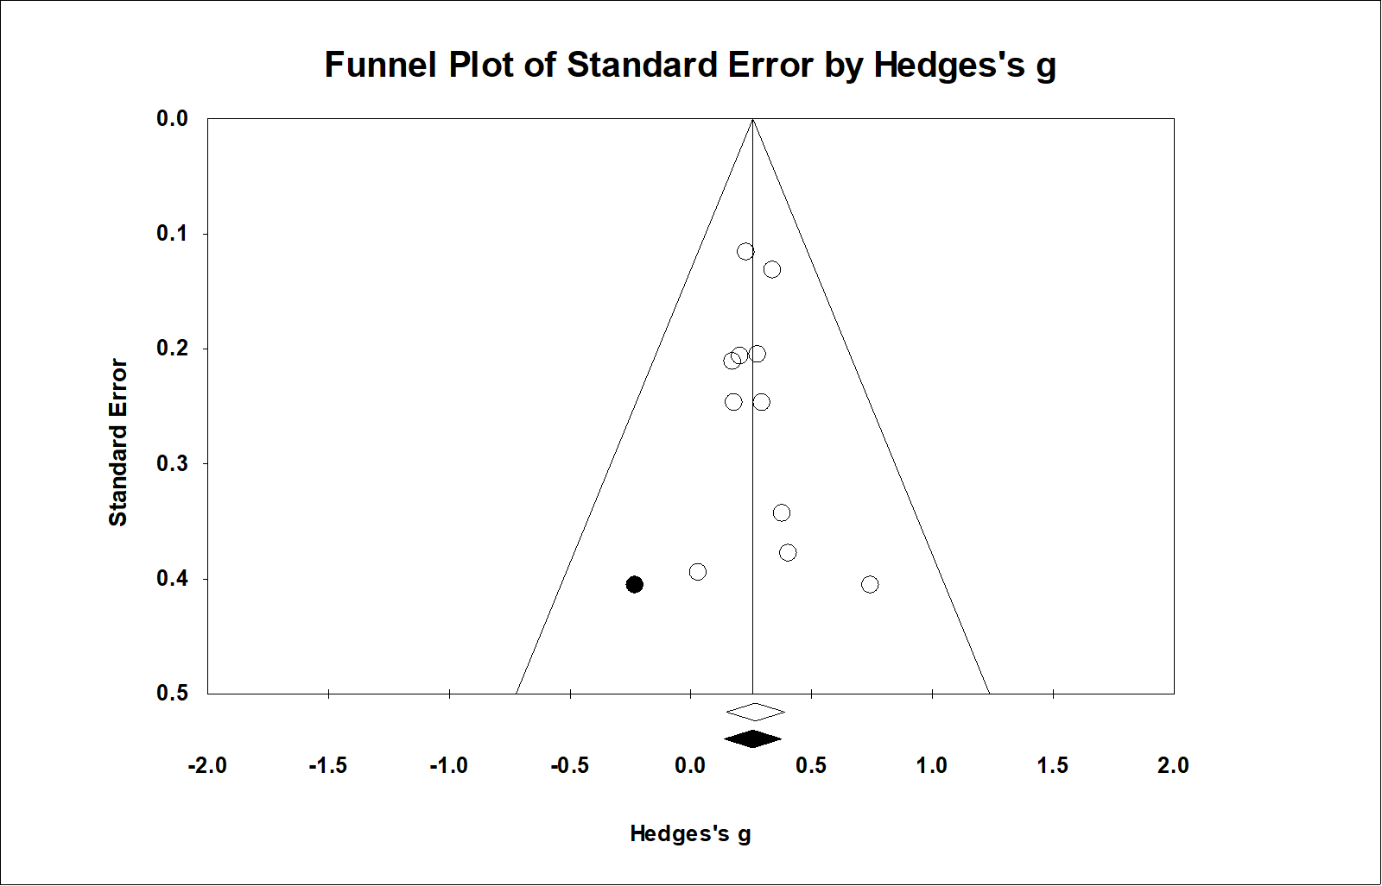
Depression

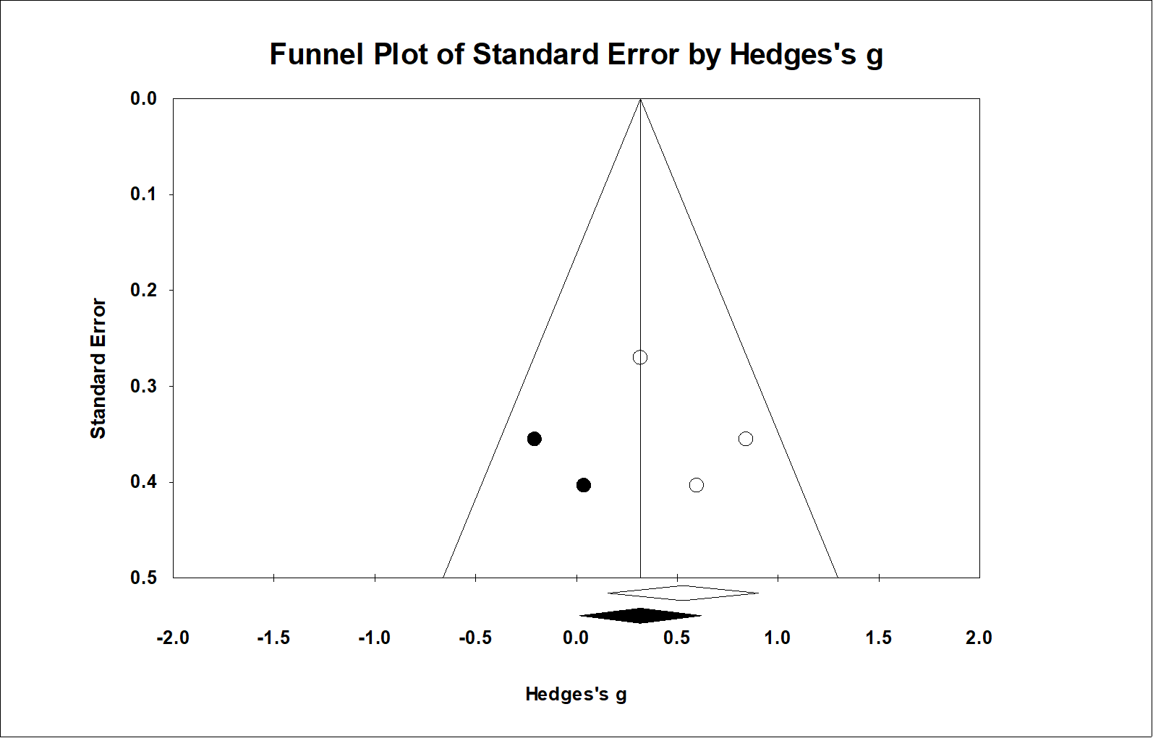
Burden

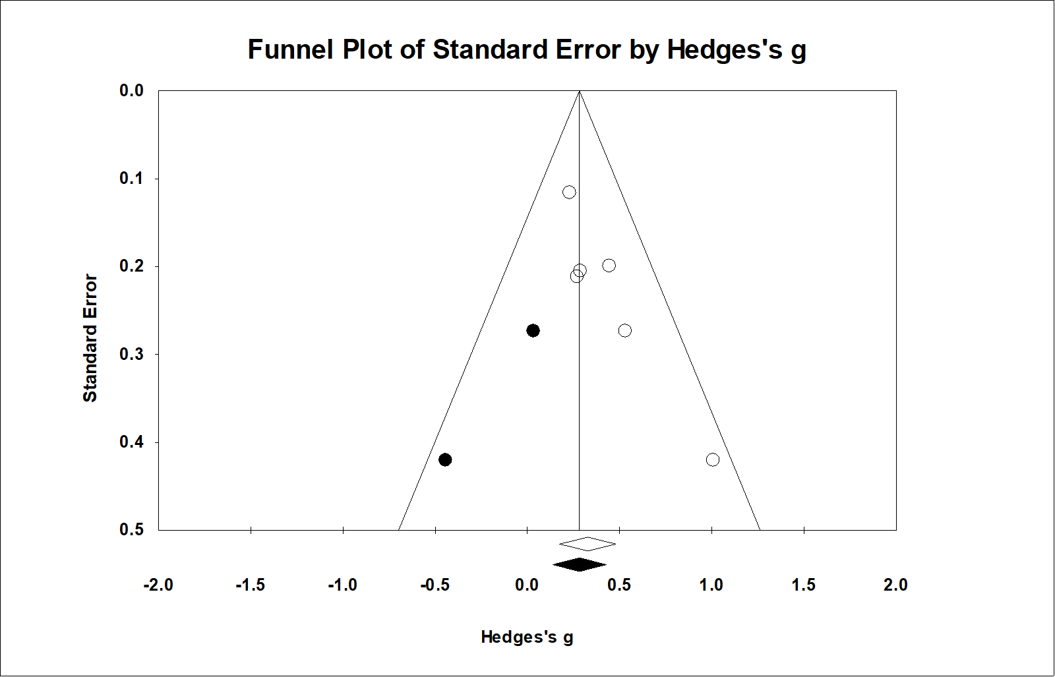
Distress

