Appendix A2.

Forest Plots for Meta-analyses of Anxiety, Depression, Burden and Distress Outcomes

Note. Favours A = favours control group; Favours B = favours intervention group.

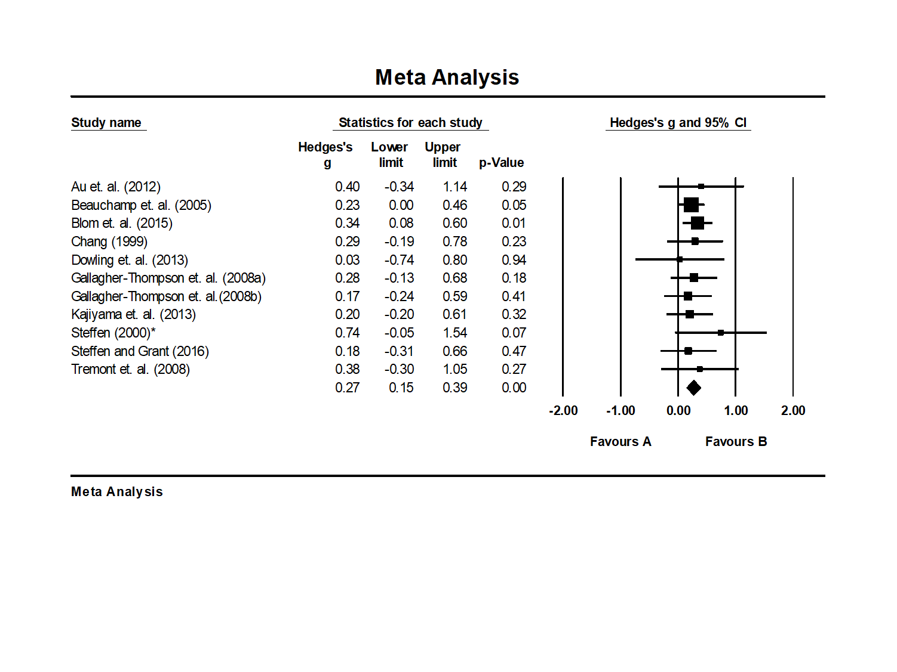
Depression
Anxiety

Distress
Burden

