Supplementary Table 4: Participants characteristics for participants with and without PAI-BOR data in Study 2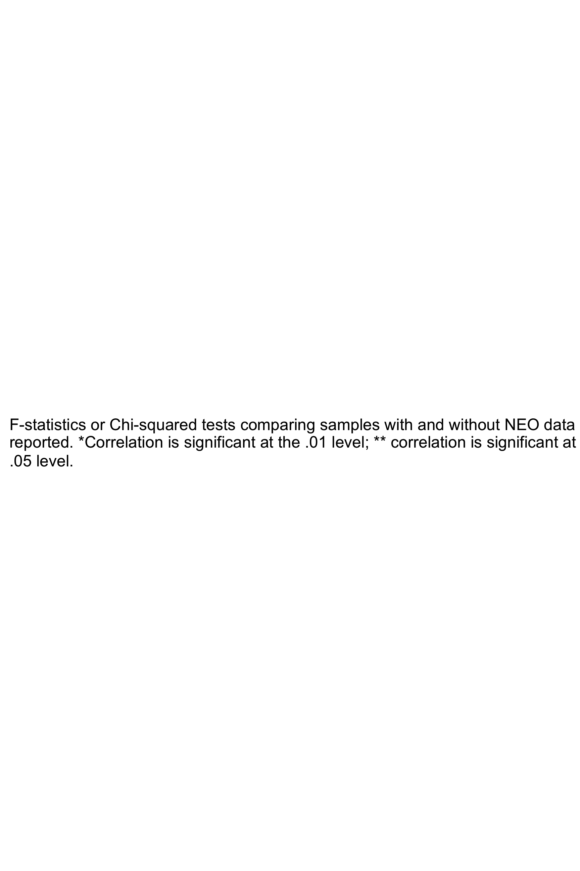data in Study 1

 | Study 2 Attempters total  (n = 69) | Study 2 Attempters with PAI-BOR  (n = 39) | Study 2  Attempters  missing PAI-BOR  (n = 30) | F or Chi sq | p-value
Female, no. (%) | 34 (49%) | 19 (49%) | 15 (50%) | .011 | .916
White, no. (%) | 63 (91%) | 34 (87%) | 29 (97%) | 1.92 | .166
Educational level, years (SD) | 14 (3.1) | 14.3 (2.9) | 13.5 (3.4) | .104 | .749
Age at baseline assessment (SD) | 61.3 (10.1)  [41-85] | 60.3 (9.7) | 62.4 (10.6) | .121 | .729
Age at most recent attempt (SD) | 60.9 (10.6)  [41-85] | 60.1 (9.7) | 61.9 (11.9) | 1.75 | .190
Total attempts (SD) | 2.2 (2) | 2.5 (2.4) | 1.9 (1.1) | 4.75* | .033
Suicidal intent (SD) | 17.9 (5.6) | 18.1 (4.9) | 17.7 (6.5) | 3.58 | .063
Lethality of most recent attempt (SD) | 3.5 (2) | 3.2 (2.1) | 4.0 (1.6) | 1.66 | .202
Violent method (%) | 9 (13%) | 4 (10%) | 5 (17%) | .614 | .433
F-statistics or Chi-squared tests comparing samples with and without NEO data are reported. *Correlation is significant at the .01 level; ** correlation is significant at the .05 level.

