Supplementary Table 3: Participants characteristics for participants with and without PAI-BOR data in Study 1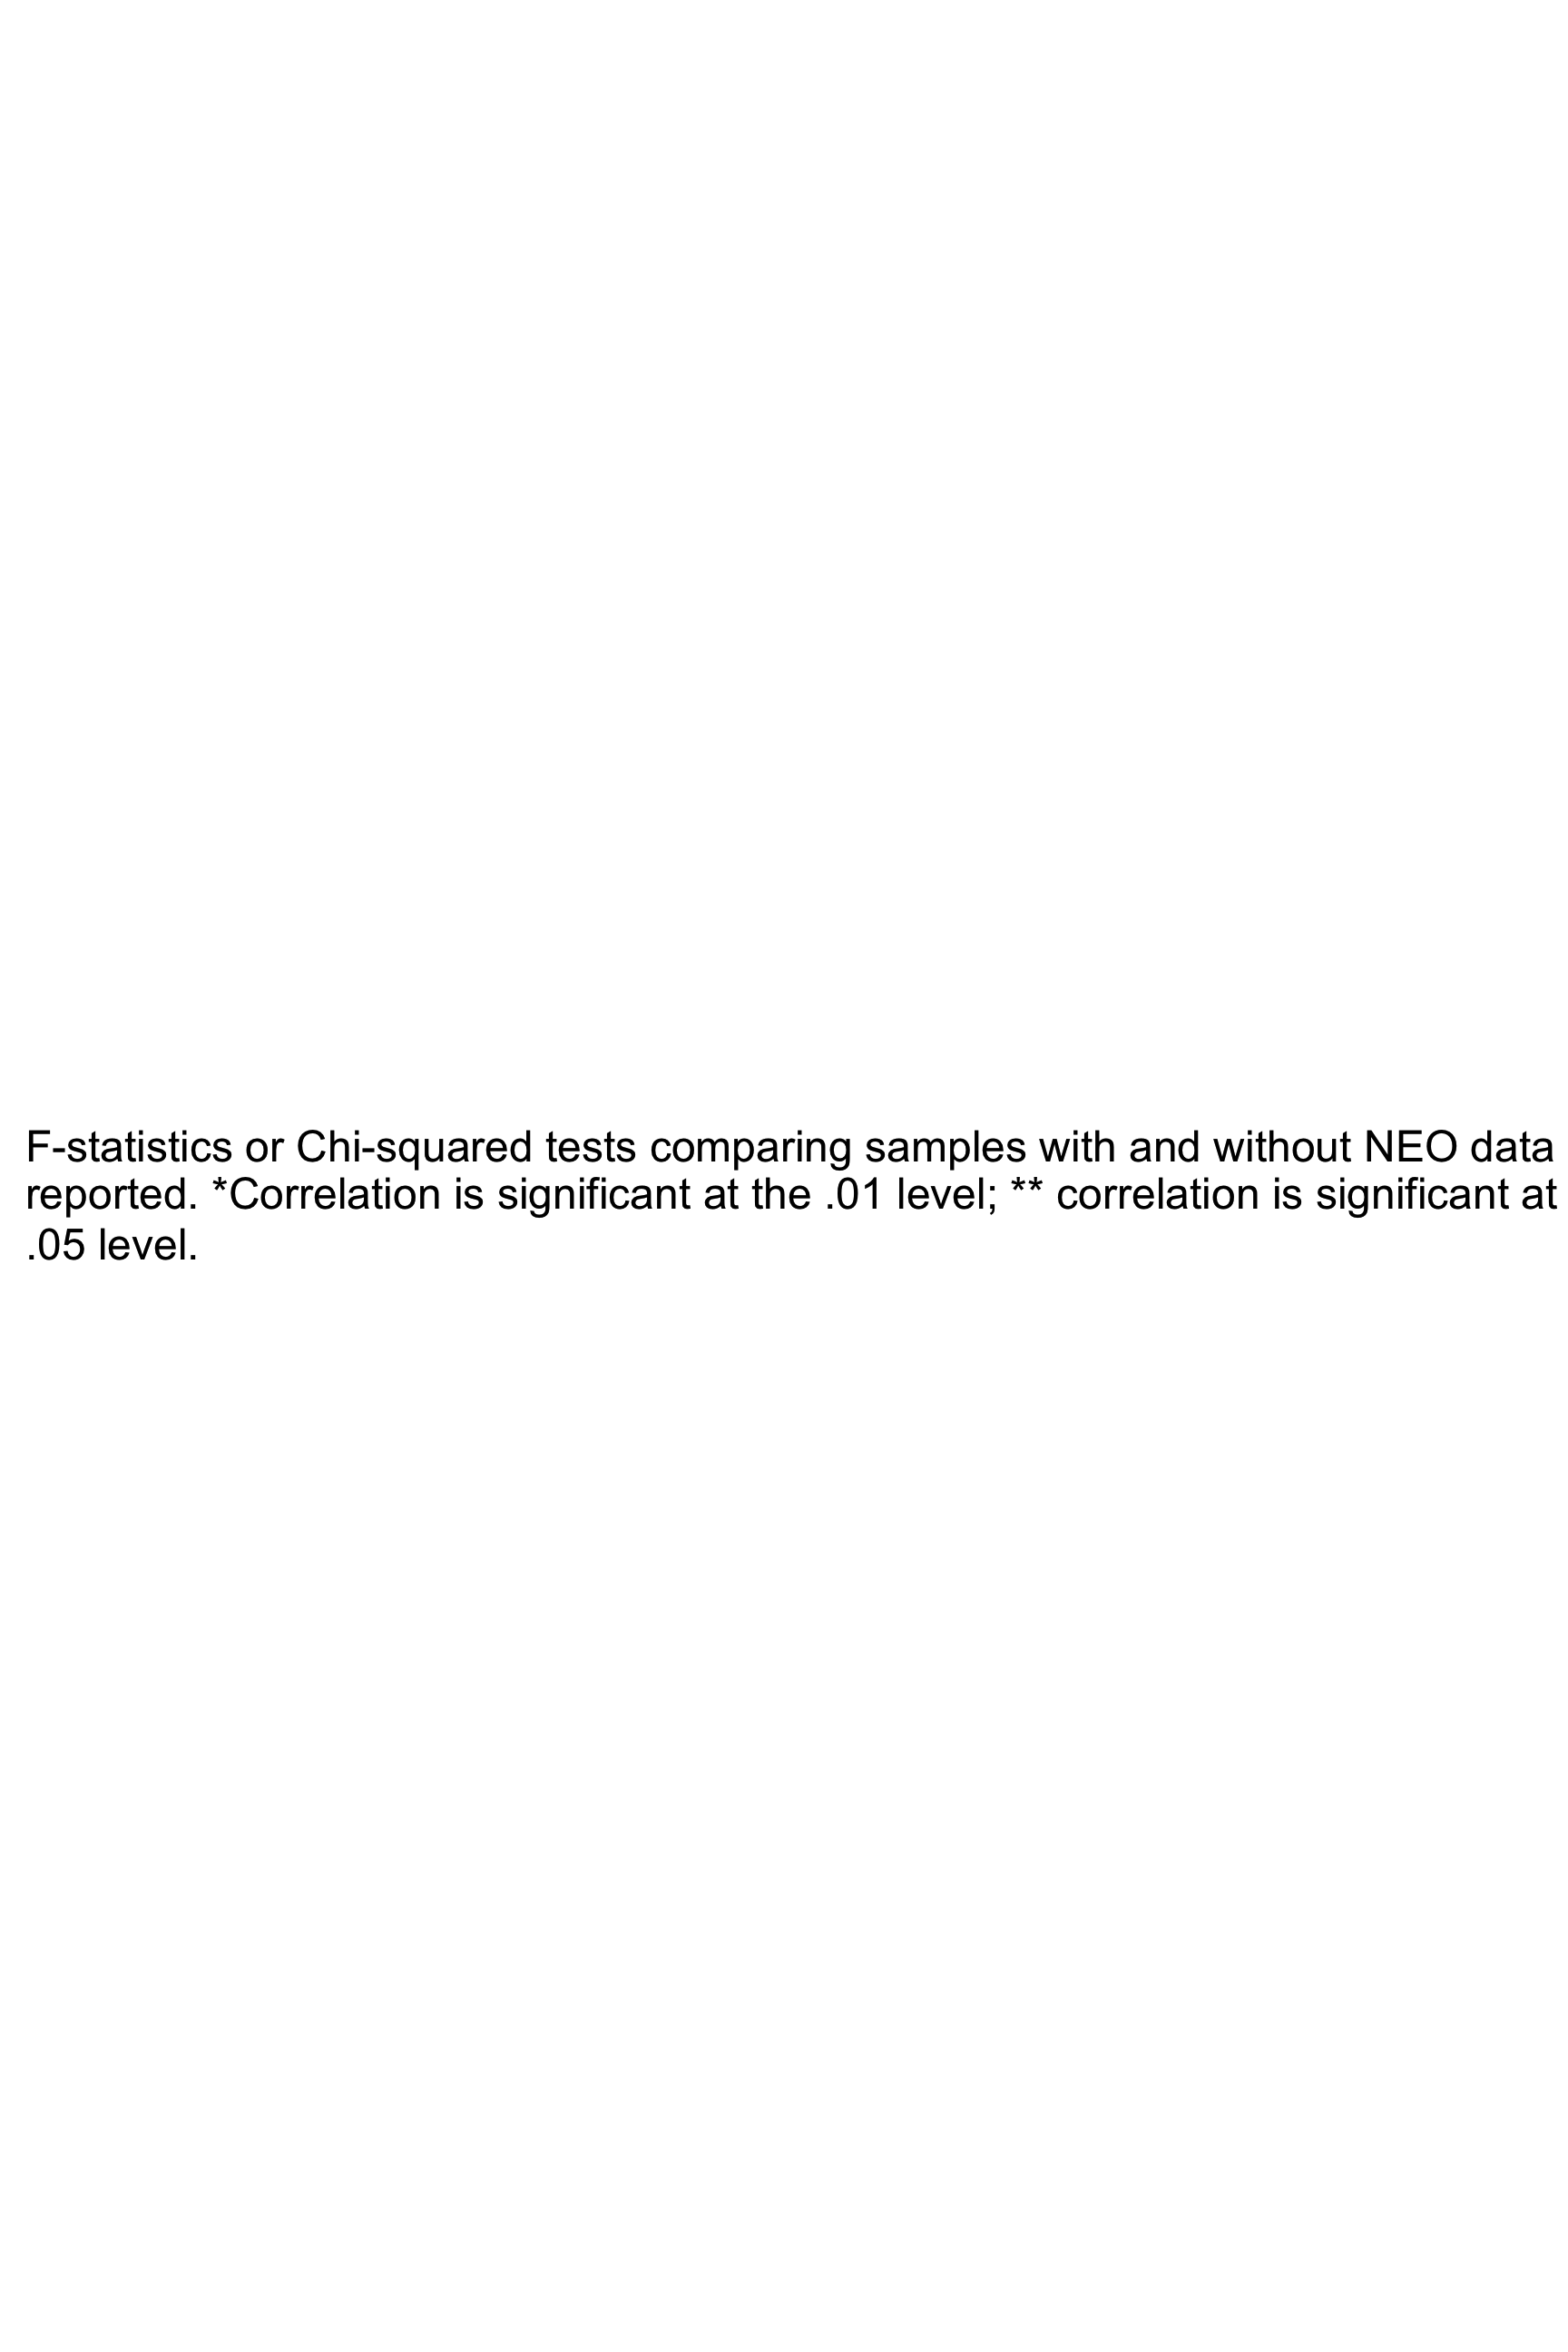data in Study 1
 | Study 1 Attempters total  (n = 50) | Study 1 Attempters with PAI-BOR  (n = 37) | Study 1  Attempters  missing PAI-BOR  (n = 13) | F or Chi sq | p-value
Female, no. (%) | 25 (50%) | 18 (49%) | 7 (54%) | .104 | .747
White, no. (%) | 44 (88%) | 32 (86%) | 12 (92%) | .309 | .578
Educational level, years (SD) | 14.1 (3) | 14.2 (2.8 | 13.9 (3.5) | .026 | .871
Age at baseline assessment (SD) | 61.1 (10)  [41-79] | 60.5 (9.9) | 62.7 (9.2) | .147 | .703
Age at most recent attempt (SD) | 60.4 (10.2)  [41-79] | 60.3 (9.9) | 60.9 (11.7) | 1.50 | .228
Total attempts (SD) | 2.4 (2.2) | 2.6 (2.4) | 1.8 (1.3) | 2.16 | .148
Suicidal intent (SD) | 18.4 (5.4) | 18.4 (4.7) | 18.4 (7.1) | 4.38* | .042
Lethality of most recent attempt (SD) | 3.4 (2.1) | 3.2 (2.2) | 4.0 (1.7) | .737 | .395
Violent method (%) | 6 (12%) | 4 (11%) | 2 (15%) | .191 | .662

F-statistics or Chi-squared tests comparing samples with and without NEO data are reported. *Correlation is significant at the .01 level; ** correlation is significant at the .05 level.

