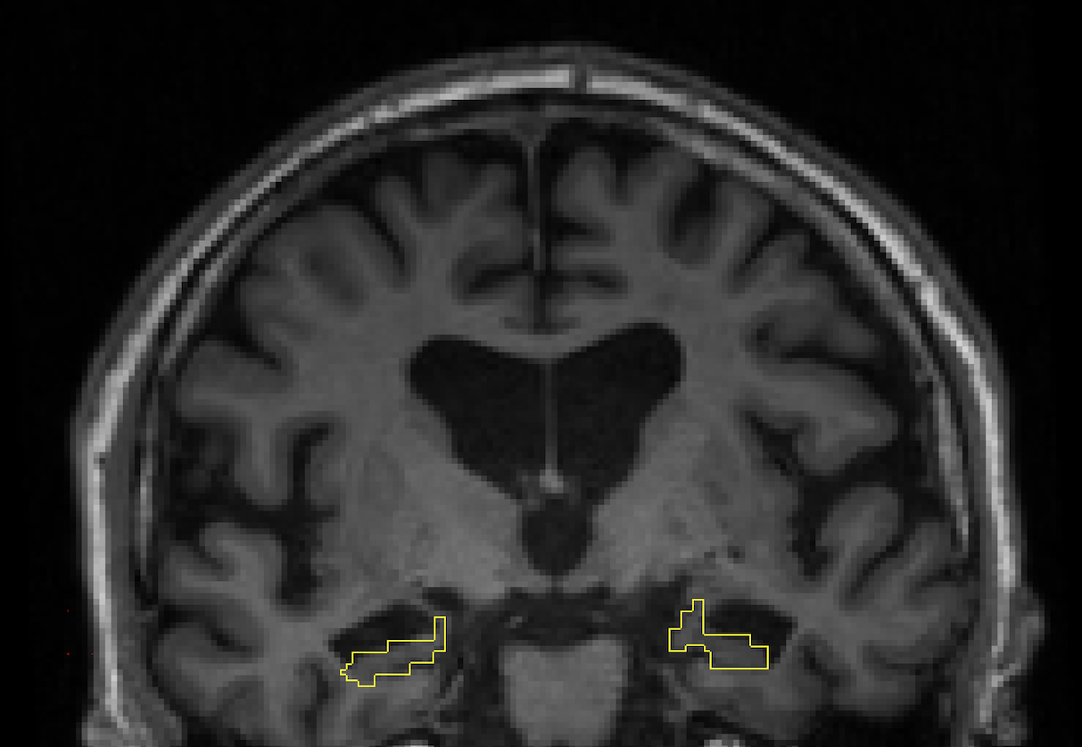

Supplementary Figure 1. For each subject, the resampled hippocampal segmentation in diffusion space was overlaid on his/her anatomical T1 to guide visual inspection of registrations. This figure illustrates the robustness of our analytical pipeline, even in subjects with prominent hippocampal atrophy.

