Supplementary table 1. Baseline demographic, clinical, magnetic resonance imaging morphometric and biomarker characteristics in subjects with mild cognitive impairment, grouped according to gender and APOE status
Gender | Male | Female | P value
APOE4,  % non-carrier/heterozygous/homozygous carrier | 48.3 / 40.5 / 11.3 | 45.1 / 42.4 / 12.5 | 0.42
Positive family history for dementia, % | 46.2 | 49.6 | .56
Age, years; mean (SD) | 73.4 (7.2) | 71.3 (7.6) | <0.001
Education, years; mean (SD) | 16.2 (3.0) | 15.3 (2.8) | <0.001
ADAS-Cog score, points; mean (SD) | 10.7 (4.4) | 10.1 (4.7) | .08
FAQ score, points; mean (SD) | 3.68 (4.3) | 2.68 (3.9) | .002
ICV, liters; mean (SD) | 1.62 (0.14) | 1.43 (0.12) | <0.001
Whole brain volume, % of ICV; mean (SD) | 66.74 (5.35) | 68.07 (5.04) | .002
Hippocampal volume, % of ICV; mean (SD) | 0.43 (0.08) | 0.46 (0.08) | <0.001
Medial temporal lobe volume, % of ICV; mean (SD) | 1.26 (0.17) | 1.29 (0.18) | .03
CSF Aß₁₋₄₂, pg/ml; mean (SD) | 172.5 (54) | 172.8 (49) | 0.96
CSF t-tau, pg/ml; mean (SD) | 79.5 (42) | 92.7 (60) | .05
APOE status | APOE4 non-carrier | APOE4 carrier | P value
Gender, % men | 60.2 | 57.1 | 0.24
Positive family history for dementia, % | 16.3 | 23.5 | .15
Age, years; mean (SD) | 73.2 (7.9) | 72.6 (7.0) | 0.32
Education, years; mean (SD) | 16.0 (2.9) | 15.6 (3.0) | 0.13
ADAS-Cog score, points; mean (SD) | 9.63 (4.4) | 11.15 (4.6) | <0.001
FAQ score, points; mean (SD) | 2.84 (3.8) | 3.72 (4.5) | 0.01
ICV, liters; mean (SD) | 1.55 (0.16) | 1.54 (0.17) | 0.62
Whole brain volume, % of ICV; mean (SD) | 67.47 (5.21) | 67.13 (5.30) | 0.40
Hippocampal volume, % of ICV; mean (SD) | 0.45 (0.08) | 0.43 (0.08) | 0.005
Medial temporal lobe volume, % of ICV; mean (SD) | 1.29 (0.18) | 1.26 (0.18) | 0.08
CSF Aß₁₋₄₂, pg/ml; mean (SD) | 198.1 (50) | 149.1 (36) | <0.001
CSF t-tau, pg/ml; mean (SD) | 65.4(34) | 103.4 (52) | <0.001

SD, standard deviation; APOE, Apolipoprotein E; ADAS-Cog, Alzheimer’s Disease Assessment Scale-Cognitive subscale; FAQ, Functional Activities Questionnaire; ICV, intracranial volume; CSF Aß₁₋₄₂ , Cerebrospinal Fluid Amyloid-beta 1-42 concentration; CSF t-tau, Cerebrospinal Fluid total tau protein concentration.
Significant differences (P < .05) are indicated in bold.

A. Males
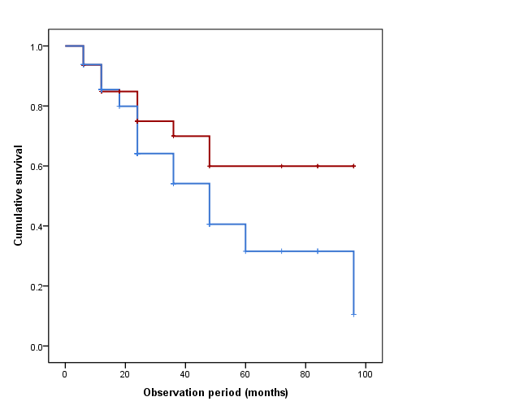

B. Females
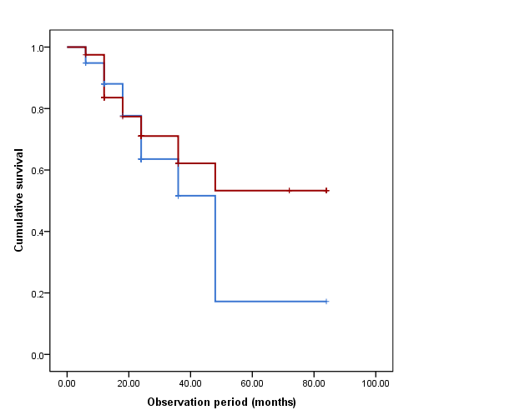

C. APOE4 non-carriers
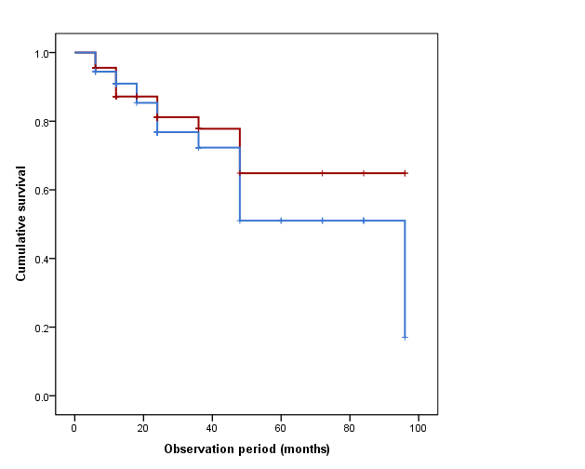

D. APOE4 carriers
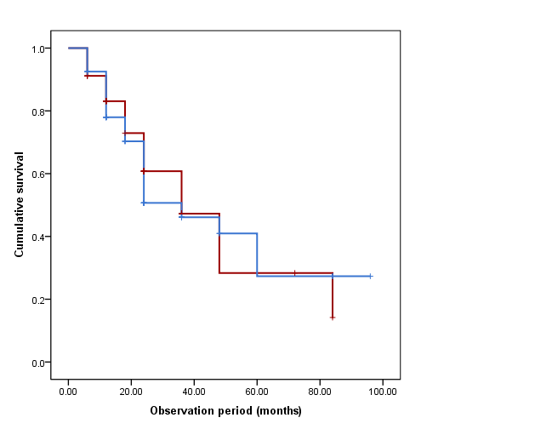
Supplementary Fig. 1. Kaplan-Meier curves of conversion from mild cognitive impairment to Alzheimer’s disease in males (A), females (B), and APOE4 non-carriers (C), and carriers (D). The lines indicate large (blue lines, top tertile) and small (red lines, bottom tertile) intracranial volumes.
A

B

C

D

E

F
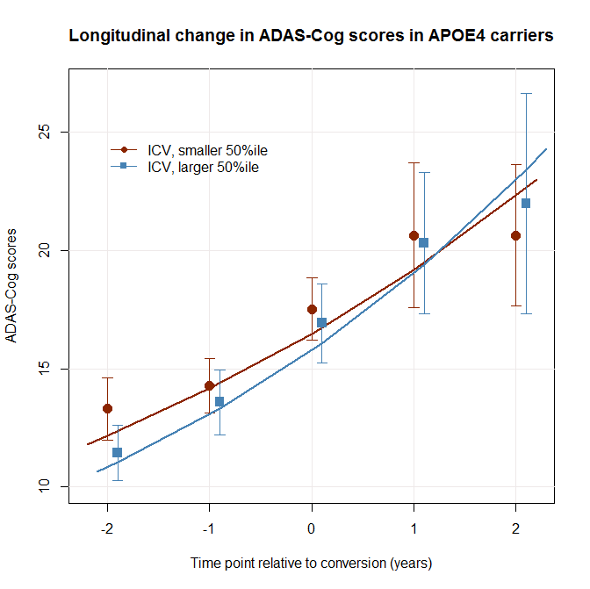
Supplementary Fig. 2. Cognitive and anatomical decline in converters around the time of conversion. Medial temporal lobe volume and intracranial volume ratios and Alzheimer’s disease assessment scale – cognitive subscale (ADAS-Cog) scores were plotted in females (A and B), APOE4 non-carriers (C and D), and carriers (E and F). The overall rate of decline was more rapid in females compared to males, and in APOE4 carriers compared to non-carriers. Time x group interactions were not significant in any of the plots presented above.

